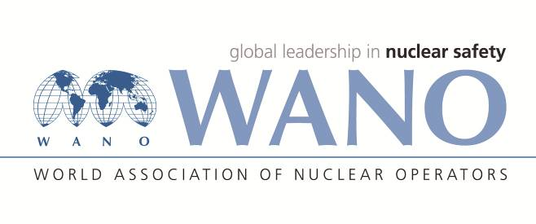 | World Association of Nuclear Operators  Moscow Centre  WANO – MC  25 Ferganskaya, Moscow, 109507, Russia  Phone. +7 495 376 15 87  Fax: +7 495 376 08 97  info@wanomc.ru

REQUEST
to provide technical and organizational information via WANO

- NPP/Organization: MVM Paks NPP
- The topic of information request: Failures to containment electrical cable penetration assemblies
- The goal of information request: Getting information from other plants regarding the following:
Statistics and management of the failures to containment electrical cable penetration assemblies, and identification of the causes of electric failures.
- Problem description:
At the localization system of Unit 2, the measurement of one of the trays (20XL10L505N1) generated a ’high level’ signal, which was not justified by the operational parameters or interventions performed in the system (no intervention was performed). The inspections confirmed that the signal was false. The PVC insulation of the original Russian design containment electrical cable penetration assembly (20ZE4590.05) was assumed to have deteriorated. After filling up all trays, the issue of ‘high level’ signal occurred at several trays. After the unit was shut down, the containment wall penetration was repaired (full replacement using new technology).
Inspections of the dismantled cable connection nozzle were not able to clearly identify the cause of the failure (radiographic and destructive testing).
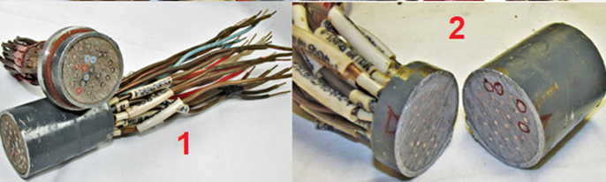

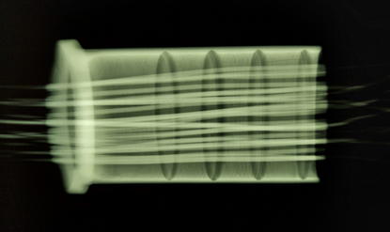
- Specific questions:
- Is there any similar equipment (localization tower containment electrical cable penetration assembly) in the nuclear power plant?
- Have you experienced any similar failure?
- How frequently have such failures occurred?
- How did you manage and resolve failures?
- What is your experience in the identification of the causes of the failure?
- What was the cause of the failure? Can you give any recommendations on how to identify the cause of the failure (measuring devices, methodology, etc.).
- Proposed organizations for sending this request:
Plants with VVER type reactors
- Department – request initiator: Operating Experience Section
- Contact details of the requester: József LUKÁCS, Safety engineer; lukacsj@npp.hu
- Date of request: 18.11.2021

WIO at Paks NPP Jelena Hadnagy

