## WANO2ndleveltop[1]

**Quarterly Interaction Report of Bushehr NPP and WANO MC**

**WANO**

**Moscow Centre**

**Quarterly Interaction Report of**

**Bushehr NPP and WANO-MC**

**for 2 quarter 2021**

**(Bushehr_R_2021_Q2**)

Bushehr

2021

**Approval Page**

|  |  |  |
| --- | --- | --- |
| **APPROVED BY:** |  | **APPROVED BY:** |
| **Bushehr Plant Director**  **_____________ Reza Banazadeh**  **«____»_________2021** |  | **WANO-MC Director**  **_______________ Vasiliy Aksenov**  **«____»_________2021** |
| **AGREED BY:**  **NPP Chief Engineer**  **_____________ Mohsen Shirazi** |  | **AGREED BY:**  **WANO-MC First Deputy Director**  **____________ Anatoliy Kirichenko**  **WANO-MC Deputy Director**  **____________ Sergey Frolov**  **WANO-MC Deputy Director**  **____________Sergey Vybornov**  **Head of WANO-MC Representatives Group**  **______________ Vadim Tarykin** |
|  |  | **DEVELOPED BY:**  **WANO-MC Representative**  **______________ Hamid Azarbad** |

Contents

1. Summary 4

2. Interaction between WANO and plant 5

3. Proposals on additional support and/or modification of the Interaction plan 8

Annex 1. Status of AFIs from the previous Peer Review 8

Annex 2. Status of SOER recommendation implementation 12

Annex 3. Follow-up from previous Member Support Missions 15

Annex 4. Status and trends of the WANO Index and Performance Indicators 16

Annex 5. Events 26

Annex 6. Participation of plant employees in WANO activities 27

Annex 7. Targeted observation reports 27

## 1. Summary

Status of BUSHEHR NPP-1:

BNPP-1 status (Update 2021.07.05) is (working on power) – 100 % NR.

In this quarter the unit connected to the grid on April 23, 2021 after reserve shutdown.

On May 19, 2021, the unit disconnected from the grid to eliminate hydrogen leakage from the gas cooling system of rotor.

* + - * Total production of electrical energy: 48,443,740 Mwh .
      * Total net electric energy to national electricity grid: 44,031,370 Mwh .
      * The amount of electricity production in last fuel loud: 5,625,217 Mwh .
      * Effective days: 231.7 days.

Regarding the performance indicators of the power plant and based on the analysis of the indicators, it should be noted that the plant has achieved the long-term individual and industry goals for the key WANO performance indicators except the FLR, US7 and as a result UCF. This fact is associated with a long loss of time to repair defects, unscheduled repair extensions and late prepare the unit for start, as well as many EP signals and unit stops on 2019, meanwhile other indicators and NPP safety at all, have a detectable trend and are generally adjusted. Description and comments of the status of WANO performance indicators are provided in Annex 4.

Regarding the Events on the power plant, it should be noted that during the reporting period (2Q21), no reportable event and no deviation have been reported. The investigation of the low level events was carried out by the station. All corrective actions from previous quarters were implemented in a timely manner per the established procedures. In the 2nd quarter of 2021, the total number of LLEs reported and recorded was 2 events. Also the total number of near misses reported and recorded was 381 events. Detailed information on events and deviations is provided in Annex 5.

Regarding the interactions of the power plant with WANO in the last quarter, it should be noted that in the last quarter of 2021, due to the coronavirus pandemic and its restrictions, participation in WANO activities was limited to remote meetings and online video conferences. Details are available in Annex 6.

Regarding WANO's Peer Review program, it should be noted that the last WANO Peer Review conducted in Bushehr NPP from November 19, 2019 to December 05, 2019, and after which in recent months and during the reporting period, the main priorities and issues of NPP and OSR was planned to control implementing the corrective measures and monitoring of their realization) The representative is responsible for monitoring and controlling the implementation of corrective measures (. Results of the assessments by OSR based on the monitoring and evaluations of corrective measures and monitoring of Areas for Improvement gave an acceptable picture about the operating of NPP. in this regard and considering the pandemic situation, planned support activities by MC for this quarter have been rescheduled to the other next mounts on this year and )If the current situation continues( 2022 year, Details are presented in Annex 3.

## 2. Interaction between the Plant and WANO-MC

**2.1. Interaction in areas of special attention**

The most important interaction between NPP and WANO is WANO Peer Review program,

|  |  |  |
| --- | --- | --- |
|  | **Activity** | **Date** |
| 1 | 2nd WANO Peer Review | **CPO**: 08.11-19.11.2019  **PR**: 19.11-06.12.2019 |
| 2 | Monitoring and control of Implementing of Corrective Actions by OSR according to the Plan | Up to Follow-Up |
| 3 | Follow-Up of 2nd WANO Peer Review | Planned for:  17 December 2021 |

This review identifies areas of attention that are assessed as Areas For Improvement (AFI). The last Peer Review of the Bushehr NPP in 19.11-06.12.2019 identified 7 areas for improvement (AFIs). 4 areas (included 6 AFIs) have been assigned to the area of special attention, for which it has been decided to conduct WANO activities at the NPP. The “Interaction Plan” updated with new action plans reacting on the results of the WANO PR at Bushehr NPP.

1. Description of the AFI:

AFIs on the area “Operations Fundamentals and Operational Focus”:

OP.1-1: The MCR crew did not always effectively diagnose/monitor equipment condition and used procedures to make correct operational decisions in the abnormal and accident conditions simulated at the full-scope simulator. Significant AFI

HU.1-1: Operations and technical administrative managers do not always promote the environment conducive to minimizing the likelihood of human errors during lineup activities

OF.1-1: The plant personnel do not always effectively monitor the in-service condition of the equipment to identify and resolve operational problems.

1. Description of the AFI:

AFI on the area “Organization and Administration - Organisational Effectiveness”:

OR.3-1: Risk assessment methods and procedures are not always systematically used in the decision-making process to control collective risk. Significant AFI

1. Description of the AFI:

AFIs on the area “Emergency Preparedness”:

EP.1-1: The plant has not fully implemented the Severe Accident Management (SAM) arrangements. Significant AFI

1. Description of the AFI:

AFI on the area “Performance Improvement”:

PI.2-1: The root causes are not always identified in the event investigation, or are identified out-of-time. Significant. Recurrent AFI

There were factually 4 areas specified in the WANO and Bushehr NPP Interaction Plan based on PR results. For all AFIs the “Plan of Corrective Measures” has been developed and implementation of this plan started and is under control by WANO OSR (Based on the order from NPP director).

For this year on the basis of results of the WANO PR from Bushehr NPP, WANO OSR monitoring and observations, and the received recommendations from WANO MC, the interaction between Bushehr NPP and WANO MC developed as a way for support and has being organized as well as specified plan in the interaction plan of Bushehr NPP and WANO-MC for 2020-21. But, Unfortunately, due to world pandemic situation COVID-19, the planned activities for 2020 was postponed. So, the interaction plan updated. Additionally, based on the decision of MC GOM an extended and new updated interaction plan for 2021-22 is under preparation and will be agreed with MC.

Details and descriptions of the proposed support for WANO are available in the following sections.

**2.2. Interaction in other areas**

* WANO-MC On Site Representative participates in NPP activities including working committee or groups (Safety committee, Missions Preparation, Events evaluation committees, General and targeted assessments, internal and external audits, Risk management self-assessment, and provides the station with WANO support and from WANO resources,
* WANO-MC OSR provided all WANO support to departments and managements based on their requests (when needed),
* WANO-MC OSR organized technical communication with other NPPs when required for Technical request information exchange and WS, Seminars and MSMs organization and organization support during BNPP experts’ missions.
* WANO-MC OSR Participated in the activities to review the corrective actions resulted from the WANO Peer Review and preparing the list of CA and reviewing translated to English version of CA for sending to WANO-MC,
* WANO-MC OSR Standard support activities for organization of WANO-NPP activities and missions and also updating the internal website via downloading the materials from WANO closed website and putting them on related places in the close local NPP network and sending announcements to related managers and sections.
* WANO-MC OSR Standard work, activities and meetings:

|  |  |  |  |  |
| --- | --- | --- | --- | --- |
| **Date** | **Activity** | **Reason for the activity** | **Resources** | **Comments** |
| Daily | Daily monitoring | station safety performance | WANO-MC Representative at Bushehr NPP (OSR) |  |
| Daily | Daily OSR report | Station Status and Safety Performance + Coronavirus Status | WANO-MC Representative at Bushehr NPP (OSR) |  |
| Weekly | NPP management meeting | -WANO News  - feedback for/from WANO | WANO-MC Representative at Bushehr NPP (OSR) |  |
| Weekly | Weekly OSR report | - weekly information about OSR activities and NPP status to MC | WANO-MC Representative at Bushehr NPP (OSR) |  |
| Weekly | MC OSRs meeting | -WANO News  - feedback for/from NPP and WANO activities | WANO-MC Representatives (OSRs) |  |
| Weekly /Monthly /Quarterly | Meeting with NPP Director | - CA of WANO PR implementation status  -Interaction activities with WANO MC and results of monitoring  -- determination of experts to WANO activities/missions  -- WANO news and results and plans | WANO-MC Representative at Bushehr NPP (OSR) | At least twice a month |
| Daily/Monthly | Targeted Observation | - Regular TO on selected NPP areas according to WANO PO&C based on an order from NPP director for NPP preparation for next WANO PR Follow-Up on 4Q 2021 | WANO-MC Representative at Bushehr NPP (OSR) , Bushehr NPP managers and experts. | 4 TO  and currently the preparation for 4 planned TO for next 6 months until Follow-Up is under progress |
| 2nd Quarter  2021 | Throughout the quarter 13 information requests were received. For those requests, 7 feedback messages were received and 4 answers was sent to the WANO Operating Experience Group. | Technical requests from stations. | WANO-MC Representative at Bushehr NPP, Bushehr NPP managers and experts. |  |
| 2nd Quarter  2021 | Regular updates of information on the WANO-MC Representative Office’s information stand. | By initiative of the WANO-MC | WANO-MC Representative at Bushehr NPP (OSR) |  |
| 2nd Quarter  2021 | Distributed WANO documents and materials via the local network and targeted distribution. | The receipt of the respective materials by the WANO-MC | WANO-MC Representative at Bushehr NPP |  |
| 2ndQuarter  2021 | Cooperation with the Young Generation candidates activists | Regularly and by initiative of the WANO-MC | WANO-MC Representative at Bushehr NPP | preliminary regular informal activities with 7 voluntaries |

**3. Proposals on additional support and/or modification of the Interaction plan**

OSR is directly in contact with the NPPD managers and specialists, coordinates and supports the WANO interaction with NPPD, BNPP-1, and 2-3 new IRAN units.

In the meantime, the WANO support is organized in a standard way through the WANO OSR activities at Bushehr NPP and the planned activities have been fulfilled.

Unfortunately, due to world pandemic situation COVID-19, the planned activities for 2020 was postponed. On the other hand, based on the decision of MC GOM an extended and new updated interaction plan for 2022-23 was prepared and sent to MC managers to review, and will be agreed with MC. NPP management team is in permanent contact with WANO-MC via the On-Site-Representative (OSR). For now, we are waiting for the pandemic situation to be clarified for the remaining months in 2021, and the interaction plan will be agreed in the near future.

## Annex 1. Status of AFIs from previous Peer Review Reports

## Results of previous PR/DIPR

In the period of 19 November to 04 December 2019, (PR: 19.11-05.12.2019 + CPO: 08.11-19.11.2019), Moscow Centre conducted a peer review of Bushehr Nuclear Power Plant.

The plant performance was reviewed in 2 fundamentals, 6 functional and 10 production areas. In this PR the Crew Performance Observations(CPO) were carried out at the full-scale simulator in the period from 08 to 20 November 2019 and for this purpose, the PR team included two experts and a CPO leader.

A preliminary visit to the plant took place from 11 to 17 June 2019. During the preliminary visit, the WANO team conducted observations of outage activities, emergency drills and the MCR crew training at a full-scope simulator. In addition, the team conducted Crew Performance Observations at the full-scope simulator.

The Peer Review was conducted following the Design-Informed Peer Review (DIPR) methodology. This means that the facts and areas for improvement were weighted in terms of their significance for the fulfilment of the design-basis safety functions.

The WANO team has acknowledged that overall, the Bushehr NPP is maintained in a good condition; the production activities are quite effective in many areas and have shown significant improvement in recent years. The integrated indicator ‘WANO Index’ has grown from 60% to 80% in the last three years.

The PR team identified:

* 5 strengths, (MA.1-1, MA.2-1, CY.1-1, RP.1-1, OR.4-1, HU.1-1).
* 7 areas for improvement (AFIs); OP.1-1, RP.1-1, OF.1-1, PI.2-1, OR.3-1, HU.1-1, EP.2-1).

out of these there were:

* 1 Repeated AFI (PI.2-1).

## Strengths (Good Practices)

Merits of the plant performance are reflected in the following strengths identified by the Peer Review team:

* MA.1-1 – A tool coding system has been introduced at the station to track handling of the work tools, rigging and accessories (type 2)
* MA.2-1 – The station actively practices video recording of the work processes to raise training effectiveness and gain experience in the conduct of challenging and rarely performed activities (type 2)
* CY.1-1 – Chemistry personnel use portable laboratory instruments to measure oxygen and hydrogen concentrations in the primary coolant (type 2)
* RP.1-1 – The station uses a touch monitor to display the radiological data for premises in the radiological control area (type 2)
* OR.4-1 – Video tutorials presenting management standards are shown at manager meetings to enhance senior management professionalism (type 1)
* HU.1-1 – Safety plates are placed on the tile control panels in order to preclude inadvertent mistakes of the MCR (ECR) personnel and prevent unauthorized control of valves and machinery (type 2)

## Areas for improvement

The Peer Review team has identified seven Areas for Improvement (AFI). One of them repeats the AFI from the PR conducted in 2015 (**). Three AFIs have been qualified as particularly significant (*), though the rest also demand intense attention.

***Subsection for the period between the peer review and follow-up peer review:***

The peer review in19 November to 04 December 2019 identified 7 areas for improvement (AFIs):

|  |  |  |  |
| --- | --- | --- | --- |
| **No.** | **Area for Improvement** | **Status of corrective actions by OSR on 2Q2021** | **Level as assessed by the Representative on 2Q2021** |
| **1.** | **OP.1-1:** *The MCR crew did not always effectively diagnose/monitor equipment condition and used procedures to make correct operational decisions in the abnormal and accident conditions simulated at the full-scope simulator | **In the process**  **SAT=64%**  **AI=28%**  **FAR=0%** | In this quarter,  Targeted Observation TO and assessment conducted.  **Level as assessed by the Representative = B+** |
| **2.** | **OF.1-1:** The plant personnel do not always effectively monitor the in-service condition of the equipment to identify and resolve operational problems | **In the process**  **SAT=95%**  **AI=0%**  **FAR=0%** | In this quarter,  Targeted Observation TO and assessment conducted.  **Level as assessed by the Representative = B-** |
| **3.** | **OR.3-1:** *Risk assessment methods and procedures are not always systematically used in the decision-making process to control collective risk | **In the process**  **SAT=80%**  **AI=10%**  **FAR=0%** | Implementing the CA were under monitoring by OSR in this quarter, so that targeted observations TO and assessment will be on the next quarter. |
| **4.** | **HU.1-1:** Operations and technical administrative managers do not always promote the environment conducive to minimizing the likelihood of human errors during lineup activities | **In the process**  **SAT=85%**  **AI=5%**  **FAR=0%** | In this quarter,  Targeted Observation TO and assessment conducted.  **Level as assessed by the Representative = B** |
| **5.** | **PI.2-1: \*\***The root causes are not always identified in the event investigation, or are identified out-of-time | **In the process**  **SAT=85%**  **AI=5%**  **FAR=0%** | Implementing the CA were under monitoring by OSR in this quarter, so that targeted observations TO and assessment will be on the next quarter. |
| **6.** | **RP.1-1:** Practices and procedures of radiological monitoring used by the personnel do not fully provide for reliable surveillance of radiological situation and for prevention of spread of contamination | **In the process**  **SAT=90%**  **AI=3%**  **FAR=5%** | Implementing the CA were under monitoring by OSR in this quarter, so that targeted observations TO and assessment will be on the next quarter. |
| **7.** | **EP.1-1:** *The plant has not fully implemented the Severe Accident Management (SAM) arrangements | **In the process**  **SAT=30%**  **AI=33%**  **FAR=25%** | Implementing the CA were under monitoring by OSR in this quarter, so that targeted observations TO and assessment will be on the next quarter. |

The PR team detected 7 areas for improvement. AFIs vary in scope and significance, and they would require different efforts to improve the current situation. The most important areas are the following 3 areas: PI.2-1, EP.2-1, OR.3-1.

List of repeated or continuing AFIs:

Repeated AFI: AFI PI.2-1 : The root causes are not always identified in the event investigation, or are identified out-of-time.

The repeated and important AFI PI.2-1 is associated with non-technical problems, human errors and weaknesses in the area of administration and leadership. It is necessary to note that the operational experience accounting system does not effectively collects and analyzes the plant information, and does not further supports the plant leadership actions in assessing the organization’s performance. Detection of performance weaknesses, their significance assessment, and support to the leaders in making the decisions on the corrective measures and improving the performance indicators are not always efficient.

For the all abovementioned AFIs, “Plan of Corrective actions for all AFIs” have been developed and introduced by Station Order No. LTR-1000-244471 dated Feb 16, 2020.

***Status of preparation for the next peer review / follow-up peer review:***

The next peer review (Follow-Up) is scheduled for December 2021. As of now, BNPP and WANO MC OSR implemented a self-assessment of SOERs recommendations and the result was sent to NPP directorate and MC.

The following preparations for the peer review follow-up are underway:

1. Based on the results of WANO PR and for improving the level of areas developed the corrective actions program for each area. Additional corrective measures for EP area have been prepared and developed and all the measures are under control and monitoring.

___________________________________________________________________________.

1. NPP Self-assessments and assessments by OSR based on WANO documents are planned to be implemented at Bushehr NPP based on the order from NPP director. For all these 7 areas planned self-assessment by NPP counterparts and WANO OSR, and at the same time will be implemented the targeted observations by WANO-MC OSR according to the scheduled plan. All results of implemented targeted observations will be reviewed on the meetings with NPP managers and NPP CE with participation of WANO MC OSR. Currently the TO and assessment on 3 production areas was implemented and the results of implemented targeted observations was reviewed on the meeting with NPP Director and NPP Chief engineer.

___________________________________________________________________________.

## Annex 2. Status of SOER recommendation implementation

The last independent assessment of SOER recommendations implementation was performed during WANO PR 2019. During WANO PRs, 239 recommendations included in the 17 SOERs have been reviewed. Out of 17 SOERs, the peer review teams have reviewed 17, implementation of the recommendations of all active SOERs have been reviewed that the total amount of implemented (completed) recommendations is 239.

**Assessment of implementation of the SOER recommendations:**

Out of 17 reviewed SOERs (1998-1, 1999-1, 2001-1, 2002-1, 2002-2, 2003-1; 2003-2, 2004-1, 2007-1, 2007-2, 2008-1, 2010-1, 2011-1, 2011-3, 2013-1…) the Peer Review looked at **72** outstanding recommendations made in 17 ‘Significant Operating Experience Reports’ (SOER). Fifty-two **(52)** reviewed recommendations were rated as ‘Satisfactorily implemented’ (SAT), **17** got the status of ‘Attention to implementation needed’ (AI), and **3** were qualified as ‘Further action required’ (FAR).

SOER reports with ‘FAR’ recommendations:

– SOER 1999-1 ‘Loss of grid’ (5d)

– SOER 2007-1 Rev.1 ‘Reactivity management’ (1b)

– SOER 2010-1 ‘Shutdown safety’ (12a)

Significant progress has been made in the implementation of the SOER recommendations, although the station overestimated the status of recommendation implementation in its pre-PR self-assessment. The recommendations that the WANO team has rated as ‘FAR’ point to the necessity of improving the operational personnel behavior and response to reactivity variations, as well as to the need to broaden emergency management training for Unit shutdown conditions and for severe accidents.

The total amount of implemented (completed) recommendations is 217.

|  |  |  |  |
| --- | --- | --- | --- |
| No. | SOER recommendation | Status by WANO Team’s assessment 2019 | Status by self- assessment on  **2nd Q 2021** |
| 1 | 2 | 4 | 4 |
|  | 1998-1  Safety System Status Control | SAT– 6 | SAT– 6 |
| 0 | 0 |
| 0 | 0 |
|  |  |
|  | 1999-1 with the 2004 Addendum.  LOSS OF GRID | SAT– 19 | SAT– 21 |
| 1 | 0 |
| 1 | 0 |
|  |  |
|  | 2001-1  Unplanned Radiation Exposure | SAT– 12 | SAT– 13 |
| 1 | 0 |
| 0 | 0 |
|  |  |
|  | 2002-1 Rev.1  Severe Weather | SAT– 5 | SAT– 6 |
| 1 | 0 |
| 0 | 0 |
|  |  |
|  | 2002-2  Emergency Power Reliability | SAT–9 | SAT–9 |
| 0 | 0 |
| 0 | 0 |
|  |  |
|  | 2003-2 Rev.1  Reactor Pressure Vessel Head Degradation at Davis-Besse | SAT– 10 | SAT– 10 |
| 0 | 0 |
| 0 | 0 |
|  |  |
|  | 2004-1  Managing Core Design Changes | SAT– 4 | SAT– 5 |
| 1 | 0 |
| 0 | 0 |
|  |  |
|  | 2007-1 Rev.1  Reactivity Management | SAT– 25 | SAT– 26 |
| 0 | 0 |
| 1 | 0 |
|  |  |
|  | 2007-2  Intake Cooling Water Blockage | SAT– 13 | SAT– 13 |
| 0 | 0 |
| 0 | 0 |
|  |  |
|  | 2008-1  Грузоподъемные приспособления, подъем и перемещение грузов | SAT– 20 | SAT– 20 |
| 0 | 0 |
| 0 | 0 |
| NP- 0 | NP- 0 |
|  | 2010-1  Shutdown Safety | SAT– 21 | SAT– 22 |
| 0 | 0 |
| 1 | 0 |
|  |  |
|  | 2011-1 Rev.1  Large Power Transformer Reliability | SAT–23 | SAT–23 |
| 0 | 0 |
| 0 | 0 |
| 0 | 0 |
|  | 2011-3 Rev.1  Fukushima Daiichi Nuclear Station Spent Fuel Pool/Pond  Loss of Cooling and Makeup | SAT– 5 | SAT– 6 |
| 1 | 0 |
| 0 | 0 |
| NP – 1 | NP – 1 |
|  | 2013-1  Operator Fundamentals Weaknesses | SAT– 9 | SAT– 12 |
| 3 | 0 |
| 0 | 0 |
| 0 | 0 |
|  | 2013-2  Post-Fukushima Daiichi Nuclear Accident Lessons Learned | SAT– 30 | SAT– 32 |
| AI – 2 | 0 |
| 0 | 0 |
| NP – 1 | NP – 1 |
| NR – 0 | NR – 0 |
|  | 2015-1 Rev.1  Safety Challenges from Open Phase Events | SAT– 5 | SAT– 6 |
| AI - 1 | AI - 0 |
| FAR - 0 | FAR - 0 |
| NP - 0 | NP - 0 |
|  | 2015-2  Risk Management Challenges | SAT – 1 | SAT – 7 |
| AI - 6 | AI - 0 |
| FAR - 0 | FAR - 0 |
| NP - 0 | NP - 0 |
| No. | SOER recommendation | Status by WANO’s assessment 2019 | Status by self- assessment 2Q2021 |

Results of assessment: The numbers of the recommendations reviewed by WANO MC PR Team are 239 in which:

|  |  |  |
| --- | --- | --- |
| SAT | Satisfactorily Implemented | **217 (%90)** |
| AI | Awaiting Implementation | **17 (%7)** |
| FAR | Further Action Required | **3 (%2)** |
| NP | Not Relevant to the plant | **2 (%1)** |
| NR | Not Reviewed by the PR Team | **0 (%0)** |

**Current SOER recommendations status:**

Corrective actions program of the remaining recommendations of SOER reports which had not been satisfactorily implemented during WANO-2019 peer review was reviewed on the last quarter together with the relevant divisions and managements and WANO MC OSR. The final report of the self-assessment was sent to MC recently.

**Annex 3. Follow-up from the previous Member Support Missions**

**Status of the conducted activities:**

(3.1.) Information about the MSMs, held in the 2ndquarter 2021.

Bushehr nuclear power plant hosted no Member Support Mission MSM at the Bushehr NPP site on 2ndquarter 2021.

**The results of the assessment of the MSM effectiveness**

(3.2.) Status of conducted activities (previous MSMs).

In the second quarter of 2021, no formal evaluation was made about the effectiveness of the MSMs recommendations. first, due to the fact that there is not enough time to complete the realization of recommendations because nuclear power plant had PR on the previous quarter, as well as another reason due to the special situation at the nuclear power plant (Covid-19 Pandemic) and limits and restrictions as well as limits and restrictions on the presence of other NPP employees at work. But, the implementation of recommendations of the held MSMs is under control by NPP and OSR. Corrective measures are ongoing to address identified deficiencies and the deadline of the corrective action plan is monitored by OSR based on results of MSMs. Evaluation of effectiveness of each MSM will be performed after one year and after that all corrective measures is closed as well.

Summary (statistics) of the planned and completed MSMs (total / MSMs based on AFIs) in the reporting period (from the first PR on 2015). The average rating for the effectiveness of the implemented implementation:

|  |  |  |  |  |  |  |
| --- | --- | --- | --- | --- | --- | --- |
|  | **MSM Title** | **Dates** | **Date of completion of the last corrective action** | **Assessment of effectiveness** | | |
|  | 1. Self assessment  (AFI – PI) | February 26- March 02, 2016 | April 2018 | Customer | F-up PR | WANO-MC Representative |
| 3.84 |  | 3.84 |
|  | 2. Configuration management. Temporary and permanent modification  Engineering support (CM.3-1) | 06-09 February 2016 | May 2018 | Customer | F-up PR | WANO-MC Representative |
| 4 |  | 4 |
|  | 3. The system performance of the equipment and the assessment of its condition.  EN.1-1 | 27-29 Feb 2016 | March 2017 | Customer | F-up PR | WANO-MC Representative |
| 3.5 |  | 3.5 |
|  | 4. The adoption of effective operational decision making  LF.1-1 | 23-26 April, 2016 | 2018 | Customer | F-up PR | WANO-MC Representative |
| 3 |  | 2 |
|  | 1. Methods for eliminating the human error - Supervision on personnel performance  AFI base (HU.1) | 20 – 25 October 2017 | Feb. 2019 | Customer | F-up PR | WANO-MC Representative |
| 3.68 |  | 3.68 |
|  | 2. Radiation control and prevent the spread of contamination and minimize Radwaste volumes.  AFI base (RP.3-1 and RP.4-1) | 07 -11 August 2017 | 2019 | Customer | F-up PR | WANO-MC Representative |
| BM |  | BM |
|  | 3. Procedure for justification of application of TVS-2M in WWER-1000 nuclear power plant ", | 01-05 July 2017 | 2021 | Customer | F-up PR | WANO-MC Representative |
| 3.6 |  | 3.66 |
|  | 1. Sever accident management system  AFI base (EP-2-1) | 08-11 December 2018 | 2020 | Customer | F-up PR | WANO-MC Representative |
| 3.5 |  | 3.7 |
|  | 2. BM Visit - Systems and requirements of the crisis management centres, emergency preparedness of NPPs. (EP-2-1) | 6-13 May 2018 | 2019 | Customer | F-up PR | WANO-MC Representative |
| BM |  | BM |
|  | 1. The manner of conducting nuclear safety status assessment in a NPP | 6-12 July 2019 | 2020 | Customer | F-up PR | WANO-MC Representative |
| 3.56 |  | 3.7 |
|  | 2. I&C systems and equipment specifications and their functions and performance during the occurrence of severe accidents. AFI base (EP-2-1) | 28 Sep – 2 Oct. 2019 | 2020 | Customer | F-up PR | WANO-MC Representative |
| 4 |  | 4 |
|  | 3. Leadership | 5-9 October 2019 | 2020 | Customer | F-up PR | WANO-MC Representative |
| 3.5 |  | 3.5 |

**Status of planned activities:**

(3.3.) Information about the MSMs, Planed for Bushehr NPP on 2021:

Current plan:

|  |  |  |  |  |  |  |
| --- | --- | --- | --- | --- | --- | --- |
| **No.** | **MSM topics / Action** | **Venue** | **Dates** | **Area** | **Comment** | **Status** |
| 1 | MSM on topic: “Improving the work and performance of operational staff or Improvement on Operators Personnel works” | Bushehr NPP | 2021  TBD | OP.1-1 HU.1-1 OF.1-1 | MSM  (Assist-Visit) | 🞏 |
| 2 | MSM on topic: “Risk Management and Risk Assessment ” | Bushehr NPP | 2021  TBD | OR.3-1 | MSM | 🞏 |
| 3 | BM MSM entitled “Improving the work and performance of operational staff ” | BM visit | 2021  TBD | OP.1-1 | MSM-BM | 🞏 |

Due to the covid-19 situation, the implementation of this MSM is under consideration.**Annex 4. Status and trends of the WANO performance indicators** **↑**

**General analysis of the WANO Index trends:**

According to the review and analysis of the Bushehr NPP safety performance indicators based on the WANO performance indicators which are concerned to 2019 to 2021 years (specially to 2019 and 2021Q1 available analyses in this quarter), Positive trend demonstrated until the second quarter of 2019, Paying attention to the rates of the WANO indicators shows that NPP has improved its safety and performance over the 2018 year.

This shows the effectiveness of actions implemented before the end of 2018 and the first half of 2019. In 4 quarters on 2019 there is a negative trend on the general index of NPP depending to the US7 and UA7 indicator.

From second quarter of 2019, some NPP indicators have not fulfilled the long term goals of the WANO such as indicators US7 and FLR. This fact is associated with a long loss of time to repair defects and prepare the turbine for start as well as many EP signals and unit stops, Next pages will show these indicators and their current rate.

Analysis of the state of production figures briefly mentions that US7 has increased significantly. In addition, there were events that adversely affected the operation of the reactor plant in parallel with the emergency protection system and affected UCLF, FLR, GRLF and the overall NPP index.

Thus, this issue is being considered by the NPP as a topic for deeper analysis and measures.

In the overall evaluation of indicators that a score between zero to 100 is belonged to the power plant and is known as Method 4, the indexes and indicators are based on the weight coefficients are cumulative in determining the overall rate of the power plant. In the first season of 2019, the power plant has been equal to 89.57, which shows a good increase of 4.57, compared to the previous season. This has led to the improvement of the rank and position of the Bushehr nuclear power plant, in the manner that, the position of the power plant, which was in the last quartile, to the second quartile of the Moscow center power plants for first time.

For the first time after the commercial commissioning of the Bushehr nuclear power plant, the UCF, UCLF and FLR indexes from the last quartile have been upgraded to upper quartiles.

In relation to chemical indexes of water, the member's industrial accidents and the performance indicators of the safety systems, the indicators are ideal and the optimal area is considered.

From second quarter of 2019, NPP indicators have fulfilled the long term goals of the WANO except some indicators as well as US7, UCF and FLR, while other indicators have an acceptable trend, and negative trends and safety of nuclear power plant are generally improving.

Negative status and trend of 3 mentioned indicators is due to some reasons. Main cause which has led to fall of performance indicators and subsequently NPP index in 2019 has been in the production indicators. Long time annual repairs and refueling led to the drop of Unit Capability Factor. This reduction of indicator aggravated from September, 3 and as a result of failure in bearing No. 1 of the turbine. This led to the rise of Unplanned Capability Loss Factor and Forced Loss Rate. On the other hand, increase in the number of actuations of reactor emergency protection system (One manual in Feb, 2019 and three automatic actuations in May, September and December) has led to rise of indicators US7 and UA7. These factors together have led to the fall of overall index and ranking of Bushehr NPP.

Bushehr NPP has made a comprehensive analysis for this issue. As the result with more accurate and detailed planning and efficient control in future repairs, NPP will try to prevent the delays on repairs duration and reduce them if possible. By studying the causes of the root causes and contributing auxiliary factors and events leading up to the emergency protection of the reactor, the underlying factors of events have been eliminated, and with targeted training and preparation NPP will try to prevent events that occur with the human factor causes. Hereafter, had begun and implemented compensatory and corrective actions in order to improve the trend of indicators which was shown on overall index indicator of NPP.

These measures were regarding to reducing the overhaul and mid-life repairs time period, reduction the Plant downtime by reducing the overhaul and semi-overhaul time period.

Also about increasing the operation cycle of the Plant with practical methods exist for increasing the production duration and getting more productivity from the same fuel and to remain in operation for a longer period of time with practical methods exist for increasing the Plant power production.

The actions to reducing the unplanned shutdowns such as measures taken to reduce the unplanned shutdowns during Plant operation and preventing unplanned shutdown during the operation of Plant and practically improve the human-machine relationship and to reduce human errors involved in the Plant unplanned shutdowns.

In 4th quarter on 2020 the negative trend on the index of NPP depending to the US7 and UA7 indicators has been reversed.

By reducing the values and number of manual and automatic protection systems to zero in 2020, it is anticipated that this indicator will be improved and 10 points will be added in the power plant index.

(Table 3. (WANO PI Report)) Analysis of the minimum values of the WANO Index for MCs for 2021Q1 (NPP units located in the worst quartile of WANO MC)

|  |  |  |  |
| --- | --- | --- | --- |
| **Unit of NPP** | **WANO Index value** | **WANO Index tendency**  **(**value is getting better (↑), worse (↓) or unchanged (↔)) | **Contributors in the decrease of the WANO Index value** |
| Bushehr 1 | 62.1 (60.9) | ↑ | FLR, UA7, UCF |

Table 1: Safety status in WANO MC 2021Q1:

| № | NPP | Performance indicators (worst quartile) | | | | | | Performance indicators | | |
| --- | --- | --- | --- | --- | --- | --- | --- | --- | --- | --- |
| FLR, % | SSPI | US7 | FRI | CRE | CPI | TISA2 | UCF | WANO index |
| 6 | Bushehr NPP | FLR-1 (individual) / (WQ) |  | US7-1 (individual)/ (WQ) |  |  |  |  | 78. 79 | 62.1 |

|  |  |  |  |
| --- | --- | --- | --- |
| **no PIs in the worst quartile** | **1-2 PIs in the worst quartile** | **3 PIs in the worst quartile** | **4-5 PIs in the worst quartile** |

**Table 1** contains the WANO PI values for the 4Q of 2020 (2020Q4). All the values have a 36 months’ calculation cycle, except for the fuel reliability FRI values (3 months’ cycle). The column “WANO Performance Indicator (worst quartile)” contains the PI data of NPP of the associated power units of Moscow Centre arranged as follows: power units/NPPs, which do not meet the individual target or do not contribute to meeting the industrial target (pointed out as appropriate)/belong only to the worst WANO-MC quartile over the previous quarter.

Next figures show the WANO Index values of the Moscow Centre power units for the end of the 2020.

| [**Unit**](http://ru.wikipedia.org/wiki/%D0%AD%D0%BD%D0%B5%D1%80%D0%B3%D0%BE%D0%B1%D0%BB%D0%BE%D0%BA) | Year | **Main contributors in the worsening of the index (over 3 years)** |
| --- | --- | --- |
| 1 | 2018 | UA7, US7, UCLF, UCF |
| 2019 | UA7, US7, |
| 2020 | US7, FLR, UCF. |

For the purpose of comparison, a distribution of the current values of the WANO Index is provided below for the WANO-MC units as 1st quarter 2021. It can be seen that the indices for Bushehr NPP are 62.1 the medial value of 87.1.

Fig.1 shows the WANO Index values of the Moscow Centre power units for the end of the 1st quarter 2021:

**Fig.1: Distribution of the current WANO index values by WANO-MC units as of 1st quarter of 2021**

**Bushehr NPP index=62.1**

Bushehr NPP

UA7 chart:

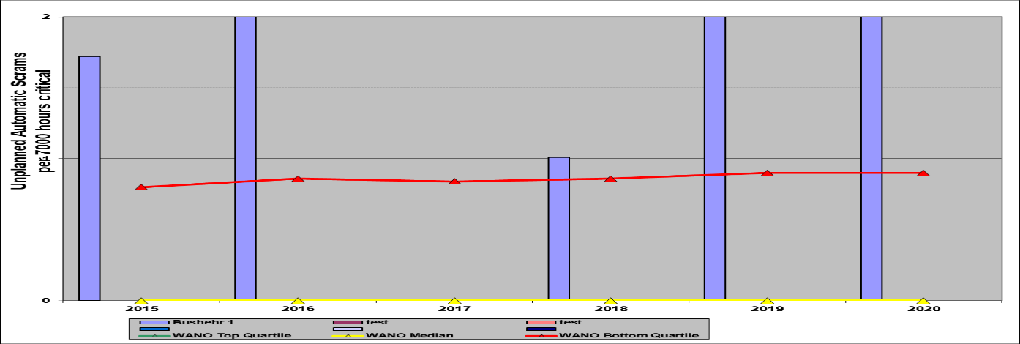

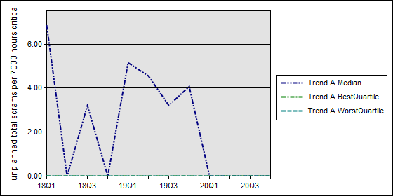

Information on the key indicators (FLR, US7):

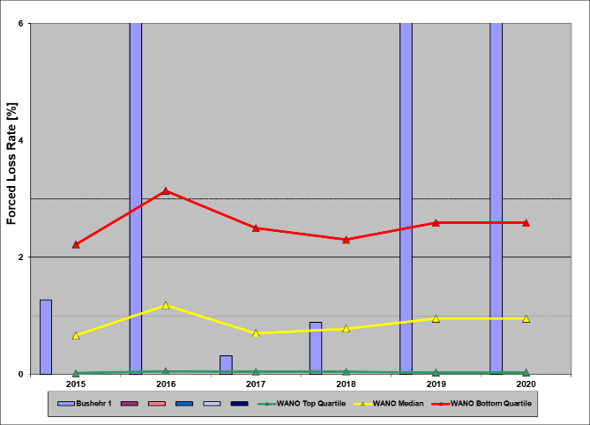**FLR =** 12.6 > 5. **Forced loss rate.**

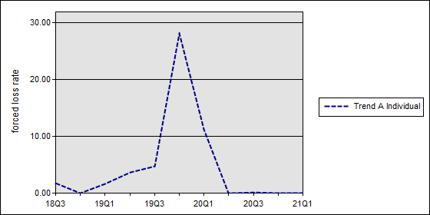

**US7** = 1,43 > 1,0. **Unplanned Total Scrams per 7,000 hours critical.**

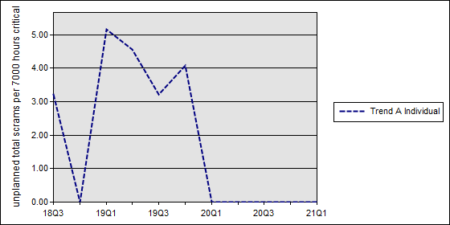

Bushehr 1 Performance Indicators Compared to Moscow Centre - PWR Based on 3-y Average PI Results for 1Q2020:



Unfortunately this table is not available in forth quarter 2020.

(So Q3 2020 For comparing):



WANO-INPO Index over all Indicators:



WANO Index trend for BUSHEHR NPP 2018Q2 - 2021Q1:

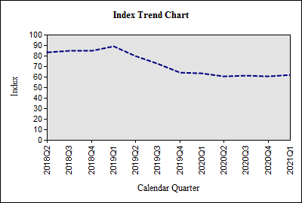**Power histories:**

Overview of the power histories of the plant.

**Electricity output diagram for Bushehr NPP unit 1:**

D

K

L

J

I

H

G

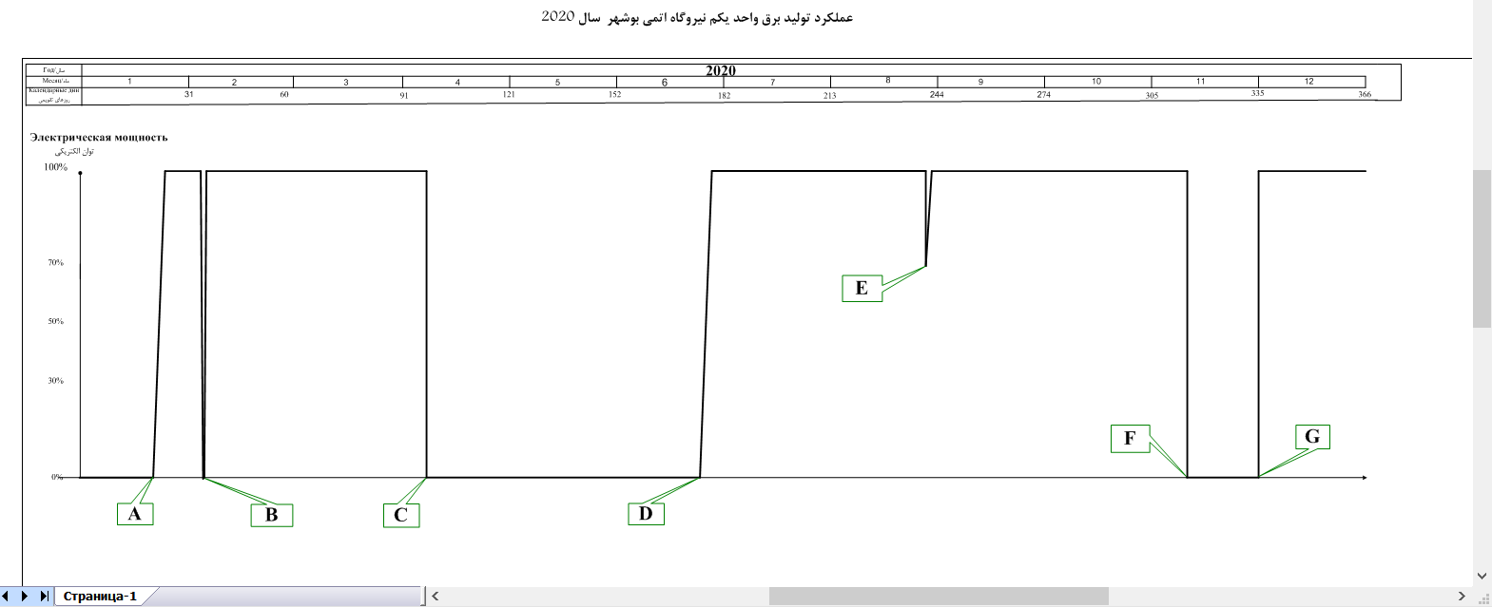Power Production Performance of 7th Fuel Cycle of Bushehr NPP on 1398-99(**2020**):

**АЭС Бушер в 2020 году**

Bushehr NPP-1 Power Generation Performance - 2020

A- On 09.01.2020 at 09:00 after the repair of bearing No.1 of the turbine, the Unit was connected to the national grid.

B- On 04.02.2020 at 06:12, closure of stop valves of the turbine and disconnection of generator from the grid due to decrease of oil pressure of the turbine control line, and on 05.02.2020 at 04:20 the Unit was connected to the national grid.

C- On 12.04.2020 at 21:47, shutdown of the Unit for refueling Outage.

D- On 21.06.2020 at 14:07, connecting the Unit to the national grid after refueling and performing repairs

E- On 27.08.2020 at 21:16, Decrease of Unit power to 70% of the nominal power due to increase of temperature of turbine oil and loss of power of bus bar 10BF and shutdown of chillers. On 28.08.2020 at 04:00, the Unit reached 100% of its nominal power.

F- On 09.11.2020 at 02:28, shutdown of the Unit for removing the defect of water leak from the flange YP23S003.

G- On 01.12.2020 at 01:46, connecting the Unit to the national grid after removing the defect.

**Annex 5. Events**

* 1. **Events subject to be reported to the regulator**

**in 2nd quarter 2021:** Over the reporting period, no events reported to the authority in 2nd quarter 2021. (based on information from OE group).

|  |  |  |  |  |  |
| --- | --- | --- | --- | --- | --- |
| № | Unit | Date and time of event | Description of event | INES  rating | All available significant information  for WANO (Direct/root causes, HU aspects, equipment,…) |
| 1 | - | - | - | - | - |

**5.2. Events investigated by the plant.**

Over the reporting period, there is 0 event not reported to the Authority but investigated by the plant in this quarter (based on information from OE group).

|  |  |  |  |  |
| --- | --- | --- | --- | --- |
| № | Unit | Date and time of event | Description of event | The direct and the root causes of events |
| - | **-** | - | - | - |

**5.3. Statistics and analysis of not significant (near misses) events**

In the Second quarter of 2021, the plant personnel identified and registered 2 LLEs. Also the total number of near misses reported and recorded was 381.

Information of LLEs identified for the four years:

|  |  |  |  |  |  |
| --- | --- | --- | --- | --- | --- |
| Year | 1st quarter | 2nd quarter | 3rd quarter | 4th quarter | Total |
| 2017 | 471 | 419 | 353 | 365 | 1608 |
| 2018 | 359 | 391 | 236 | 246 | 1232 |
| 2019 | 358 | 379 | 216 | 241 | 1194 |
| 2020 | 320 | 566 | 180 | 253 | 1319 |
| 2021 | 301 | 381 |  |  |  |

## Annex 6. Participation of the plant employees in WANO activities

Suggestions for the participation in WANO activities over 2ndquarter of 2021:

|  |  |  |  |
| --- | --- | --- | --- |
| Type of activities | Number of suggestions submitted | Number of suggestions accepted | Number of suggestions rejected |
| Peer reviews | 1 | 1 | 0 |
| MSMs, benchmarking visits | 0 | 0 | 0 |
| Seminars, workshops** | 4 | 4 | 0 |
| Benchmarking visits* | 0 | 0 | 0 |
| Total: | 5 | 5 | 0 |

*Benchmarking hosted by the Bushehr plant.

**4 online workshop were held by WANO MC and our 4 - 5 experts for each programme were attended in these activities.

Participation of Bushehr NPP personnel in the activities outside of the site in 2ndquarter 2021:

|  |  |  |  |  |
| --- | --- | --- | --- | --- |
| No. | Title of activity | Date of activity | Place of activity * | Plant participants |
| 1 | WANO-MC Workshop Fire Safety | 16 - 19 April 2021 | Online | Seyyed Agha Reza Kasaei |
| 2 | Conference on Probabilistic Safety Assessment at operating NPPs | 18 - 20 May 2021 | Online | Ali Khosrowabadi |
| 3 | WANO MC Governing Board | 27 May 2021 | Online | Reza Bannazadeh |
| 4 | CNO Forum | 30 June 2021 | Online | Mohsen Shirazi |
| 5 | WANO-MC PR of Zaporozhye NPP | 13-27 May 2021 | Online | Hamid Azarbad |

* All Online Meetings held on WANO MC OSR Office.

## Annex 7. Targeted observations

4 Targeted Observations was planned and conducted in this quarter. ( 3 TO on Production Area and 1 TO on SOER).

Three assessments as the Targeted Observations were carried out in the 2nd quarter of 2021, based on the order from NPP director on 2020 after NPP Peer Review programme. Because the OSR evaluation and assessment activities on NPP focused to monitor the realization of the PR corrective actions plan due to the special situation (Coronaviruses’ Pandemic).

According to PR CA plan on NPP, conducting of targeted observations were planned on the status of the AFIs for the 2nd and 3rd quarters on 2021. These Targeted Observations focused on the AFIs and results of WANO PR on October 2019 and assessments will be according to the WANO peer review procedures for each area.

During this period, the scheduled reviews of the OPERATION Area (3 production AFIs) were carried out by WANO MC OSR and NPP supervision management involved in these reviews. AFI OP.1-1 , AFI OF.1-1 AFI HU.1-1 were reviewed as TO. Each targeted observation was conducted on a week. Some NPP sections were reviewed such as Production division, Human Resources and Training Center, Reactor Management, Nuclear Safety and Fuel Management, Performance Planning Management, Equipment and Systems Performance Analysis Management, I&C and Electric Managements, Radiation Safety Management, and the Planning and Technical Documents Management.

The result of Targeted Observations was reported to NPP directorate. The results were reviewed on 3 meetings with NPP director, NPP chief engineer and Deputy for production.

During this time period, recommendations of SOER reports which had not been satisfactorily implemented during WANO-2019 peer review was reviewed on the last quarter together with the relevant divisions and managements and WANO MC OSR took part in this Self-Assessment.