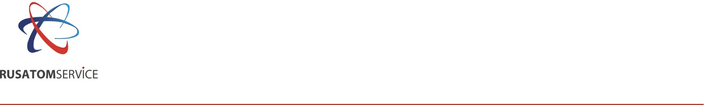

**Rusatom Service JSC**

**+7 (495) 995 7680**

**info@rusatomservice.ru**

____________№ _____________

|  |  |
| --- | --- |
| Applicant:  NUCLEAR POWER PRODUCTION AND DEVELOPMENT, COMPANY OF IRAN (NPPD) NO.8, TANDIS ST. AFRICA AVE., TEHRAN IRAN, P.O.BOX: 14395/1486  Beneficiary:  JSC RUSATOM SERVICE  15A, LENINSKY PROSPECT, MOSCOW, 119071. RUSSIAN FEDERATION  TEL: +7(495)9957680 | Proforma invoice No.PPM/T-2  Dated: 10.04.2018 |
| Reference: Contract No.PPM/T-4100 dated Sep.2017 (Hereinafter “the Contract”) |
| concluded between the |
| Applicant and the Beneficiary |

| No. | Description of Works/Services | Amount (Euro) |
| --- | --- | --- |
| 1 | Training | **12 411 466,23 consist of**  1st year (2018) – 5 655 558,08  2nd year (2019) – 4 752 250,67  3rd year (2020) – 1 469 326,29  4th year (2021) – 534 331,19  **Including:**  TOTAL ADVANCE PAYMENT 10%: 1 241 146,63  ADVANCE PAYMENT (1st year (2018): 565 555,81  ADVANCE PAYMENT (2nd year (2019): 475 225,07  ADVANCE PAYMENT (3rd year (2020): 146 932,63  ADVANCE PAYMENT (4th year (2021): 53 433,12  TOTAL NET AMOUNT 75%: 9 308 599,67  NET AMOUNT (1st year (2018): 4 241 668,56  NET AMOUNT (2nd year (2019): 3 564 188,00  NET AMOUNT (3rd year (2020): 1 101 994,72  NET AMOUNT (4th year (2021): 400 748,39  TOTAL IRI TAX 5%: 620 573,30  IRI TAX 5% (1st year (2018): 282 777,90  IRI TAX 5% (2nd year (2019): 237 612,53  IRI TAX 5% (3rd year (2020): 73 466,31  IRI TAX 5% (4th year (2021): 26 716,56  TOTAL RETENTION MONEY 10%: 1 241 146,63  RETENTION MONEY (1st year (2018): 565 555,81  RETENTION MONEY (2nd year (2019): 475 225,07  RETENTION MONEY (3rd year (2020): 146 932,63  RETENTION MONEY (4th year (2021): 53 433,12 |
| Total | | 12 411 466,23 |

1. Payment: By irrevocable Documentary Letter of Credit which shall be established by the Applicant in favour of the Beneficiary in accordance with the Contract as referred to above.

2. The said Letter of Credit (L/C) will be payable to the Beneficiary by representation by the Beneficiary of the following clean documents fully complied with the L/C terms and conditions:

2.1. The Price of Contract related to the Training of the Principal’s personnel as per Appendices No. 20 and 21 will be paid to the Contractor based on the Schedule of Payment described in the Appendix No.6 to the Contract against the following documents:

2.1.1. Certificate of Training Completion (as per Appendix No.11), which will be developed and signed by the Contractor and approved by the Principal in 4 originals. The Principal shall consider and sign the Certificate of Conducted Training initialed by its representative at BNPP-1 within 7 days from the date of receipt from the Contractor at NPPD office in Tehran.

2.1.2. Signed commercial invoice of the Contractor for the completed Training as per Appendices No.20 and 21 to the Contract in 4 originals.

2.1.3. To ensure good performance Warranty of the Contractor's obligations related to Training under this Contract, 10 % (ten percent) of the amount of invoices issued by the Contractor, shall be retained as good performance Warranty.

2.1.4. The 100% (hundred percent) of the retained retention money of the Training shall be released within 25 (twenty five) days after connection of the Unit to the Grid subject to successful assessment for the effectiveness of the Training of the individuals trained Principal’s personnel (Paragraph 4.2.9 of the Appendix 20 to the Contract) who have been taken part in the respective Works. If any persons of the trained Principal’s personnel don’t take part in the respective Works, for such respectful reasons as disease, layoff, death, Principal’s decision, etc., the related amount of the retention could be released.

3- Other terms:

1. The Applicant bank shall be Bank Markazi Jomhouri Islami Iran, Tehran, Iran.
2. The Beneficiary's bank shall be JSC “Gazprombank”, Moscow, Russian Federation
3. Ten Percent (10%) of each invoice amount which is presented by the beneficiary from time to time shall be deducted as Retention. Such Retention shall be released according to the Applicant's instruction to the Applicant's bank.
4. This Proforma Invoice has been issued on the strength of the Contract No.PPM/T-4100 dated Sep.2017.

This is to certify that the prices quoted in this Proforma Invoice are true and correct.

_______________________

E.A. Salkov