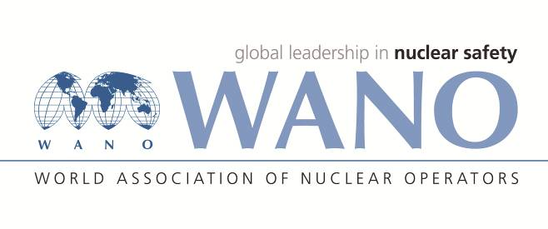 | World Association of Nuclear Operators  Moscow Centre  WANO – MC  25 Ferganskaya, Moscow, 109507, Russia  Phone. +7 495 376 15 87  Fax: +7 495 376 08 97  info@wanomc.ru
REQUEST
to provide technical and organisational information via WANO

- NPP/Organisation: Kudankulam NPP

- The topic of information request:
Observation of radioactive contamination in RPV flange area during refuelling shutdown, which results in increase in ambient radiation field.

- The goal of information request: Getting relevant information from other member plants
- Problem description:
During refuelling shutdown, reactor cavity is drained after the completion of refuelling for carrying our ISI activities related box up of reactor pressure vessel. High level of radioactive contamination is observed at RPV flange area. This is a potential source radiation exposure of radiation workers and a potential source of spread of radioactive contamination. Spectrometric study indicated that constituents of this contamination are activation products, predominantly Zr-95 and Nb-95.

- Specific questions:
- Do similar observations are observed in other VVERs?
- If yes,
- Are the sources of this contamination established?
- What are the levels of radiation field observed due to this contamination?
- What are the radionuclide compositions of this contamination?
- What is the procedure used to remove this contamination?
- What is the contribution of Zr-95 and Nb-95 observed in this contamination?
- What fraction of collective dose for RSD is consumed in these decontamination operations?

6.Proposed organisations for sending this request:
WANO-MC
7.Department – request initiator: WIO-MC
8.Contact details of the requester:
Sanjeev Bhardwaj , +91-9489080628, sbhardwaj@npcil.co.in
9.Date of request:20-08-2021

