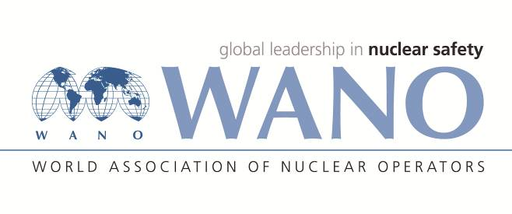 | World Association of Nuclear Operators  Moscow Centre  WANO – MC  25 Ferganskaya, Moscow, 109507, Russia  Phone. +7 495 376 15 87  Fax: +7 495 376 08 97  info@wanomc.ru

REQUEST
To provide technical and organisational information via WANO

- NPP/Organisation: Kudankulam NPP

- The topic of information request:
Tube leakage in the emergency cool down heat exchanger (type ТАР- 240И, ИЖЕР.065157.011), KKS code: 24JNB40AC001 in KKNPP-2. OEM (JSC Baltiyski Zavod)

- The goal of information request: Getting relevant information from other member plants

- Problem description:
At KKNPP in UNIT#2, during plant operation the internal leak in the Steam generator blow down circuit was observed. In scheduled plant outage in 2022, the leakage was confirmed from emergency cool down heat exchanger’s tubes. Since as per design the heat exchanger is vertical shell-and-tube type with weld sealed enclosed housing, the heat exchanger elliptical top/bottom parts from the shell has cut to identify leaked tubes and its plugging by the method of welding.

- Specific questions:
- Are there any power plants in which heat exchanger (type ТАР- 240И, ИЖЕР.065157.011) tube leak defects been detected during its service and of what nature?
- If yes, what repairs are specified in the manufacturer’s documentation?
- Information and experience concerning the heat exchanger tube repairs– Heat exchanger disassembly and reassembly; tube leak identification, method of tube plugging, cutting ,welding and NDT requirement, discrepancies in the maintenance documentation or inaccurate sequence of the operations

6. Suggested organisations to receive this inquiry:
NPPs with VVER-1000 reactors which are using heat exchanger (type ТАР- 240И, ИЖЕР.065157.011).
7.Department – request initiator: MMU
8.Contact details of the requester:
Sanjeev Bhardwaj , +91-9489080628, sbhardwaj@npcil.co.in
9.Date of request:29.04.2022

