

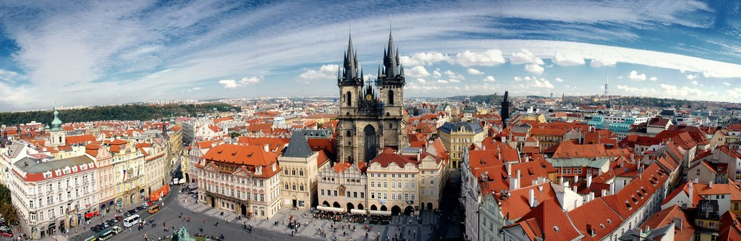

**WANO-MC**

**Governing Board Meeting**

**Agenda**

13 April 2016.

Prague

Czech Republic

**revision 3**

| **Time** | **Activity** | **responsible** |
| --- | --- | --- |
| **13:00÷18:00** | **WANO-MC Governing Board meeting** |  |
| **13:00**  **13:05** | **Meeting opening** | **Janos Toth**  **WANO-MC Chairman** |
| **13:05**  **13:10** | **Approval of WANO-MC Governing Board Agenda** | **Janos Toth**  **WANO-MC Chairman** |
| **13:10**  **13:15** | **Approval of WANO-MC Governing Board Minutes** | **Janos Toth**  **WANO-MC Chairman** |
| **13:15**  **13:30** | **WANO Activity over the period 10.2015-04.2016** | **Janos Toth**  **WANO-MC Chairman** |
| **13:30**  **13:40** | **Approval of WANO-MC annual report for 2015** | **Vasily Aksenov**  WANO-MC Director  **Sergey Frolov**  WANO-MC Deputy Director |
| **13:40**  **13:55** | **Consideration of changes in WANO Policy-2- WANO members’ responsibilities** | **Sergey Frolov**  WANO-MC Deputy Director |
| **13:55**  **14:10** | **Observation of Policy 11- NPP support prioritization** | **Sergey Frolov**  WANO-MC Deputy Director |
| **14:10**  **14:40** | **Working group results on MC management model** | **Peter Tuominen**  **working group Chairman** |
| **14:40**  **15:00** | **Proposals concerning WANO-MC Articles of association Changes** | **Sergey Frolov**  WANO-MC Deputy Director |
| **15:00**  **15:20** | Coffee-break |  |
| **15:20**  **15:40** | **Consideration of changes in new entrant strategy** | **Vasily Aksenov**  WANO-MC Director  **Sergey Frolov**  WANO-MC Deputy Director |
| **15:40**  **16:00** | **Consideration of changes in WANO-MC policies** | **Sergey Frolov**  WANO-MC Deputy Director |
| **16:00**  **16:10** | **Approval of WANO-MC Advisor Selection Committee Minutes** | Advisor Selection Committee Chairman  **Vadim Tarykin**  WANO-MC Improvement Coordinator |
| **16:10**  **16:30** | **Approval of the budget committee report for 2015** | **Margarita Panarina**  WANO-MC Chief accountant |
| **16:30**  **17:00** | **Consideration of interaction levels** | **Anatoliy Kirichenko**  WANO-MC First Deputy Director |
| **17:00**  **17:10** | **export control in the field of nuclear energy** | **Sergey Frolov**  WANO-MC Deputy Director |
| **17:10**  **17:20** | **implementation of a long-term plan Compass. MC activities in the field of personnel preparation** | **Vadim Tarykin**  WANO-MC Improvement Coordinator |
| **17:20**  **17:30** | **WANO key meetings in 2016** | **Sergey Frolov**  WANO-MC Deputy Director |
| **17:30**  **17:35** | **about the next WANO-MC Governing Board meeting** | **WANO-MC Governing Board Chairman** |
| **17:35**  **18:00** | **other** | **WANO-MC Governing Board Chairman** |