**Attachment 1**

**Persepolis**

Persepolis was the ceremonial capital of the [Achaemenid Empire](https://en.wikipedia.org/wiki/Achaemenid_Empire) (ca. 550–330 BC). Persepolis was built by Darus and it was Achaemenid capital for many years. It is situated 60 km northeast of the city of [Shiraz](https://en.wikipedia.org/wiki/Shiraz) in [Fars Province](https://en.wikipedia.org/wiki/Fars_Province), [Iran](https://en.wikipedia.org/wiki/Iran). Archaeological evidence shows that the earliest remains of Persepolis date back to 515 BC. It exemplifies the [Achaemenid style](https://en.wikipedia.org/wiki/Achaemenid_architecture) of architecture. [UNESCO](https://en.wikipedia.org/wiki/UNESCO) declared the ruins of Persepolis a [World Heritage Site](https://en.wikipedia.org/wiki/World_Heritage_Site) in 1979. Although Alexander and Greek army destroyed everything, Persepolis is still magnificent and amazing. The site includes a 125,000 square meter terrace, partly artificially constructed and partly cut out of a mountain.

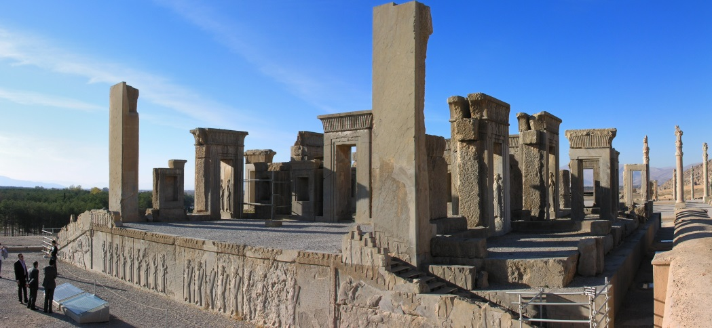

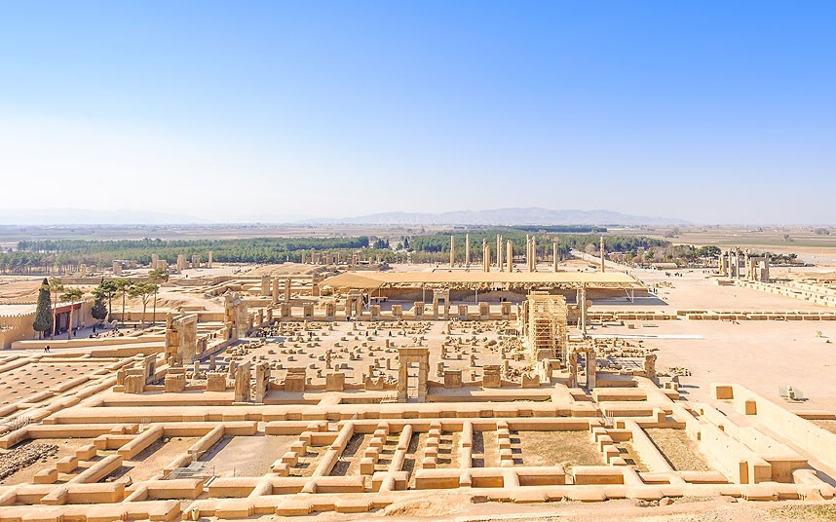

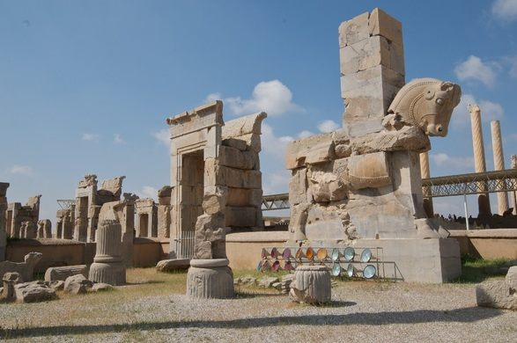

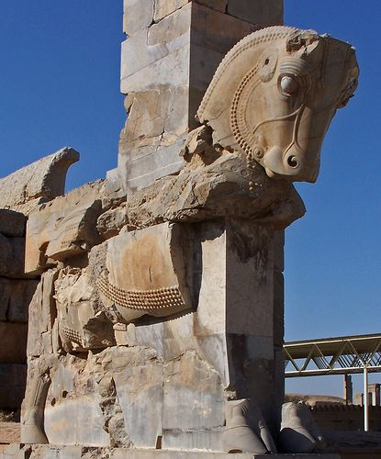

**Naqsh-e Rustam**

Naqsh-e Rustam is an ancient [necropolis](https://en.wikipedia.org/wiki/Necropolis) located about 12 km northwest of [Persepolis](https://en.wikipedia.org/wiki/Persepolis), in [Fars Province](https://en.wikipedia.org/wiki/Fars_Province), [Iran](https://en.wikipedia.org/wiki/Iran), with a group of ancient Iranian [rock reliefs](https://en.wikipedia.org/wiki/Rock_relief) cut into the cliff, from both the [Achaemenid](https://en.wikipedia.org/wiki/Achaemenid_Empire) and [Sassanid](https://en.wikipedia.org/wiki/Sassanid) periods. It lies a few hundred meters from [Naqsh-e Rajab](https://en.wikipedia.org/wiki/Naqsh-e_Rajab), with a further four Sassanid rock reliefs, three celebrating kings and one a high priest. Naqsh-e Rustam is the [necropolis](https://en.wikipedia.org/wiki/Necropolis) of the [Achaemenid dynasty](https://en.wikipedia.org/wiki/Achaemenid_dynasty) (c. 550–330 BC), with four large tombs cut high into the cliff face. The oldest relief at Naqsh-e Rustam dates back to c. 1000 BC. Though it is severely damaged, it depicts a faint image of a man with unusual head-gear, and is thought to be [Elamite](https://en.wikipedia.org/wiki/Elam) in origin.

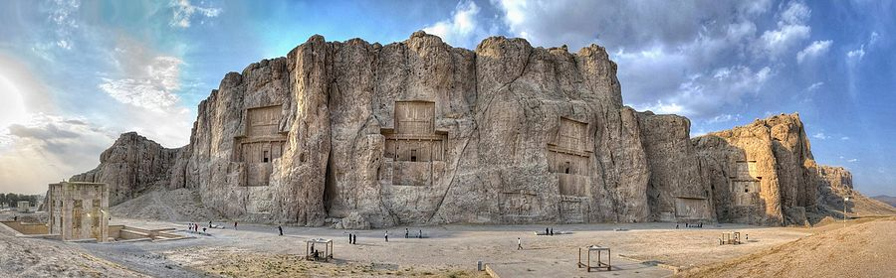

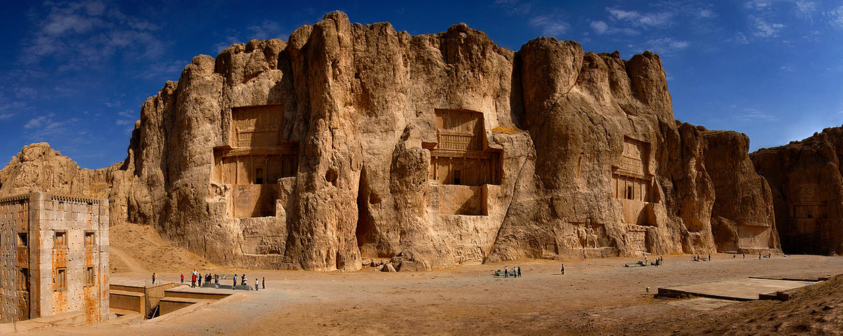

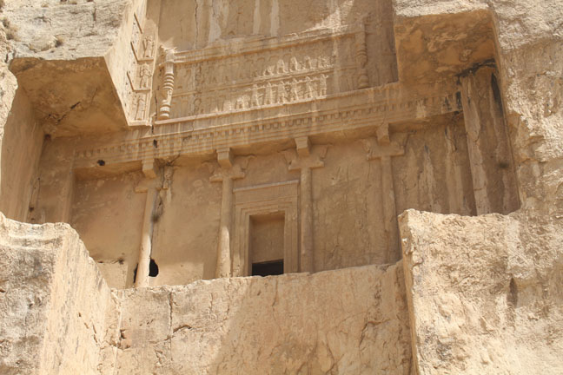

**Attachment 2**

**Tomb of Hafez**

The Tomb of Hafez and its associated memorial hall, the Hāfezieh, are two memorial structures erected in the northern edge of [Shiraz](https://en.wikipedia.org/wiki/Shiraz), [Iran](https://en.wikipedia.org/wiki/Iran), in memory of the celebrated Persian poet [Hafez](https://en.wikipedia.org/wiki/Hafez). The open pavilion structures are situated in the Musalla Gardens on the north bank of a seasonal river and house the marble tomb of Hafez. The present buildings, built in 1935 and designed by the French architect and archaeologist [André Godard](https://en.wikipedia.org/wiki/Andr%C3%A9_Godard), are at the site of previous structures, the best-known of which was built in 1773. The tomb, its gardens, and the surrounding memorials to other great figures are a focus of tourism in Shiraz.

Hafez was born in Shiraz in 1315 and died there in 1390. A beloved figure of the Iranian people, who learn his verses by heart, Hafez was prominent in his home town and held a position as the court poet. In his memory, a small, dome-like structure was erected in Shiraz near his grave at Golgast-e Mosalla in 1452 at the order of [Babur Ibn-Baysunkur](https://en.wikipedia.org/wiki/Babur_Ibn-Baysunkur), a [Timurid](https://en.wikipedia.org/wiki/Timurid_dynasty) governor.

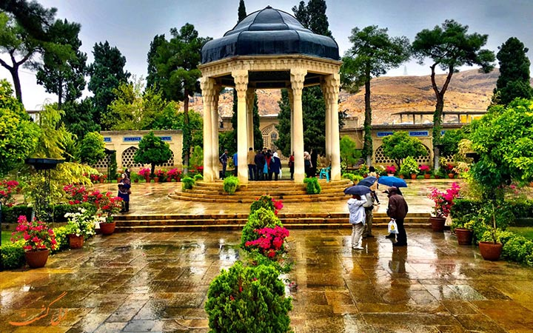

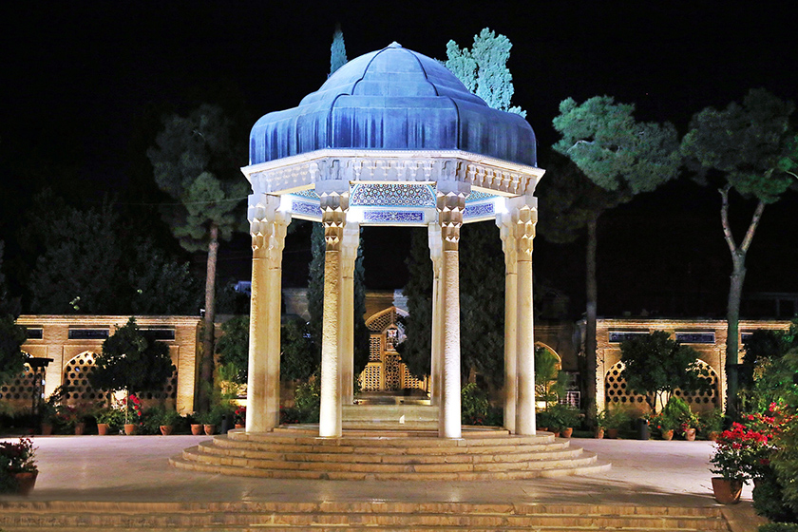

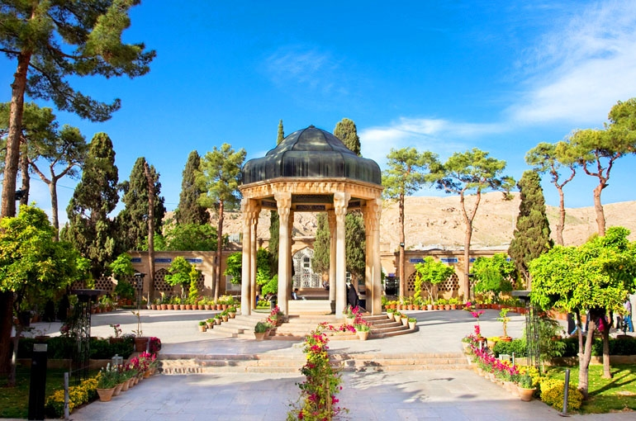

**Saraye Moshir**

Saraye Moshir is traditional [Bazaar](https://en.wikipedia.org/wiki/Bazaar) in [Shiraz](https://en.wikipedia.org/wiki/Shiraz), Southern city of [Iran](https://en.wikipedia.org/wiki/Iran). It was founded more than 250 years ago under the order of government general of [Fars province](https://en.wikipedia.org/wiki/Fars_province) in Shiraz named Mirza Abolhassan MoshirolMolk. It was made as bazaar in the first days of its establishment. Hereafter the time passed and history began. In some days this place was used as a museum and also as a traditional restaurant and Tea-Serving center. After the revolution in Iran it was closed for some years. then it began to become a place for making handcrafts and artful goods. till then up to now it has continued.

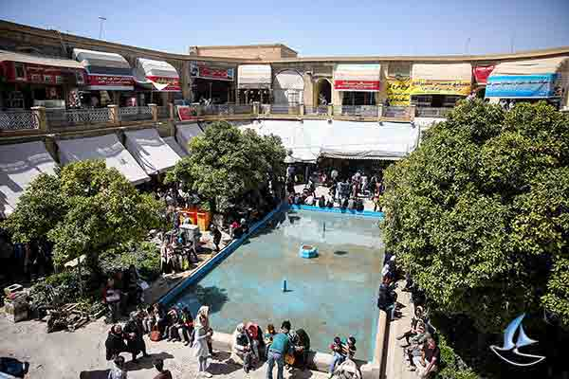

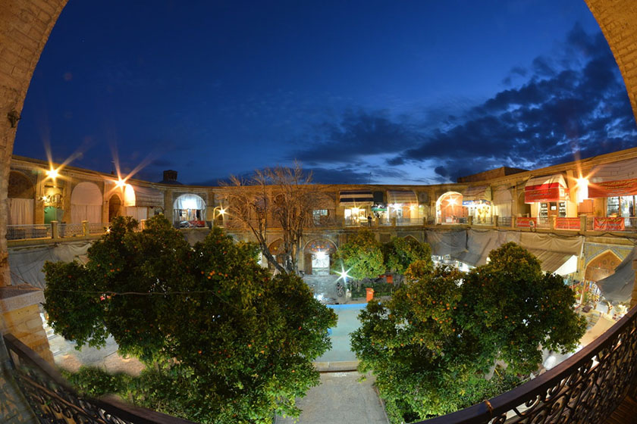

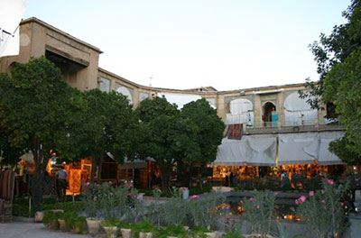

**Vakil Bazaar**

Vakil Bazaar is the main [bazaar](https://en.wikipedia.org/wiki/Bazaar) of [Shiraz](https://en.wikipedia.org/wiki/Shiraz), [Iran](https://en.wikipedia.org/wiki/Iran), located in the historical center of the city.

It is thought that the market originally was established by the [Buwayhids](https://en.wikipedia.org/wiki/Buwayhid) in the 11th century AD, and was completed mainly by the Atabaks of [Fars](https://en.wikipedia.org/wiki/Fars_Province), and was renamed after [Karim Khan Zand](https://en.wikipedia.org/wiki/Karim_Khan_Zand) only in the 18th century.

The bazaar has beautiful courtyards, [caravanserais](https://en.wikipedia.org/wiki/Caravansarai), bath houses, and old shops which are deemed among the best places in [Shiraz](https://en.wikipedia.org/wiki/Shiraz) to buy all kinds of [Persian rugs](https://en.wikipedia.org/wiki/Persian_rugs), [spices](https://en.wikipedia.org/wiki/Spices), [copper](https://en.wikipedia.org/wiki/Copper) handicrafts and [antiques](https://en.wikipedia.org/wiki/Antiques).

Like other Middle Eastern bazaars, there are a few mosques and [Imamzadehs](https://en.wikipedia.org/wiki/Imamzadeh) constructed beside or behind the bazaar.

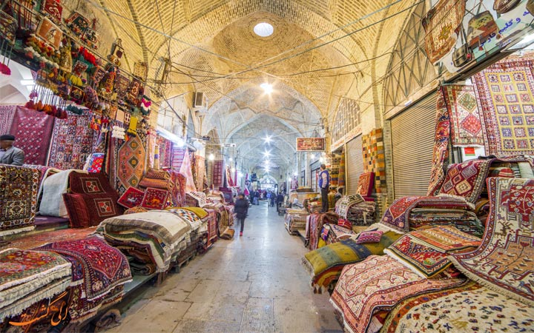

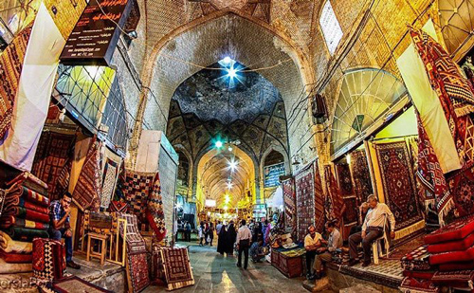

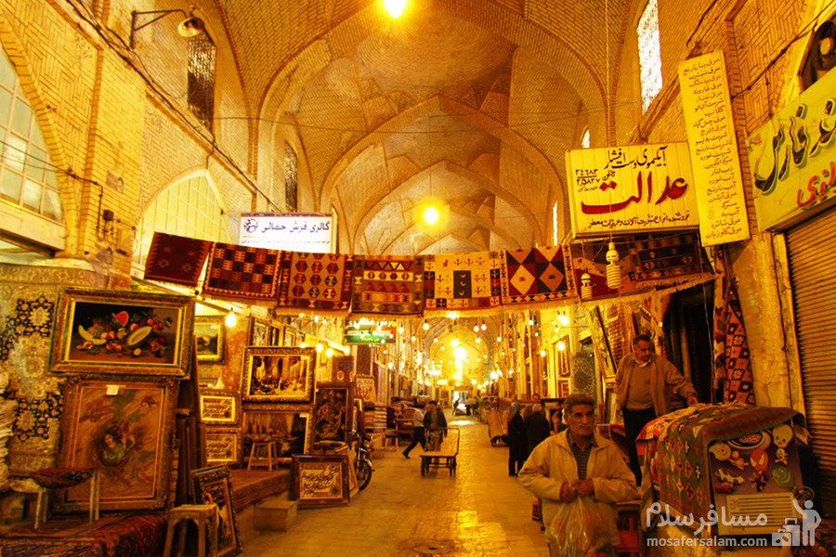

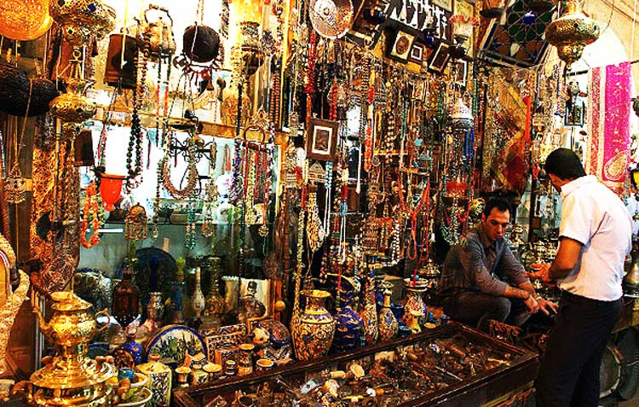

**Attachment 3**

**Zinat Al-Moluk House**

This house belongs to the Qajar Era. The construction of this house started in 1290 AH and it ended in 1302 AH. Most rooms in this house have wooden roofs with pictures of different animals, flowers, bushed and birds drawn on them. The basement of this house is now a museum and statues of important celebrities and famous people of Shiraz and Fars are located there.

This fine city mansion, named after the daughter of the owner, was originally the andaruni (private quarters) area of the neighouring Bagh-e Naranjestan complex. The 20 finely decorated rooms are embellished with paintings, stucco decoration and mirrors, and the mosaic floors were designed to resemble ornate Persian rugs. The intimate gardens, with their fountains and fringe of palm trees, are sheltered behind a walled compound forming a sun trap in winter and a shaded refuge in summer.

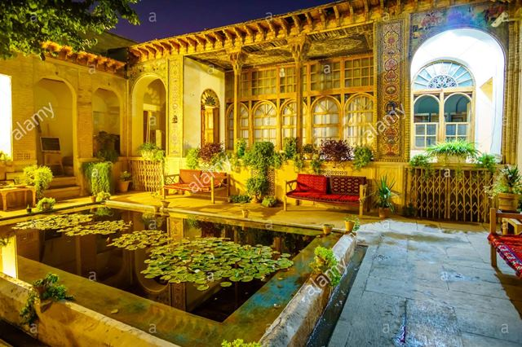

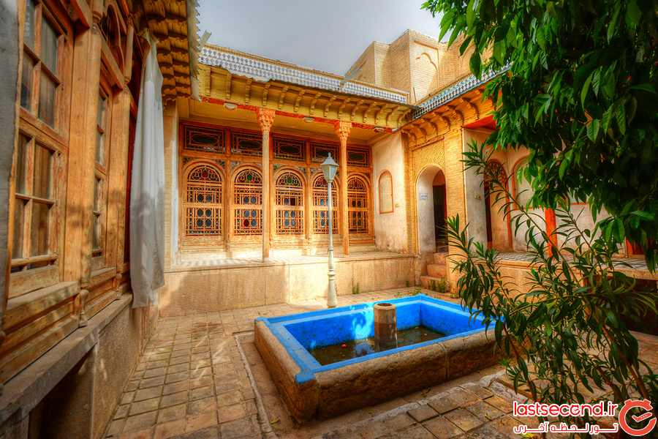

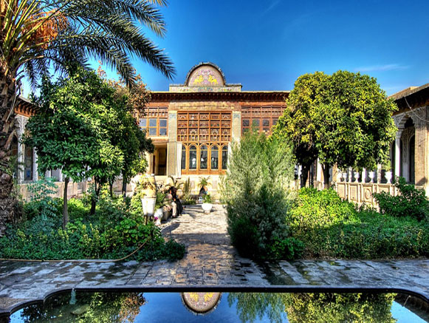

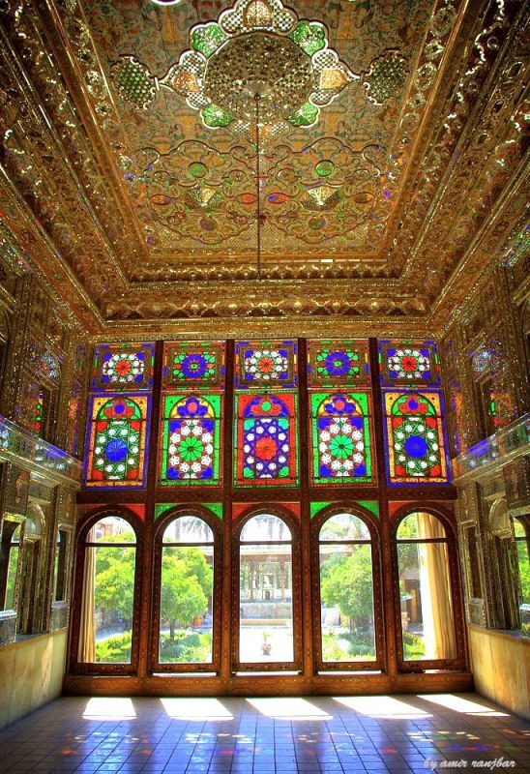

**Qavam House**

Qavam House (also widely called "Narenjestan e Ghavam") is a traditional and historical house in [Shiraz, Iran](https://en.wikipedia.org/wiki/Shiraz,_Iran). It is at walking distance from the Khan Madrassa.

It was built between 1879 and 1886 by Mirza Ibrahim Khan. The [Qavam family](https://en.wikipedia.org/wiki/Qavam_family) were merchants originally from [Qazvin](https://en.wikipedia.org/wiki/Qazvin). But they soon became active in the government during the [Zand dynasty](https://en.wikipedia.org/wiki/Zand_dynasty), followed by the [Qajar](https://en.wikipedia.org/wiki/Qajar_dynasty), and [Pahlavi dynasty](https://en.wikipedia.org/wiki/Pahlavi_dynasty) as well.

The Qavam "Naranjestan" preserves the elegance and refinement enjoyed by the upper-class families during the 19th century. The paintings on the low ceilings of the house are inspired by [Victorian](https://en.wikipedia.org/wiki/Victorian_era) era Europe.

The mirrored porch was a focal point of the house, overlooking a small garden that was designed with fountains, [date palms](https://en.wikipedia.org/wiki/Date_palm), and flowering plants.

During the second Pahlavi era, the House became the headquarters of [Pahlavi University](https://en.wikipedia.org/wiki/Pahlavi_University)'s [Asia Institute](https://en.wikipedia.org/wiki/Asia_Institute), directed by [Arthur Upham Pope](https://en.wikipedia.org/wiki/Arthur_Upham_Pope) and [Richard Nelson Frye](https://en.wikipedia.org/wiki/Richard_Nelson_Frye). Frye and his family also lived in the house for a while.

The house today is a [museum](https://en.wikipedia.org/wiki/Museum) and is open to the public.

