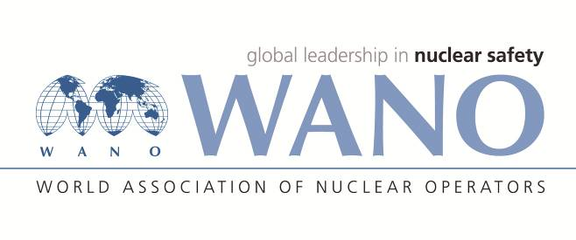 | World Association of Nuclear Operators  Moscow Centre  WANO – MC  25 Ferganskaya, Moscow, 109507, Russia  Phone. +7 495 376 15 87  Fax: +7 495 376 08 97  info@wanomc.ru
REQUEST
to provide technical and organizational information via WANO

- NPP/Organization: Jiangsu Nuclear Power Corporation, Tianwan NPP
- The topic of information request:
Application experience of НП-084-15 regulation

- The goal of information request:
We hope to know the application experience of НП-084-15 regulation, including the experience of in-service inspection cycle, the experience of quality assessment, and the additional requirements from the nuclear safety supervision department when applying the new regulation.
- Problem description:
Tianwan NPP is mainly composed of VVER units, and the work of in-service inspection (ISI) is carried out in accordance with Russian regulations. As the new regulation about ISI (НП-084-15) has been published, which the ISI cycle are different from the original regulation (ПНАЭ Г 7-008-89)，it is necessary to evaluate the impact of the new regulation on ISI in Tianwan NPP, so benchmark with international VVER units in application experience of НП-084-15 regulation is necessary.
- Specific questions:
- Whether the in-service inspection is carried out in accordance with the new regulation НП-084-15? Whether the in-service inspection cycle has been adjusted? Whether the in-service inspection components have been adjusted?
- Whether the nuclear safety supervision department has put forward additional requirements when applying the new regulation?

- Proposed organizations for sending this request:
WANO-MC NPPs
- Department – request initiator:
Mr. Ma Lianji, Engineer of technical support department, Tianwan NPP.
- Contact details of the requester:
Tel. (office): +86 518 82245437
E-mail. malj@cnnp.com.cn
- Date of request: 12.xx.2021

