**Menu bar-Previous MBRs**

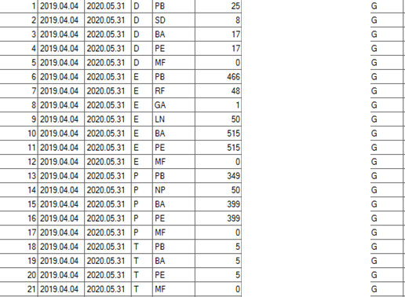

Fig.1 The correct form of MBR from 2019.04.04 to 2020.05.31

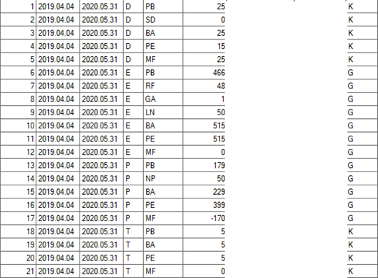

Fig.2 The MBR which is generated by STAR Version 2.8.1.013 Sp4.

1 to 5 and 18 to 21 lines in unit column K is not correct and should be G.

Lines 2 (SD), 3 (BA), 4 (PE) and 5 (MF), No of items is correct and it should be 8, 17, 17 and 0 respectively.

Line 13 (PB), No of items is not corresponding to No of items of PE of previous MBR and it should 349, so line 15 should be 399 and line 17 should be 0.

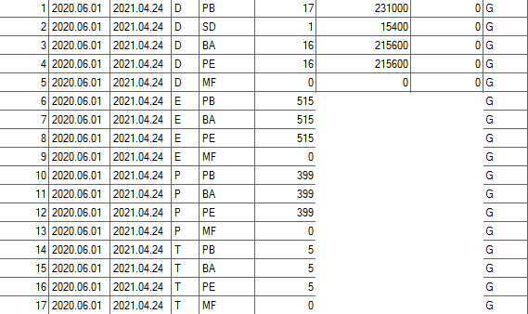

Fig.3 The correct form of MBR from 2020.06.01 to 2021.04.24

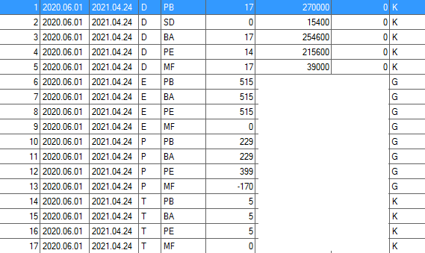

Fig.4 The MBR which is generated by STAR Version 2.8.1.013 Sp4.

1 to 5 and 14 to 17 lines in unit column K is not correct and should be G.

In first line (PB), the element weight is not corresponding to the element weight of PE of previous MBR. It should be 231000 not 270000.

In second line (SD), the no of item is 0 but it should be 1.

In third line (BA), the element weight is not correct and should be 215600.

In third and fourth lines (BA,PE), the No of item should be 16.

In fifth line (MF), the No of item and the element weight should be 0.

In 10th and 11th lines (PB,BA), the No of item is not corresponding to PE of previous MBR. It should be 399. So the line 13 should be 0.

**PIL report**

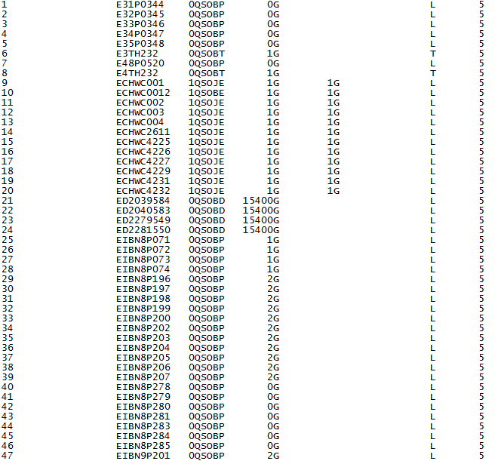

The number of items of some batches with small quantity is not correct and should not be 0 (This column in Itemized List is correct for these batches)