**Appendix**

**Hot Zero Power physical tests at BNPP unit 1 after the third reloading**

**Measurement results**

Table 1. Temperature reactivity coefficient (Тeff = 0 eff days, HZP, H1-9 on ULS, Ppc = 15.9 MPa, βeff = 0.655%)

|  |  |  |  |  |  |
| --- | --- | --- | --- | --- | --- |
| H10,  % | ТPC, °С | ∂ρ/∂t full (±2σ),  pcm/оС | ∂ρ/∂t U calc,  pcm/оС | ∂ρ/∂t H2O (±2σ),  pcm/оС | ∂ρ/∂t H2O calc  pcm/оС х103 |
| 74.7 | 276.4→275.1 T↓ | -4.5±0.5 | -2.94 | -1.5±0.2 | -1.07  (H10=80%) |
| 74.7 | 276.0→278.9 T↑ | -4.9±0.5 | -2.94 | -2.0±0.2 |
| 30.2 | 278.3→277.3  T↓ | -7.9±0.8 | -2.92 | -5.0±0.5 | -3.83  (H10=40%) |
| 23.5 | 275.3→276.1  T↑ | -7.5±0.8 | -2.92 | -4.5±0.5 |

Table 2. Differential worth of 10th group CR. (H10 ↓, H1-9 on ULS).

|  |  |
| --- | --- |
| H10, % | ∂ρ/∂Н, 103 %/cm |
| 100.00 | - |
| 96.38 | 0.94 |
| 92.18 | 2.08 |
| 88.80 | 2.32 |
| 83.45 | 2.63 |
| 78.66 | 2.72 |
| 74.35 | 2.70 |
| 70.03 | 2.67 |
| 66.27 | 2.52 |
| 62.79 | 2.59 |
| 58.85 | 2.49 |
| 54.91 | 2.41 |
| 50.96 | 2.33 |
| 47.02 | 2.22 |
| 42.79 | 2.04 |
| 37.72 | 1.79 |
| 31.81 | 1.46 |
| 24.21 | 1.02 |
| 9.85 | 0.30 |

Table 3. Integral worth of 10th group CR. (H10 ↓, H1-9 on ULS).

|  |  |
| --- | --- |
| H10, % | Δρ, % |
| 100.00 | - |
| 92.75 | -0.02 |
| 91.62 | -0.03 |
| 85.98 | -0.08 |
| H10, % | Δρ, % |
| 80.91 | -0.13 |
| 76.41 | -0.17 |
| 72.28 | -0.21 |
| 67.78 | -0.25 |
| 64.76 | -0.28 |
| 60.82 | -0.31 |
| 56.88 | -0.35 |
| 52.93 | -0.38 |
| 48.99 | -0.42 |
| 45.05 | -0.45 |
| 40.54 | -0.48 |
| 34.90 | -0.51 |
| 28.71 | -0.55 |
| 19.70 | -0.58 |
| 4.86 | -0.60 |

Table 4. Differential worth of 10th group CR. (H10 ↑, H1-9 on ULS).

|  |  |
| --- | --- |
| H10, % | ∂ρ/∂Н, 103 %/cm |
| 4.86 | - |
| 31.62 | 1.39 |
| 38.38 | 1.71 |
| 44.58 | 2.13 |
| 49.65 | 2.30 |
| 54.16 | 2.53 |
| 59.23 | 2.63 |
| 64.20 | 2.69 |
| 68.90 | 2.72 |
| 72.00 | 2.74 |

Table 5. Integral worth of 10th group CR. (H10 ↑, H1-9 on ULS).

|  |  |
| --- | --- |
| H10, % | Δρ, % |
| 4.86 | - |
| 27.95 | 0.24 |
| 35.28 | 0.27 |
| 41.48 | 0.32 |
| 47.67 | 0.35 |
| 51.62 | 0.40 |
| 56.69 | 0.45 |
| 61.76 | 0.49 |
| 66.64 | 0.54 |
| 71.15 | 0.55 |

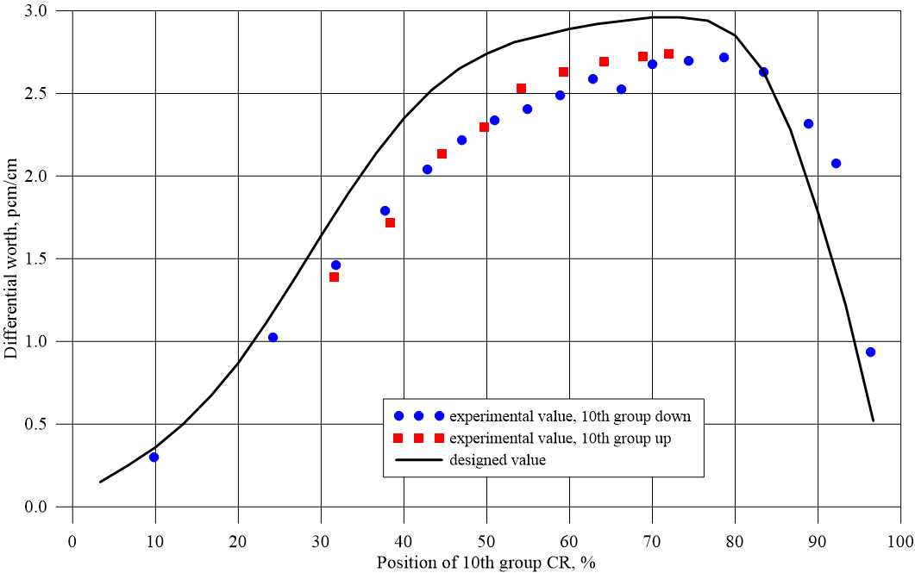

Figure 1. Experimental and calculated differential worth of 10th group CR

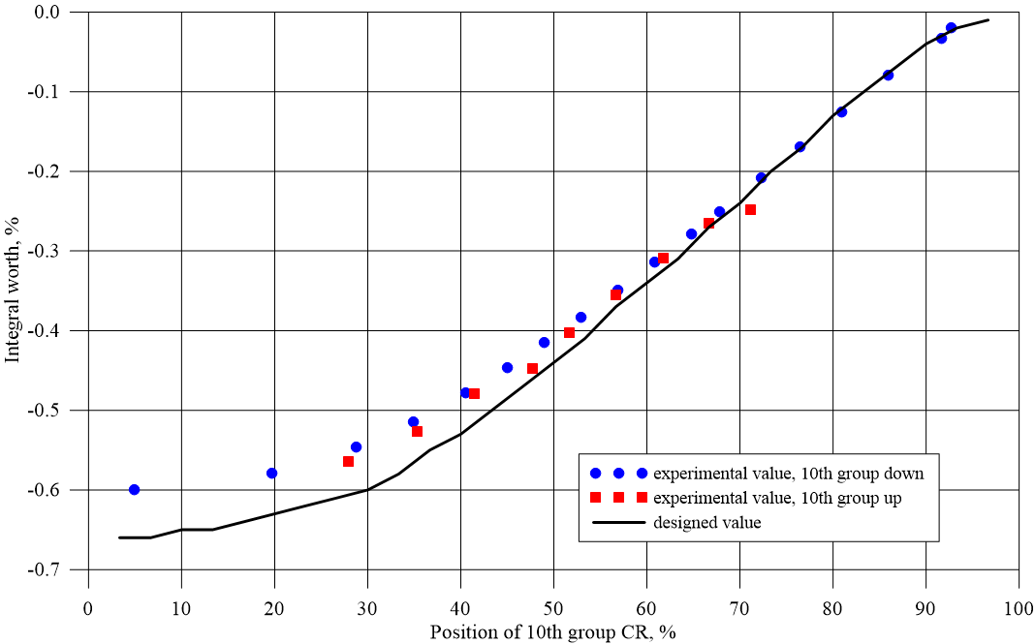

Figure 2. Experimental and calculated integral worth of 10th group CR

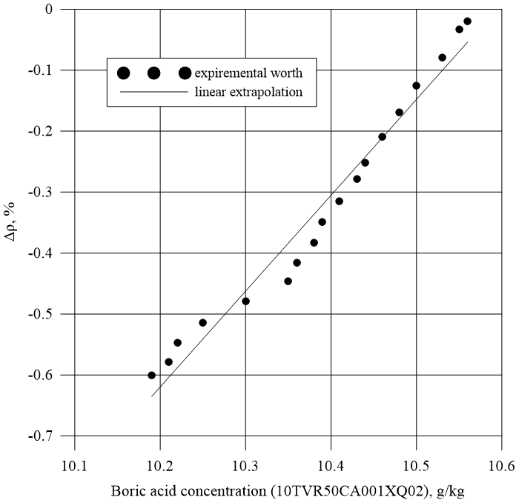

Figure 3. Boron meters readings during ∂ρ/∂Н worth test

Boron acid concentration reactivity coefficient measured based of boron meter readings is -1.57%/g/kg. Calculated value of boron acid concentration reactivity coefficient is -1.61%/g/kg.

Table 6. Results of EP worth measurement with spatial correction

|  |  |  |  |
| --- | --- | --- | --- |
| EP configuration | Δρexp, βeff | Δρexp, % | Δρdesign, % |
| EP worth stuck 155  (without CR 154) | -13,2±1.3 | -8,6±1.0 | -8,5 |
| Full EP worth *  (without CR 154) | -17,9±1.5 | -11,7±1.2 | - |

* - full EP worth estimated on the basis of ic 13 only