**How to use the MS Teams meeting function through the free web interface**

If you do not think you will need Teams in your future life and do not wish to get immersed in the details, please follow this version. For this usage you do not have to install anything, and you do not need any Microsoft or Teams account. (Please note that you cannot use the web app on your mobile device. You will need a PC or a Mac computer for it.)

In the meeting invitation letter that I send you, you will find a link stating “Join Microsoft Teams Meeting” as shown below:

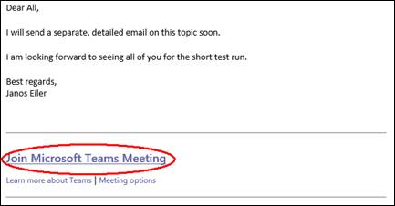

A few minutes before the starting time of the meeting, please click on this link, which will open your web browser and will offer some choices:

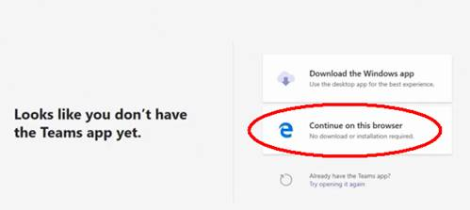

Please select “Continue on this browser”. It will open the meeting preview pane and you can mute or unmute your microphone and turn the camera on or off before you join the meeting. If needed, you can also open “Devices” and choose the appropriate speaker, microphone and camera:

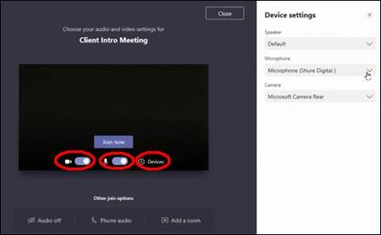

Or, in a different Team version:

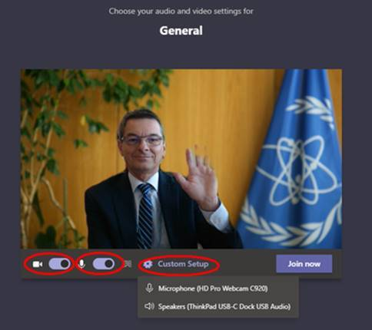

When everything seems to work, please push “Join now”. That’s it for the web interface. You may also wish to check the following, 5-min video, which explains the same:

<https://www.linkedin.com/learning/microsoft-teams-essential-training-5/attend-a-meeting-without-a-teams-account?autoplay=true&trk=learning-course_table-of-contents_video&upsellOrderOrigin=default_guest_learning>

**How to use the MS Teams meeting function through the free client application**

If you do not have the Teams application installed yet, but you are interested in using the free version (it is preferable) and are allowed to/can install it, please follow these steps. For this version you will need a Microsoft account. If you do not have one yet, no problem, it will only take a minute to establish it.

There are multiple ways to get the application. You may click on the “Join Microsoft Teams Meeting” link in my invitation email as shown above in the first figure. Then, instead of choosing “Continue on this browser” you would select “Download the Windows application”.

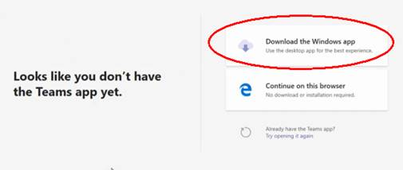

Alternatively, you may start directly from this link:

<https://www.microsoft.com/en-us/microsoft-365/microsoft-teams/download-app#desktopAppDownloadregion>

Please click on “Download Teams”.

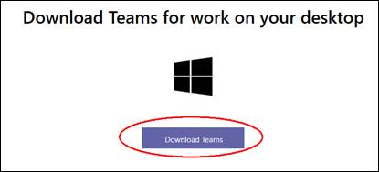

Once downloaded, simply run the installer and follow the subsequent steps to get the Microsoft Teams application installed on your PC.

When you start the application, you will have two possibilities. If you already have a Microsoft account, use your login data and sign in (red ellipsis below):

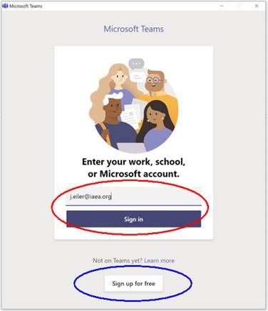

If you do not have a Microsoft account yet, please choose “Sign up for free” (blue ellipsis above) and you will go through the setup process and create the account.

When you are done with the installation, you can jump back in this guidance up to the part starting at the blue highlight to join our meeting. Obviously, instead of selecting “Continue on this browser”, you will now choose “Go to the Teams app”, but normally the app will open automatically, and you do not have to click on anything.

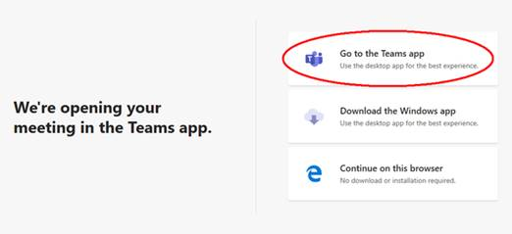

**Sharing your computer screen or an application window (e.g. your PowerPoint presentation)**

After joining a meeting, you can click on the “Share content” button, which is either floating on or is at the upper right corner of your screen (depending on the Teams interface you use).

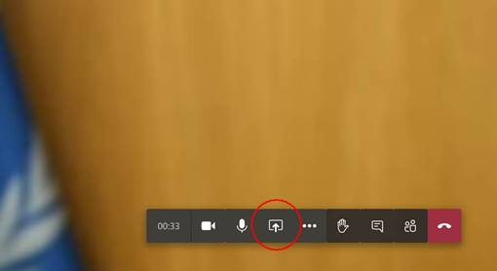



If you use Teams with the web interface, you'll only be able to share your entire screen (not the individual application windows) in your browser.

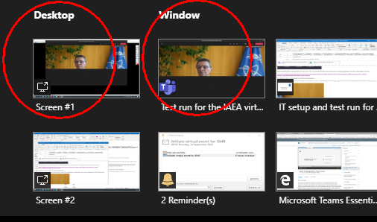

If you have the Teams client application installed on your machine, your sharing options will be multiple:

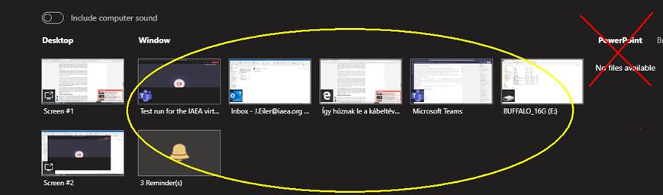

1. At the left side, under Desktop, you can choose to share your entire computer screens including notifications and other desktop activity.
2. In the middle (the yellow ellipsis), you can select a running application window to share. It can be any Word, Excel, PDF, PowerPoint, etc. window.
3. At the right side, there is a PowerPoint choice, but we should not use it. Although it shares a PowerPoint presentation, it is very slow and has a lot of features that we do not need for our meeting.

I suggest, you convert everything you want to show into PDF, open the PDF file in your computer, put the PDF reader in Full Screen view, and then you share that particular PDF window in Teams (or your entire screen if you are using the web interface). (PowerPoint animations and transitions would not come through nicely in the virtual environment, so please do not use these features.)

All participants in the meeting will see your shared content in a large pane on their monitor.

Please note that, if you wish to try MS Teams and practise, you do not have to wait until the meeting starts. You can go over the steps above anytime. However, as the meeting is not running yet, you will not be able to take the very final step and join the meeting. You will be put on a waiting line, which you can leave (close) anytime.

The following slide also provides some useful hints for your preparation:

