Monte Carlo Evaluation of neutron irradiation damage to the VVER-1000 RPV
Kamal Hadad1*, Seyed Fazel Ghazi Ardekani¹, Mohammadreza Nematollahi
¹Department of Nuclear Engineering, Shiraz University, Shiraz Iran
Corresponding author: hadadk@shirazu.ac.ir

Abstract
Neutron irradiation damage is of the most critical damage mechanisms in nuclear power plant’s pressure vessel. Neutrons transfer their kinetic energy to target atoms of RPV that start to jump creating vacancies and interstitials known as Frenkel Pair (FP). The FPs are responsible for formation of defected clusters and microstructural modifications (e.g. phase reactions, segregations). These effects deteriorate physical and mechanical properties of the RPV steels among which are increasing the hardness and decreasing the embrittlement which results in limiting the life-time of RPV. The most sensitive location in the RPV related neutron irradiation damages is in the beltline region and adjacent to the reactor core. Welds and their heat affected zones (HAZs) in this region are of particularly importance due to higher probability flaws compared with the base metal. In this paper, Monte Carlo simulation of the detailed reactor core have led to identifying the areas maximum neutron flux in the RPV. Then the SPECTER Monte Carlo codes are used to evaluate the neutron spectral-averaged DPA values for the beltline region of RPV.

Keywords: RPV, DPA, Radiation damage, VVER-1000, PARCS, SPECTER,

Introduction
The safe and reliable operation of nuclear power plants requires safeguarding the structural integrity of RPV during lifetime of the facility. The degradation of RPV steel is a complicated process dependent on many factors including: thermal treatments and radiation exposure, chemical composition, fabrication and post-production processing conditions. Neutron radiation damage is one of the most critical parameter that causes RPV degradation. Structural materials in a nuclear reactor are damaged by especially fast neutron radiation from fission reactions. Neutrons transfer their kinetic energies to target atoms which start to jump and creating vacancies and interstitials which is called “Frenkel Pair” (FP). The FPs are responsible for formation of defect clusters or microstructural changes (segregations, phase reactions). The presence of the FPs and other consequences of irradiation damage can significantly deteriorate physical and mechanical properties of the RPV steels by increasing the strength (neutron hardening) and decreasing the toughness (neutron embrittlement) and limit the life-time of RPV (Was, 2007).
In literature, there is a contradictory enough information on the neutron flux effects on radiation damage especially embrittlement of steels with different chemical compositions and concentration levels of impurity and alloy elements (Margolin et al., 2003 and 2013; Stroller, 2004; 2013; Chernobaeva et al., 2008; Yu et al., 2010; Kirk, 2010; Williams, 2011). In some papers it is shown that the sign of this effect depends on a flux value (Margolin et al., 2013)
In this paper, evaluation of radiation damage in displacement per atom (DPA) units is carried out via 2 different methods. Shared in both methods, the areas of maximum neutron flux as well as the neutron spectra in those areas are identified with PARCS, a Monte Carlo code [9] and validated with the reference data presented by in Final Safety Analysis Report (FSAR) of the VVER-1000 NPP. VVER-1000 nuclear reactor core has been extensively studied for neutronic safety using probabilistic and deterministic codes (Porhemmat et al., 2015; Hadad et al., 2006 and 2016; Erfan-Nia et al., 2012).

Materials and Methods

2.1 Reactor Core simulation by PARCS
Using SARCS (Shiraz University Advanced Cross Section library) code (Hadad et al., 2014), multigroup neutron cross section of VVER1000/446 reactor core in full power operation is generated. SARCS output is in PMAX (Purdue MAcroscopic Cross-Section) format suitable for PARCS (Purdue Advanced Reactor Core Simulator) (Downar et al., 2002) for simulating the VVER1000 reactor core. The code evaluates the energy and space dependent neutron flux. Using PARCS, beltline region and internal equipment including the core materials detailed in the plant’s FSAR documents are modelled. Reactor is critical in normal operating condition with coolant temperature of 291 C, thermal power of 3000 MWt and critical boric acid concentration of 6.56 g/kg.

The spatial and spectral flux evaluated by PARCS is validated by the reactor reference data for full power operation.
Figure 1(a) shows the evaluated flux by PARCS at the inner RPV surface and at different thickness of RPV metal. Figure 1(b) presents the location of the peak flux on the interior of reactor vessel surface. This location is the beltline region in which the maximum neutron flux occurs. RPV weld number 2 and its heat affected zone (HAZ) is located in this area.

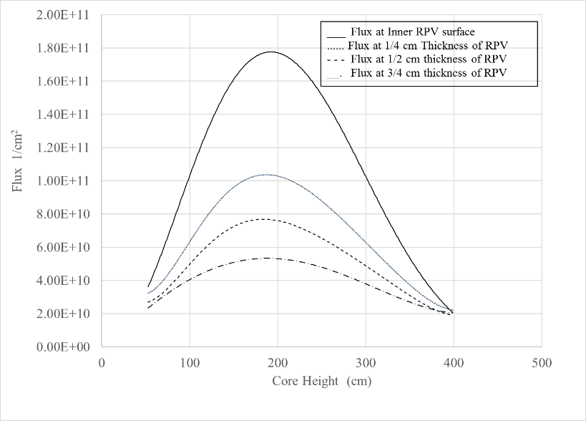 | 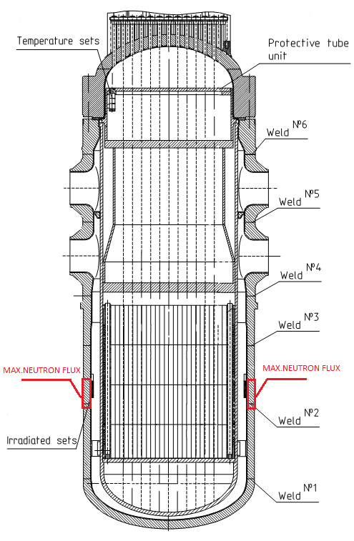
(a) | (b)
Figure 1: (a): Spatial flux profile by PARCS and (b): Location of the peak flux on the interior surface of RPV.

Surface flux on the vessel inner surface are calculated through the entire height. The evaluated neutron flux is used to determine the radiation damage described in the followings.

2.2 Evaluation of DPA using SPECOMP/SPECTER codes
The SPECTER (Greenwood et al., 1995) computer code is used to evaluate the neutron radiation damage. Using the energy-dependent neutron spectrum calculated by PARCS, SPECTER evaluates the spectral-averaged displacements, recoil spectra, total damage energy (Kerma) and gas production. The SPECTER code contains a library of displacement damage cross sections called COMPOUND.DAT. The code SPECOMP (Greenwood, 1989) has been developed to add DPA cross sections for compounds that are not already included in the file COMPOUND.DAT. Having calculated neutron flux on the RPV surface and determined the peak flux region, SPECOMP is used to simulate reactor vessel and SPECTER to calculate DPA. SPECOMP could be executed for any material combination, however only for five elements from the list of 38 elements contained in SPECTER (Greenwood et al., 1985 and 1989). Therefore, Fe, Mn, Cr, Ni, and Mo are selected.

Chemical composition of base metal and weld joint № 2 (beltline region) is shown in Table 1. Also two layers of stainless steel (SS) with 4mm and 5mm thickness coated on the inner surface or VVER-1000 RPV by weld process are included in the simulations. Their chemical analysis is shown in Table 1. Using SPECOMP, the displacement damage cross sections for VVER-1000 RPV material is calculated and appended to COMPOUND.DAT to be used by SPECTER.

Table 1. Chemical composition of the base metal (15Kh2NMFAA) , weld joint №2 ,first and second layer of SS coating (beltline region) (Amounts are in wt%, balance Fe).
Sn | Sb | Cu | P | S | Co | Ti | Mo* | Ni* | Cr* | Mn* | Si | C | Element
0.0022 | 0.0021 | 0.05 | 0.004 | 0.004 | 0.007 | - | 0.52 | 1.19 | 1.97 | 0.44 | 0.31 | 0.18 | Base metal of the second ring
0.0007 | 0.0005 | 0.04 | 0.011 | 0.007 | 0.006 | 0.012 | 0.64 | 1.18 | 1.60 | 0.99 | 0.44 | 0.07 | Weld joint №2
- | - | - | 0.015 | 0.004 | 0.02 | - | - | 12.90 | 23.20 | 1.30 | 0.95 | 0.09 | First layer SS
- | - | 0.08 | 0.005 | 0.005 | 0.016 | - | 0.03 | 9.80 | 19.01 | 1.50 | 0.07 | 0.05 | Second layer SS
*Fe, Mn, Cr, Ni, and Mo are used to simulate steel of RPV with SPECOMP.

The main elements forming precipitates in metal of RPV are Ni, Mn and Cu. Although nickel is added to VVER-1000 RPV steels to increase its hardenability and decrease the ductile-brittle transition temperature, it is generally accepted that the presence of nickel in RPV steels increases its sensitivity to neutron induced embrittlement even at low phosphorus and copper concentrations. Based on the experimental data for VVER-1000 RPV materials [20], it is claimed that the flux effect starts expressing itself with total content of nickel and manganese C_{Ni}+C_{Mn} ≈ 1.8 %. This conclusion is limited for metals of low copper content (C_{Cu}< 0.12%). Since copper has smaller solubility in α-iron than manganese and nickel, it has a stronger influence on radiation embrittlement than nickel or manganese, the flux effect starts to show itself even with its relatively low content C_{Cu}≈(0.12 ~ 0.14) % (Chernobaeva et al., 2008; Margolin et al., 2013; Hoffelner, 2012, NIKIET, 1989).

Table 2. Evaluated DPA for weld joint №2 and base metal in beltline region by SPECTER and its comparison with previous study and ASTM (Total flux = 1.9258E+10, Fluence =4.9917E+17)
Metal in beltline region |  | Damage Rate [dpa/s] | DPA/EFPY
SPECTER/SPECOM (this study) | Base metal(HAZ) | 2.021 E-11 | 5.2387E-04
 | Weld joint | 2.019 E-11 | 5.2340E-04
SRIM/TRIM (Ardekani et al., 2017) | Base metal(HAZ) | 2.220 E -11 | 5.750 E-04
 | Weld joint | 2.210 E-11 | 5.710 E-04
ASTM E693-01 for Iron (Fe) |  | 1.796 E-11 | 4.655 E-04

5. Discussion and Conclusion
Based on the calculations presented in this study, DPA value of weld joint and base metal of RPV are approximately the same and the results previous calculations with SRIM code are in coincidence with SPECTER results. The results are also in agreement with the previous research studied for Fe alone [19].
Table 1 presented the chemical composition of weld joint №2 and base metal of RPV. Phosphorus and Copper concentration in weld joint №2 and base metal of a typical VVER-1000 reactor vessel have different content. Although nickel content in both are about the same, presence of copper, phosphorus and magnesium may have a destructive synergic effect. Based on the calculations, equal amount of flux effect resulting from equal flux spectrum leads to approximate equal DPAs in the base metal and weld joint №2. Therefore, because of different chemical composition between the base metal (15Kh2NMFAA) and weld joint №2 (SV-09GNMTAA), weld joint №2 and its HAZ has the highest risk for the irradiation damage.
Consistent with the results demonstrated table 2, the maximum radiation damage (FP’s) occurs in the region of second layer and its boundary condition with base metal of RPV (7mm-9mm depth from inner surface). In accordance with Russian norms for strength calculation of equipment and pipelines of nuclear power facilities (PNAE G-7-002-86) the coated layers on the inner surface of RPV excluded from calculation of RPV strength (NIKIET, 1989). Therefore, influence of neutron radiation damage on these layers have no noticeable effect on the computational strength of RPV. Although these layers have a positive role in reducing the influence of neutron radiation damage on the base metal of RPV.

References
- Ardekani, S. F. G., & Hadad, K. (2017). Evaluation of radiation damage in belt-line region of VVER-1000 nuclear reactor pressure vessel. Progress in Nuclear Energy, 99, 96-102.
- Chernobaeva, A.A., Kryukov, A.M., Amaev, A.D., Erak, D.Yu., Platonov, P.A., Shtrombakh, Y.I., 2008. The Role of Flax Effect on Radiation Embrittlement of WWER-440 Reactor Pressure Vessel Materials. In: Proc. Of the IAEA Technical Meeting, Gus khrustalny, Russia, p.38-53.
- Erfan-Nia, A., Faghihi, F., & Hadad, K. (2012). Prompt and power reactivity coefficients for the next generation VVER-1000 reactor including hexagonal assemblies and annular fuels. Progress in Nuclear Energy, 61, 41-47.
- Greenwood, L. R. (1989). SPECOMP calculations of radiation damage in compounds. In Reactor Dosimetry: Methods, Applications, and Standardization. ASTM International.
- Greenwood, L. R., & Smither, R. K. (1985). SPECTER: Neutron Damage Calculations for materials Irradiations. Report, Argonne National Laboratory, ANL-FPP/TM-197, 14.
- Hadad, K., & Ayobian, N. (2006). Fuel burnup and fuel pool shielding analysis for Bushehr nuclear reactor VVER-1000. International Journal of Modern Physics E, 15(04), 925-938.
- Hadad, K., & Kowsar, Z. (2016). Twofold application of nanofluids as the primary coolant and reactivity controller in a PWR reactor: Case study VVER-1000 in normal operation. Annals of Nuclear Energy, 97, 179-182.
- Hoffelner, W. (2012). Materials for nuclear plants: from safe design to residual life assessments. Springer Science & Business Media.
- Kinchin, G. H., & Pease, R. S. (1955). The displacement of atoms in solids by radiation. Reports on progress in physics, 18(1), 1.
- Kirk, M. (2010, October). Assessment of flux effect exhibited by IVAR database. In Proc. of the IAEA Technical Meeting on Radiation Embrittlement and Life Management of Reactor Pressure Vessels (pp. 18-22).
- Mokhov, N. V., Rakhno, I., & Striganov, S. (2009, October). Simulation and Verification of DPA in Materials. In Proc. Workshop on Appl. High Intensity Proton Accel.(World Scientific, Singapore, 2010) pp (pp. 128-131).
- Margolin, B. Z., Gulenko, A. G., Nikolaev, V. A., &Ryadkov, L. N. (2003). A new engineering method for prediction of the fracture toughness temperature dependence for RPV steels. International journal of pressure vessels and piping, 80(12), 817-829 .

- Margolin, B.Z., Yurchenko, E.V., Morozov, A.M.,Pirogova, N.E., and Brumovsky, M., Analysis of a link of embrittlement mechanisms and neutron flux effects applied to reactor pressure vessel materials of WWER, Int. J. Nucl. Mat., 2013, vol. 434, pp. 347–356.
- NIKIET, Regulations for strength analysis of equipment and pipelines for atomic power plants (PNAE G-7-002-86), Energoatomizdat, NGA-01-85-1.(1989).
- Porhemmat, M. H., Hadad, K., &Faghihi, F. (2015). PARCS cross-section library generator; part one: Development and verification. Progress in Nuclear Energy, 78, 155-162.
- Stoller, R. E., Toloczko, M. B., Was, G. S., Certain, A. G., Dwaraknath, S., & Garner, F. A. (2013). On the use of SRIM for computing radiation damage exposure. Nuclear instruments and methods in physics research section B: beam interactions with materials and atoms, 310, 75-80.
- Stoller, R. E. (2004). The effect of neutron flux on radiation-induced embrittlement in reactor pressure vessel steels. Journal of ASTM international, 1(4), 1-12.
- Was, G. S., 2007. Fundamentals of Radiation Materials Science—Metals and Alloys, Springer, Berlin, Germany.
- Williams, T. (2011, September). On the Differences and Commonalities in Western RPV Steel Embrittlement Data after MTR or NPP Irradiation. In PAMELA Workshop, Mol.
- Yu, D., Erak, B.A. Gurovich., Y.I. Shtrombakh, D. Zhurko. Degradation and recovery of mechanical properties of VVER-1000 pressure vessel materials. International Symposium FONTEVRAUD 7, Avignon, France, 26-30 September, 2010, №O12-A096-T01.

Effective Full Power Year

