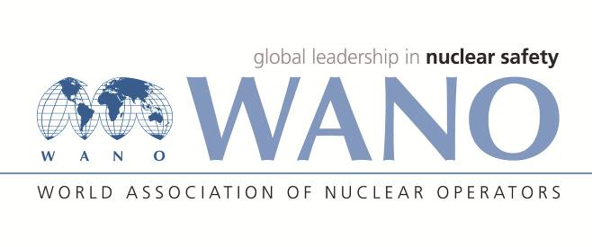 | Moscow Center  World Association of Nuclear Operators  WANO – MC  RUSSIA, 109507, MOSCOW, 25 FERGANSKAYA STREET  Tel: +7 495 376 15 87  FAX: +7 495 376 08 97  INFO@WANOMC.RU
Request
for technical and organizational information
through WANO NPP

1. NPP/ Organization: SE “NNEGC “Energoatom”
2.The subject of the informational request: Independent oversight
3.The objective of informational request: obtaining good practices, using world experience
4. Problem description: fulfilment of WANO recommendations based on the previous review
Specific questions:
- an example of an annual report of an independent oversight service (departmental oversight service) with conclusions, analysis of trends and troubling signs, as well as a brief overview and overall assessment of the company's performance;
- an example of a report on nuclear safety culture (safety culture) with examples describing and explaining the state of safety culture;
- good practices for independent oversight (СО4);
- procedures used to determine the state of safety culture.
5. Proposal of organizations to which this request is addressed: Operating organizations with the best organization of independent oversight based on the results of WANO corporate partner support missions
6.Requesting subdivision: request initiator: Directorate for Safety Oversight
7.Contact details of the requestor: Head of Technical Safety Oversight Department Dmitrii Ksenofontov, d.ksenofontov@direkcy.atom.gov.ua
8.Date of request: 15.02.2022

