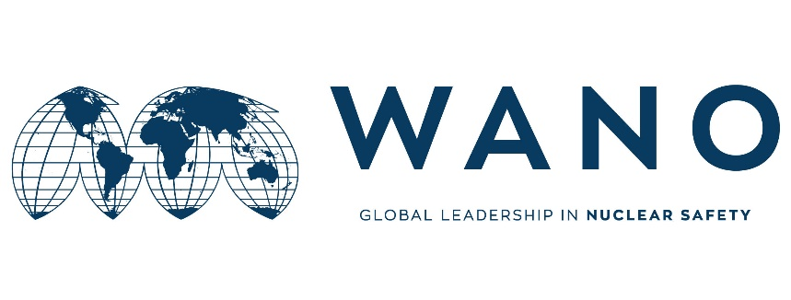 | Moscow Centre  WANO-MC  25 Ferganskaya, Moscow, 109507, Russia  Phone: +7 495 376 15 87  Fax: +7 495 376 08 97  info@wanomc.ru

MSM expert personal form

General information

MSM place: Bushehr NPP
MSM topic: I&C systems and equipment specifications and their functions and performance during the occurrence of severe accidents
MSM date: 28 September -02 October 2019
MSM working language: Russian, English
MSM leader (MC coordinator): Goncharov Ivan
Phone number: +7 915 305 73 60
e-mail: goncharov-iv@wanomc.ru
Expert data

Name | Vasilii
Surname | Likhovidov
Date of birth | 22.02.1973
Place of birth | Russia, city Voronezh
Citizenship | Russia
Passport number  (please send the scan copy) | 65№2410107
Passport issue date | 28.05.2015
Passport expire date | 28.05.2020
Job Title | Engineer
Station | Novovoronezh NPP
Company/Organization | Rosenergoatom
Work Adress | Industrial Area Yuzynaya 1, Novovoronezh,  Voronezh Region
Telephone | +7(47364)7-38-04
Home address | Flat 49, 5, Kommunalnaya street,  Novovoronezh, Voronezh Region  Russia  396072
Fax | +7 (47364) 7-33-02
Work e-mail | lihovidovva@nvnpp1.rosenergoatom.ru
Personal e-mail | bazel11@yandex.ru
Mobile phone | +79192312811
Laptop brand and serial number | -
Size of clothing  Shoes  Height | 43 (european)  178
Presentation title

Technical experience in the MSM area
Foreign languages knowledge
Native language(s) | Russian
Foreign languages | Poor | Medium | Good | Excellent
English | v
Others 1)
2)

