

WANO Guideline for

Enhanced Performance Monitoring

**Draft for implementation**

LIMITED DISTRIBUTION

V0.09

PROCESS DESCRIPTION

This page is left blank intentionally

Process Description ǀ Enhanced Performance Monitoring

|  |  |
| --- | --- |
| * + 1. DOCUMENT REFERENCE | V0.10 – draft for implementation |
| * + 1. PUBLISH DATE [MONTH] [YEAR] | Aug 2021 |
| * + 1. AUTHOR NAME | Ian Oliver & Chuck Zell |
| * + 1. REVIEWER NAME | Tomoya Matsunaga ePM workstream development team leader |
| * + 1. APPROVER NAME | Paul Newman ePM workstream sponsoring Director |
| * + 1. REASON FOR CHANGES | Second draft Update roles and responsibilities for WRep and Area Experts |
|  |

Contents

Foreword 3

1. Purpose 4

2. Scope 4

3. Enhanced performance monitoring integration within the member interaction cycle 4

4. ePM Key components and principles 5

5. Enhanced Performance Monitoring process 7

5.1 Plant performance Assessment 7

5.2 Plant performance summary report 8

5.3 Collegial Review Meeting 8

5.4 Interfaces between ePM and the Assessment process (PR and Follow-Up) 9

6. Roles, Responsibilities and required competencies of key WANO personnel to support ePM 10

6.1 WANO Representatives (WRep) 10

6.1.1 Key roles and responsibilities of WRep 10

6.1.2 Required Competencies of the WRep to support ePM 10

6.2 Area Experts 10

6.2.1 Key roles and responsibilities of the Area Experts to support ePM 10

6.2.2 Required competencies of the Area Experts to support ePM 11

6.3 Performance Analysis Personnel 11

6.4 CRM Chairperson 11

6.5 Other RC personnel 11

7. Rules and Responsibilities of members supporting ePM 12

7.1 Chief Executive Officers/Chief Nuclear Officers 12

7.2 Site Vice Presidents/Plant Managers 12

8. Member Performance Improvement Committee 12

9. ePM implementation transition 12

10. References 13

Appendix A - Plant Performance Summary Report contents 14

Appendix B – Example Plant Performance Summary Report 15

Appendix C – Enhanced Performance Monitoring Performance Indicators 16

Appendix D – Guidance on determining plant performance trajectories 23

Appendix E – Guidance for determining the plant engagement categories 25

Appendix F - Interactions and interfaces between ePM and Assessment (Peer review) 26

Process Description ǀEnhanced Performance Monitoring

# Foreword

The WANO Mission is “To maximise the safety and reliability of nuclear power plants worldwide by working together to assess, benchmark and improve performance through mutual support, exchange of information, and emulation of best practices.”

The need to establish these mechanisms of mutual support, exchange of information and emulation of best practices is also a fundamental part of the WANO Charter:

“Because performance of each member will affect all others, WANO members commit to one another to take timely action to correct significant performance issues and provide the necessary resources to support the WANO mission.”

In the decade following the Fukushima accident, the performance of many power plants has stagnated or even deteriorated. The WANO performance index shows little improvement of performance over many years. In particular, those plants occupying the lowest quartile are not achieving performance that is aligned with the better performing plants. Moreover, the data available from WANO assessments indicates that 81 units (38 stations) in the world are currently rated as WANO 3 and 4. The mean value for the WANO index of these 81 units is in the bottom quartile. Of those units in the 3rd and 4th quartile, 60 units are reporting 77% of the nuclear industry’s significant events, and 75% of the noteworthy events. The industry is also facing several challenges such as; new units under construction and coming online, some of which are operated by companies and countries that are new to the nuclear industry; continued technology changes requiring new skills and competencies; economic pressures; and early plant closures. All of this represents a risk to nuclear safety which needs to be managed effectively.

At the current stage the continuous monitoring process developed by Atlanta Centre is the most advanced and has proven to be effective. Therefore, learnings from this process have been used as the basis for the Enhanced Performance Monitoring (ePM) process. This will be used in other WANO Regional Centres (RCs) to further enhance the current tools for station performance monitoring, with the ultimate goal of detecting early signs of decline, and increase the effectiveness of assistance provided to the stations to address safety and reliability gaps between peer reviews.

EPM is one of the workstreams being implemented under the Action for Excellence (AfE) project (reference 1). It will provide the monitoring necessary to identify and communicate adverse trends quickly with the plant concerned; and provide the assistance and oversight necessary to ensure the effectiveness of the plant improvement actions, including an independent view of station performance. The goal of the AfE project is for all plants to achieve a WANO assessment rating of 1 or 2 with a corresponding improvement in measured safety, reliability and performance, and reduction in significant events by 2030.

# 1. Purpose

This guideline defines the framework, principles and common arrangements for the RCs to implement ePM. The RCs will adapt their implementation plans to take into account local differences. However, the arrangements defined in this guideline will be achieved consistently for all RCs.

The ePM is the programme used by WANO to identify important gaps in the safety, reliability and performance of plants, and provide feedback, support and an independent view to help the plant address these gaps promptly. The ePM programme follows a standard performance improvement cycle such as that described in the WANO ‘Achieving Excellence in Performance Improvement’ guideline. (Reference 2)

The purpose of ePM is to:

1. detect adverse trends in safety and reliability performance promptly,
2. provide the assistance and independent view to ensure that plant improvement actions are effective

# 2. Scope

This guideline is applicable to all nuclear plants and their corporations that are members of WANO (directly or indirectly). For simplicity, this guideline has been written as though directed primarily at nuclear plants but applies equally to the performance of corporate support functions.

The ePM is applied for operating plants. For new units and units in long-term shutdown, the ePM is applied when the unit begins start-up following the WANO Pre Start-up Review (PSUR) or the Restart Review, as applicable. For WANO members with nuclear facilities that are not nuclear power reactors (such as reprocessing facilities, test facilities or commercial propulsion reactors) ePM application is at the discretion of the RC Director General.

The ePM process is used to monitor and assess plant performance outside the peer review assessment process. During a Peer Review (PR), the PR team leader becomes the responsible person to maintain contact with station instead of the ePM WANO Representative (WRep). Routine provision of performance information for ePM such as WANO Performance Indicators, ePM Performance Indicators, WANO Event Reports (WERs) and early notification of events will continue as normal during the PR period.

# 3. Enhanced performance monitoring integration within the member interaction cycle

The ePM process is part of the wider member interaction cycle as described in Reference 1 and shown below in Figure 1:

*Figure 1 ePM and the member interaction cycle*

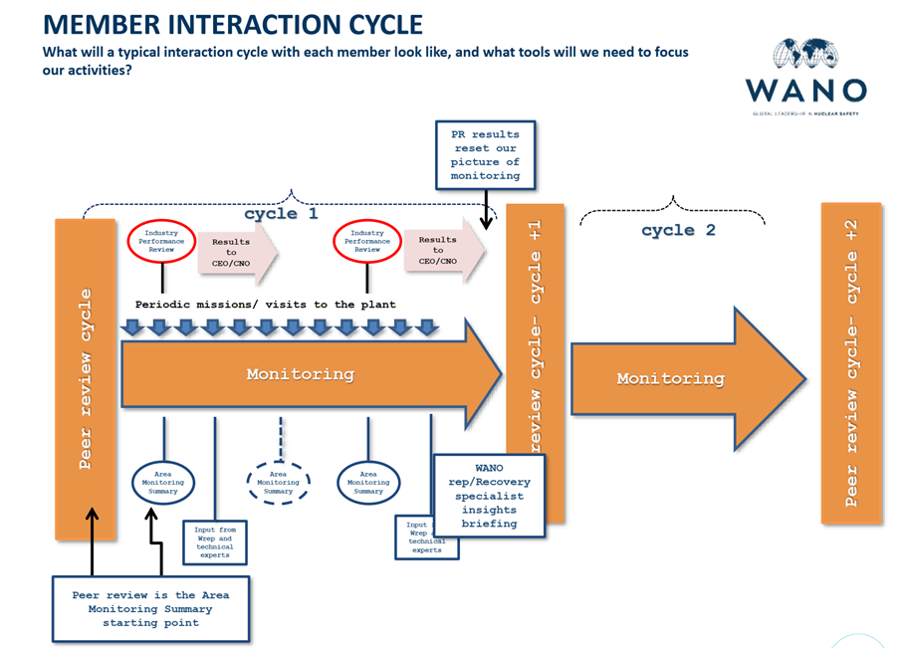

Plant peer reviews are normally conducted every 4 years at each plant. The in-depth assessment conducted during a peer review is the most accurate assessment and diagnosis of plant performance conducted by WANO. Outside the peer review period, plant performance is monitored through ePM. The ePM utilises all the performance information available to WANO to determine current performance level and support needed by each plant, and to prioritise WANO resources in support of the plants that most need it.

# 4. ePM Key components and principles

The key components and principles behind ePM are shown in Figure 2 and described below. This includes a graded approach with more frequent and deeper ePM applied where the risk to nuclear safety and reliability is assessed as high.

*Figure 2 ePM key components and principles*

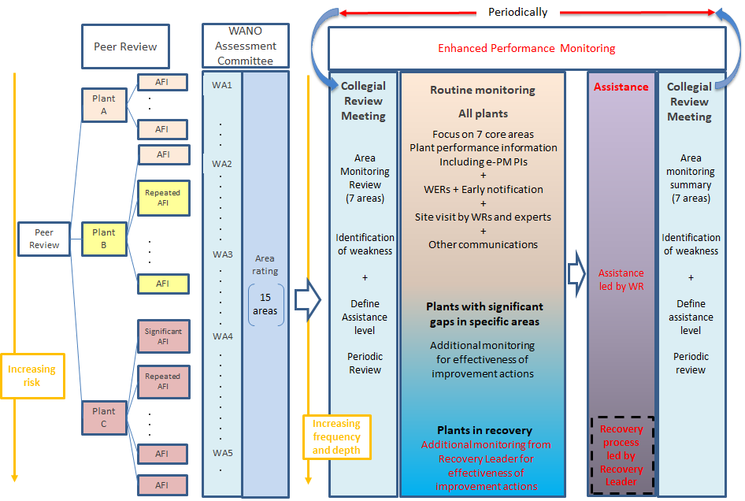

The key components of the ePM process are;-

|  |  |
| --- | --- |
| * Collection of plant performance information, such as WANO PIs, ePM PIs, WERs and early notification of events, other information supplied by the station, and information obtained from the interviews, observations and judgement of WReps, area experts and others from their plant visits and discussions with plant personnel |  |
| * Analysis of the plant performance information will develop a holistic and complete picture of plant performance including identification of important strengths and performance gaps |  |
| * Plant monitoring assessment to determine the engagement categories for monitoring and support required for the plant over the next period. This sets the level of engagement that will be provided by WANO until changes in performance dictate otherwise. Three categories are available;   + Baseline Monitoring   + Augmented Monitoring   + Assistance   + Focused Assistance |  |
| * WANO assistance and plant recovery actions to support plant recovery including monitoring the effectiveness of the improvement actions and continuing to provide an independent view to the plant (oversight) |  |

From the preparation phase near the start of the PR and to the exit meeting, the WANO single point of contact to the station in term of performance issues is the PR team leader. Outside of the PR period, the ePM WRep takes over as the WANO single point of contact to the station from the PR team leader. Regarding the follow-up PR, the process is similar to this.

Several cycles of ePM are undertaken between each peer review. The frequency will be determined depending on the performance level of the plant. More attention will be paid to plants needing more assistance as determined by the PR and ePM performance reviews. The specific frequency of monitoring for each plant will be determined by the RC using a graded approach that takes into account the performance of the plant and makes optimum use of the resources available to the RC. All plants will be reviewed at least annually.

The recovery arrangements are defined in reference 4

# 5. Enhanced Performance Monitoring process

A single cycle of the ePM process, including the recovery and assistance steps for completeness, is shown below in Figure 3:

*Figure 3 Enhanced performance monitoring cycle*

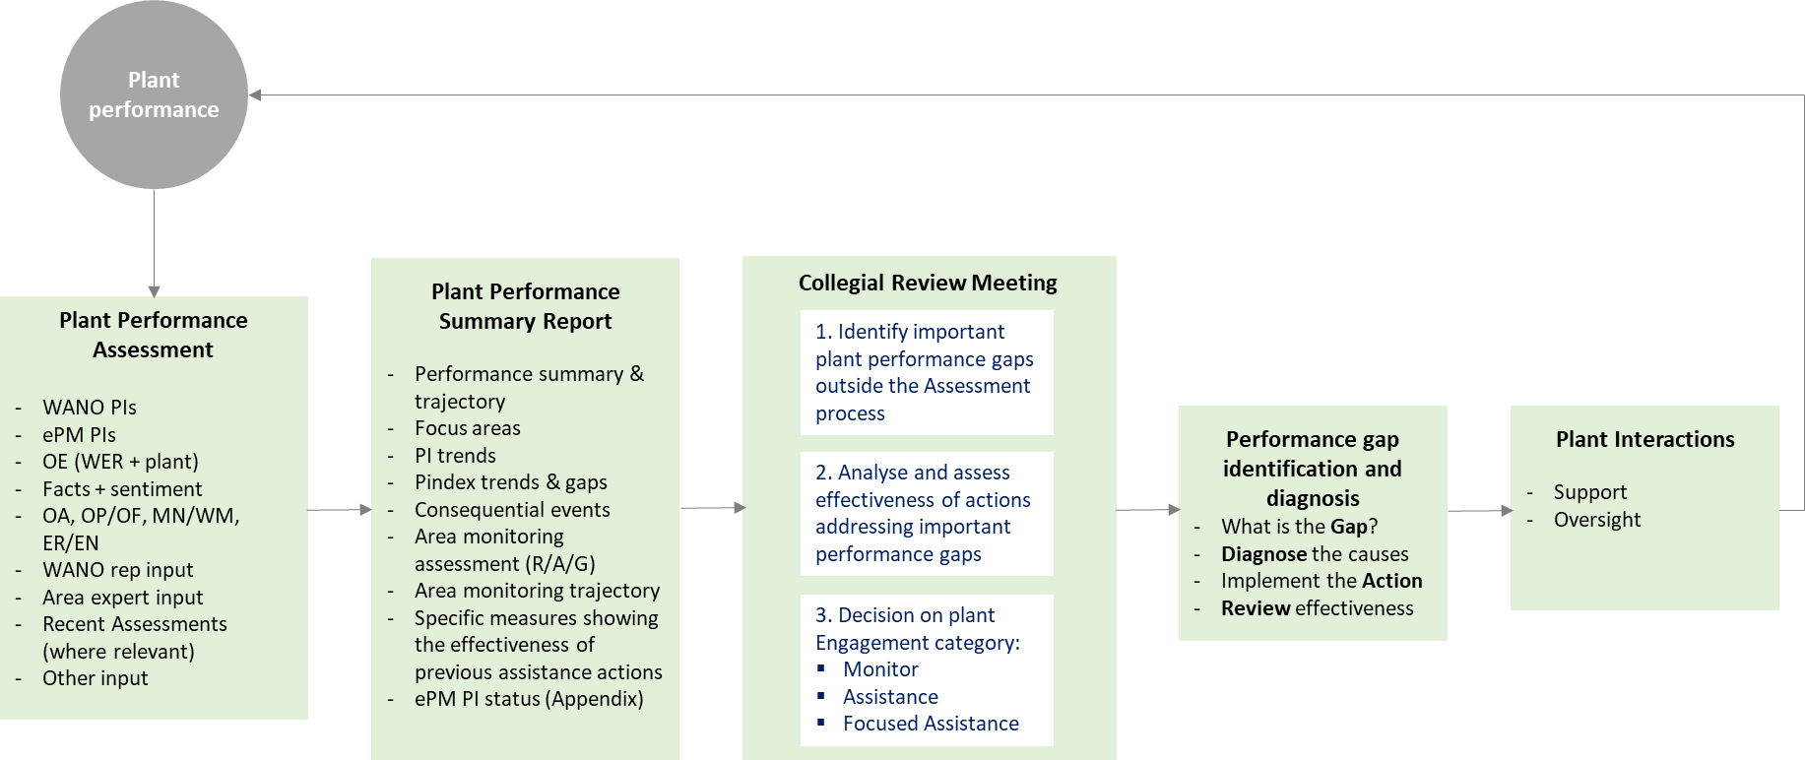

## 5.1 Plant performance Assessment

The plant performance assessment is based on all the performance information available to the WANO RC, as shown in the figure above. This includes information from WANO PIs, ePM PIs, WERs and early notification of events, other information supplied by the station, and information obtained from the interviews, observations and judgement of WReps, area experts and others from their plant visits and discussions with plant personnel.

RCs will develop their methods for assessing the plant performance information identified in Figure 3 in a way which enables them to collect the required information and then identify, trend and prioritise the important performance gaps. This will identify who is responsible for providing the information, and how it should be provided.

Seven main functional areas are defined and monitored through the plant performance assessment, as a minimum. These are OR, OF, OP, MA, WM, EN and ER. WRep monitoring activity is not limited to these areas of course. Where significant performance gaps are identified in other areas, these will be included in the plant performance assessment.

## 5.2 Plant performance summary report

Plant performance summary reports (PPSR) are used to collect and summarise the results from the plant performance assessment consistently and in a way that facilitates the performance assessment validation and review at the Collegial Review Meeting (CRM) and Member Performance Improvement Committee (MPIC) (or equivalent evaluation body). The WRep shares the PPSR with the senior station leader after review by the CRM.

The WRep is responsible for producing the PPSR in accordance with the standards defined here. Other functions provide some of the performance information as described below and this will be validated by the WRep before the PPSR is published. RCs will implement arrangements to ensure this is as efficient as possible.

Appendix A contains the specific information contained in the PPSR, and a working example is provided in Appendix B. Appendix C details the ePM PIs that are common for WANO and are used in the PPSR to support the determination of area status and trajectory. Guidance on how the trajectory is determined for the functional areas is contained in Appendix D.

## 5.3 Collegial Review Meeting

The purpose of Collegial Review Meeting is to validate the plant performance information provided by the WRep in the PPSR, including ensuring that any performance gaps identified are clearly and accurately stated, and determine the engagement categories of the plant (either Baseline Monitoring, Augmented Monitorin, Assistance or Focused assistance). Assistance for the station proposed by the WRep will also be reviewed and validated by the Collegial Review Meeting.

The Collegial Review Meeting is chaired by the director responsible for the ePM process at the RC, or his nominated deputy at management level.

The PPSR will be presented at the Collegial Review Meeting by the responsible WRep.

The Collegial Review Meeting is attended by representatives from all the functions that own and understand the performance information contained in the PPSR. This should normally include;-

* Collegial Review Meeting chairperson
* All available WReps
* Area experts covering the seven functional areas who have provided the area monitoring insights for the plant
* Representative from the Performance Analysis/Industry Analysis function with knowledge of the plant performance resulting from their analysis activities
* Others in relevant divisions such as Member Support and Industry Learning and Development, as needed

Everyone present at the Collegial Review Meeting is responsible for ensuring that the picture of plant performance as described on the PPSR is accurate, clear and based on facts. This will be achieved by good preparation before the meeting, and challenge and discussion at the meeting to get additional insights and address any areas of uncertainty, missing information or where there are diverse views. The WRep is ultimately responsible for ensuring that the information on the PPSR is accurate and clear.

At the end of the Collegial Review Meeting, the chairperson will determine the engagement category of the plant. Where the category is determined to be ‘Augmented Monitoring’ or ‘Assistance’ or ‘Focused Assistance the chairperson will ensure that the performance gap(s) identified as needing augmented monitoring and/or assistance and/or focused assistance are clearly defined to ensure that the correct problem will be dealt with through the next steps in the process (organisational diagnosis in the Assistance/Focused Assistance can be available as a tool). Further guidance on how this is done is described in Appendix E. If the chairperson is not satisfied that this is the case at the end of the meeting, then he will direct the further work necessary to achieve this.

For new units and units in long-term shutdown, the ePM is applied when the unit begins start-up following the WANO Pre Start-up Review (PSUR) or the Restart Review, as applicable. The first Collegial Review Meeting is held after about 6-month commercial operation. Until the first Collegial Review Meeting, designated WRep will provide oversight and support to the plant. If WRep thinks assistance by WRep or Area Experts is necessary to the plant before the first Collegial Review Meeting, WRep will bring the performance issues and propose assistance to the closest Collegial Review Meeting.

Guidance for setting engagement categories and actionss is provided in Appendix F.

## 5.4 Interfaces between ePM and the Assessment process (PR and Follow-Up)

The interactions and interfaces between ePM and the Assessment process, in particular Peer Reviews, is shown in Appendix G. Formalised on-site Follow-Up reviews will be undertaken according to the member performance level and their progress with improvement actions at the time. When a Follow-up review is conducted, the interactions and interfaces will be the similar to the Peer Review.

# The periodicity of peer review and scope of follow-up review will be adjusted depending on the current pant performance provided by ePM as defined WPG-01.

## 

## 6.1 WANO Representatives (WRep)

### 6.1.1 Key roles and responsibilities of WRep

・The single point of contact with the Site Vice Presidents (SVPs)/Plant Managers (PMs) for all communications regarding station performance during ePM for their dedicated stations

・Review the area monitoring insight (AMI) documents developed by the Area Experts. If the WRep has been designated as the area expert for the OA/OR area, the WRep may develop an AMI for this area if needed.

・Assess the assigned station performance

・Determine expected station performance trajectory over the next six months based on guidance in this document and the experience of the WRep.

・Maintain clear communications and a strong working relationship with SVP/PM to ensure a clear and mutual understanding of the ePM perspective on station performance and its basis.

・Detect early signs of station performance decline and review the effectiveness of improvement actions taken to address performance gaps.

・Provide oversight of plant improvement plans to ensure that they will address the identified performance gap(s). Give feedback to the plant as the plan is developed to ensure it is well targeted at the performance gap(s). Ensure that sufficient WANO ‘touch points’ are planned in alignment with the plant improvement plans to influence the required performance improvement over the duration of the plans. Ensure that the ‘return to Monitor’ criteria are clearly defined and communicated with the plant.

・Conduct turnover meetings with the PR Team Leader (TL) before and after peer reviews and Follow-up PRs so that a smooth interface between ePM and PR is achieved for the plant.

### 6.1.2 Required Competencies of the WRep to support ePM

・Plant management experience, including experience in several operational functions at a senior level sufficient to give credibility with SVP/PM and CNO. Plant Operations experience is required. The experience of plant manager or equivalent is desired. If plant manager experience is not possible, a mitigation plan will be developed and implemented to ensure the candidate is successful. The plan could include training, mentoring, coaching, and etc.

・Ability, experience and seniority to credibly and tactfully communicate potentially difficult issues with SVP/PM and CNO while influencing performance improvements

・OR area assessment qualification or equivalent including the ability to understand and diagnose complex organisational situations in a way that leads to effective action

**6.1.3 Training and Qualification of WReps for their ePM role**

The training and qualification of WReps for their ePM role is defined in the WRep ePM training and qualification specification (reference 8)

## 6.2 Area Experts

### 6.2.1 Key roles and responsibilities of the Area Experts to support ePM

・ Develop area monitoring insights (AMIs) for their dedicated areas and plants by reviewing all available performance information including; performance indicators, WERs, early notification of events from WRep, other information supplied by the station, and information, observations and findings from plant visits if conducted and discussions with plant personnel

・Detect early signs of station performance decline and review the effectiveness of improvement actions taken to address performance gaps for their dedicated areas. .

・Determine expected performance trajectory over the next six months for their dedicated areas based on guidance in this document and the experience of the expert

### 6.2.2 Required competencies of the Area Experts to support ePM

・Plant experience, including management and senior engineer/practitioner experience in the dedicated area sufficient to give credibility with station leaders and peers

・Ability and experience to communicate with area leader counterparts at the station with credibility

・Qualified Peer Review area lead reviewer including the ability to understand and diagnose performance gaps in their area in a way that leads to effective action

**6.2.3 Training and Qualification of Area Experts for their ePM role**

The training and qualification of Area Experts for their ePM role is defined in the Area Expert ePM training and qualification specification (reference 9)

## 

## 6.3 Performance Data Analysts

Performance Data Analysts collect and analyse the full range of available plant performance information including; performance indicators, WERs, early notification of events from WRep, area monitoring insights, result of Peer Review (PR)/Corporate Peer Review (CPR), and results of Member Support Mission (MSM). They assist the WReps and area experts to develop their performance assessments as needed and validate the information in the PPSR. The specific roles and responsibilities of the Performance Data Analysts are defined for each RC.

## 6.4 Collegial Review Meeting Chairperson

To ensure that a complete and accurate picture of plant performance is established and validated at the Collegial Review Meeting, and to set the engagement category (Baseline Monitoring, Augmented Monitoring, Assistance, Focused Assistance) of the plant at the end of the Collegial Review Meeting. The chairperson of the meeting is also responsible for making the final decision on the engagement category of the plant, having seen and considered the performance information in the PPSR and the evidence and arguments discussed at the meeting.

## 

## 6.5 Other RC personnel

In addition to the WReps, Area Experts and Performance Data Analysts personnel, other RC personnel have a role to play in ensuring that important plant performance information that they are aware of is recorded and made appropriate use of in the ePM process. For example, Member Support personnel can play an important role in identifying performance gaps, their causes and insights into effective improvement actions. Other RC personnel are expected to communicate this information clearly to the most appropriate person in the ePM process. These other personnel need to support the WReps as requested. This will normally be either the WRep, Area Expert or Performance Analysts.

Figure 5 shows the interfaces between the key identified roles in the ePM process including the interaction with the plant counterparts.

Figure 5

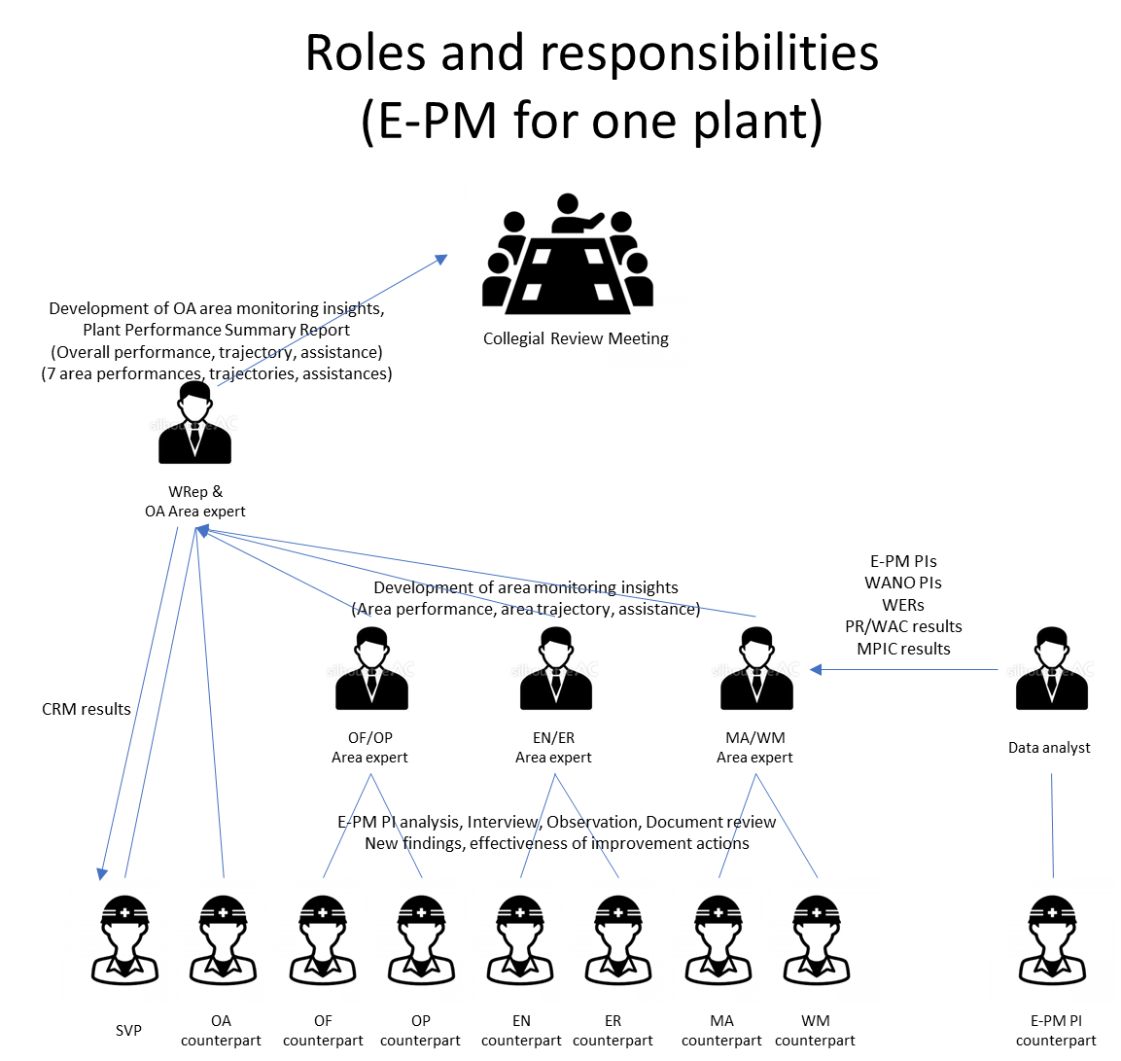

# 7. Rules and Responsibilities of members supporting ePM

## 7.1 Chief Executive Officers/Chief Nuclear Officers

* Set challenging goals and expectations for their nuclear fleet consistent with sustaining excellence in safety and reliability of nuclear plant operations.
* Provide leadership supporting an effective working relationship and ePM between their plants (and corporate) and WANO.
* Provide the support necessary to close any gaps to excellence and sustain safety and reliability at excellence levels.

## 7.2 Site Vice Presidents/Plant Managers

* Set challenging goals and expectations for their plant to achieve excellence in all performance areas through continuous improvement.
* Provide leadership effectively using e-PM process under the robust collaboration between their plant and WANO.
* Identify sign of early decline of performance, monitor effectiveness of improvement activities and take actions to address unsolved issues with WANO.
* Provide constructive feedback to WANO – via regular communication with the WANO Representative – to ensure continuous improvement in all processes.

# 8. Member Performance Improvement Committee

* Oversight function for the ePM process including the Collegial Review Meeting meeting
* Responsible for endorsing a decision to enter or exit the ‘Focused Assistance’ engagement category
* Responsible for endorsing a decision for high level support proposed by the Collegial Review Meeting

# 9. ePM implementation transition

It is expected that ePM will be fully implemented in the RCs on a progressive basis. Each RC will need to prioritise and ‘tune’ the graded approach to ePM to fit within the resources available whilst taking further action to provide more resources for AfE, for example, by being more efficient in other areas.

Consideration will be given within the transition plans at the RCs to where the constraints are and what ePM activities will be most beneficial to members first.

If the unit completed the final regular peer review in the operation life before the first implementation of ePM, RC director can decide whether ePM is implemented or other alternative monitoring is used in the remaining life based on the nuclear risk.

# 10. References

1. Implementing Action for Excellence, project plan, Marian Serban, April 2020
2. Achieving excellence in performance improvement guideline, WANO GP ATL-11-007
3. Implementing a framework to significantly improve nuclear plant performance, WANO GL 2015-01
4. WPG 10, Member Performance Improvement
5. PD 10, Member Performance Improvement
6. PCD 2018-01, WANO Representatives (WRep) process
7. WANO Performance Recovery Process
8. Collegial Review Meeting Guide
9. WRep ePM training and qualification specification
10. Area Expert ePM training and qualification specification

# Appendix A - Plant Performance Summary Report contents

* Performance summary in words. Including the previous assessment results, the present monitoring results and a judgement on the likely forward trajectory of the plant over the next 6 months (improved, stable or declined).
* Defined focus areas for the next period in words. These should align with any areas receiving assistance or recovery or otherwise identified as at risk of decline in the performance summary. The focus areas should clearly define the performance gap and summarise the actions being taken by the plant to improve.
* WANO PI index
* EPM PI (ePM PIs) matrix. The ePM PIs are key performance measures covering the seven core areas (OR, OF, OP, MA, WM, ER, EN).
* Plant power history trend
* Status of corrective actions for AFIs in previous peer review
* Specific performance measures identified as effectiveness indicators for improvement actions set in previous PR and ePM cycles
* Recent and upcoming events and major activities at the station
* Operating experience submitted to WANO
* SOER recommendation status

# Appendix B – Example Plant Performance Summary Report

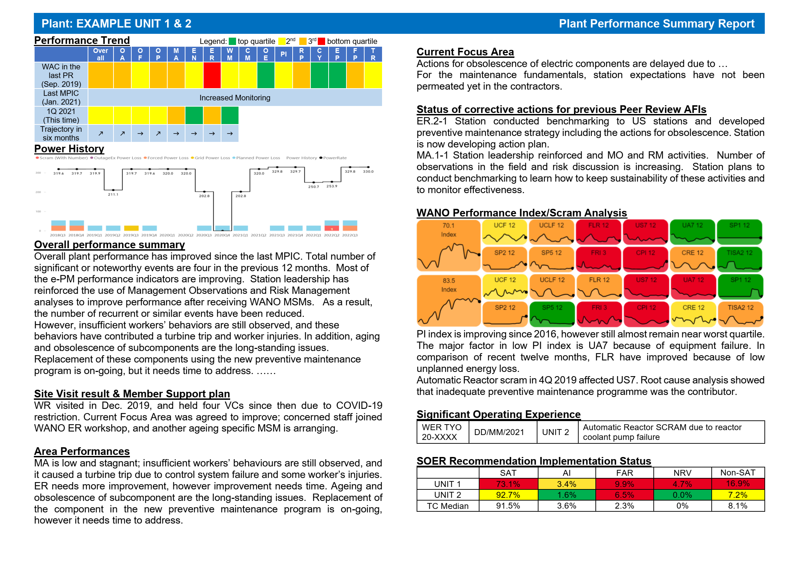

# Appendix C – Enhanced Performance Monitoring Performance Indicators

**Draft Enhanced Performance Monitoring Performance Indicators (page 1 of 6)**



**Draft Enhanced Performance Monitoring Performance Indicators (page 2 of 6)**



**Enhanced Performance Monitoring Performance Indicators (page 3 of 6)**



**Enhanced Performance Monitoring Performance Indicators (page 4 of 6)**



**Enhanced Performance Monitoring Performance Indicators (page 5 of 6)**



**Enhanced Performance Monitoring Performance Indicators (page 6 of 6)**



# Appendix D – Guidance on determining plant performance trajectories

**Guidance on determining plant performance trajectories (page 1 of 2)**

**What is ‘trajectory’?**

|  |  |
| --- | --- |
| Trajectory is the direction that a functional area or plant performance is projected to be heading over a “time-horizon” of approximately six months into the future, as compared to the current performance level. It can be assessed as either ‘improved’, ‘stable’ or ‘declined’ |  |

**How is trajectory assessed?**

Trajectory is based on an analysis of three component forces:

* Organisational effectiveness
* Proficiency
* Workload

Where these forces in combination are strong, the plant performance is expected to be improved in 6-months’ time and where they are weak performance is expected to decline.

Organisational effectiveness is a combination of leadership effectiveness, team effectiveness and the extent that the management system supports high performance. Key aspects of the management system that need to be considered are processes, procedures, availability of resources, and the strength of the various oversight functions.

Proficiency covers the extent that managers and other personnel are trained, qualified and experienced to standards consistent with excellent performance and apply their competencies consistently and at a high level.

Workload considerations include the extent that daily work is changing. A high workload can challenge the capability of the organisation and people to maintain current performance levels.

Organizational effectiveness is considered the more influential force, because strong organisational effectiveness can compensate for weak proficiency or workload. Strong organisational effectiveness means managers can be expected to take action to prevent performance decline because of proficiency or workload challenges. Weak organisational effectiveness, however, would likely result in a negative trajectory, regardless of the level of proficiency and workload.

**Guidance on determining plant performance trajectories (page 2 of 2)**

**Considerations for determining trajectory**

Past performance trends must be understood to make reliable trajectory determinations. Past performance represents the actual effect of the three trajectory forces for that period of time. Trajectory determinations should consider what the trajectory would be if no changes in the forces were made to the current state, along with consideration of what actual changes will take place.

The overall performance level of the functional area or plant organisation should be considered for making trajectory determinations. For example, for a very high performing site to have an improving trajectory, the three forces would have to be stronger than they would be for a lower performing site to have an improving trajectory. Likewise, a low performing site may have an improving trajectory with forces that are not as strong as a high performing site with a flat trajectory. This consideration also applies for a declining trajectory. For a high performing site, a minimal decline in the three forces could result in a declining trajectory. This may not apply for a lower performing site

The performance level of the area or plant organization should not be compared to the pace of industry performance when determining trajectory

Actions being taken to improve performance should be considered for the trajectory determination, along with consideration for the confidence level that the actions can be implemented and will be effective. For example, action plans may be well developed to address shortfalls, but if the likelihood of the actions being implemented and being effective is low, the action plans should not be considered as a positive impact on trajectory.

Proficiency includes all elements of the proficiency model. For example, an area with many new workers may indicate shortfalls in worker proficiency. But, if the leadership team has established compensatory actions, such as assigning experienced workers to provide increased oversight and mentoring, the proficiency aspect of trajectory could be solid.

Workload is the work facing the functional area or plant organization in terms of amount, scope and complexity. Issues such as understaffed organizations, vacant leadership roles or acting leaders is considered an impact to organisational effectiveness. Issues with lack of proficient workers that may tax others is considered an impact to proficiency.

Trajectory is not used as a predictor of a future assessment value. An area rated strong with an improving trajectory may or may not be viewed as attaining an exemplary rating six months into the future. Functional area or plant performance can improve or decline in a six-month period, but the WANO performance rating could remain the same. Similarly, if an area or plant improves or declines and is now rated higher or lower (e.g., strong to exemplary or exemplary to strong, etc.) the trajectory would not necessarily have to be re-baselined (or changed) just based on the rating change.

# Appendix E – Guidance for determining the plant engagement categories

|  |  |
| --- | --- |
| **Engagement category** | **Member/plant characteristics** |
| ***Baseline Monitoring*** | * A station where most behaviours and results are consistent with exemplary (1) or strong (2) performance. No impactful performance gaps exist. Interactions with station and corporate leadership are routine. |
| ***Augmented Monitoring*** | * A station where behaviours and results are generally consistent with exemplary (1) or strong (2) performance. * A station that experience a decline in one or more areas that are important to or are adversely impacting nuclear safety or reliability. The decline is not indicative of a broad or deep performance shortfall, but does require action by station / corporate leaders to understand, address, and correct performance in a timely manner. |
| ***Assistance*** | * A station where some behaviours and results are inconsistent with sustaining exemplary (1) or strong (2) performance. Performance monitoring identifies broad and/or deep areas of concern in one or more areas that are important to or are adversely impacting nuclear safety or reliability. * A station assessment may have declined to an acceptable (3) level; however, organizational capability and capacity of the station and the corporation are considered adequate to address the shortfalls with some industry and WANO assistance. |
| ***Focused Assistance*** | * A station is assessed in category (4) or (5); or * A station shows consistent weak performance over an extended period, indicating an inability to correct identified performance problems; or * A station exhibits a broad and/or steep performance decline over one evaluation cycle, presenting an increased risk to safe and reliable operation; or * A significant decline in plant performance occurs between evaluations, as evidenced by a series of shortfalls such as significant events, or an unplanned, long-duration shutdown; and there are indications that a plant lacks the organizational capability or capacity to respond to the problems without WANO’s or the industry’s assistance * A station assessment may have declined to an acceptable (3) level; and does NOT have the organizational capability or, the capacity of the station and the corporation are NOT considered adequate to address the shortfalls. |

# Appendix F – Guidance for engagement categories and actions

図形

Actions

* WRep can request more frequent review at CRM if needed.

# Appendix G - Interactions and interfaces between ePM and Assessment (Peer review)

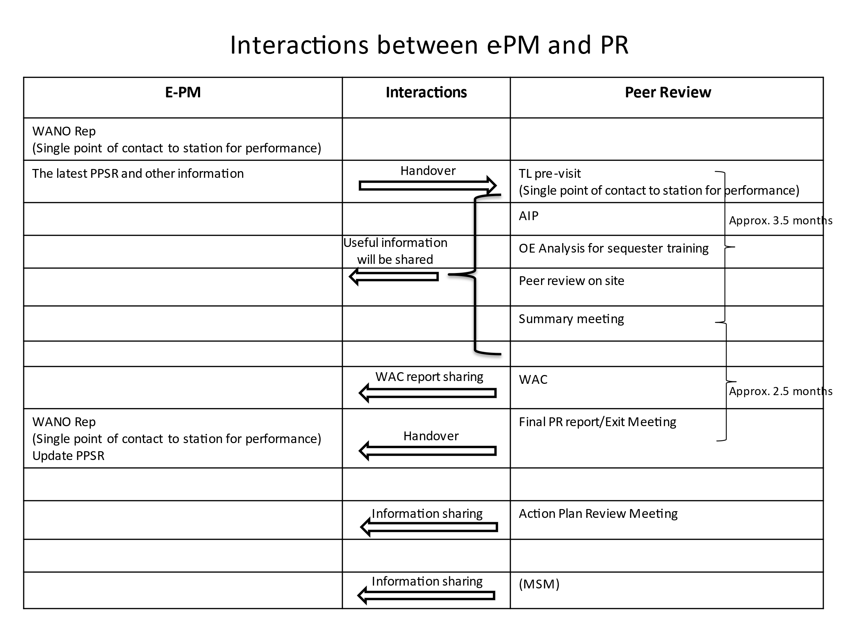

This page is left blank intentionally



members.wano.org

wano.info

ATLANTA

LONDON & SHANGHAI

MOSCOW

PARIS

TOKYO