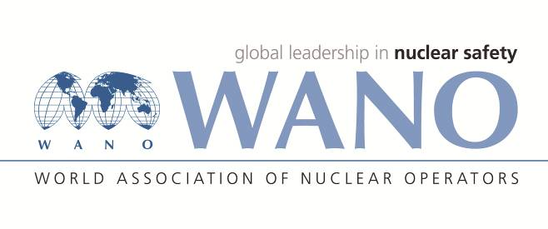
REGISTRATION FORM
Performance and control of nuclear hazardous operations including transport technological procedures when handling nuclear fuel
April 18-22, 2016, Smolensk NPP
Desnogorsk, Smolensk region, Russia
Family name: | GOL
First name: | SAEED
Date of birth: | 16/06/1974
Place of birth: | KAZEROON
Citizenship: | IRANIAN
Organization: | Nuclear Power Production & Development Co. of Iran
Organization address: | No.8, Tandis Str., Africa Ave., Tehran, Iran
Position: | Manager of Fuel and Nuclear Safety
Mobile phone: | +989177710494
Phone/Fax: | +987731112585 - +987731112586
E-mail: | bnpp@npp.co.ir
Passport number: | Please attach a copy of your passport page!
Date of issue: | 30/04/2012
Date of expiry: | 01/05/2017
Please specify the title/subject of your presentation | List of Nuclear Hazardous Works in Bushehr NPP
Please send the electronic versions of your presentations (Russian and/or English) to the Workshop Coordinators before April 8, 2016.

Do you need an invitation letter for entry visa (YES/NO): | YES
City with Armenian Consulate (for visa application): | TEHRAN
Please send a copy of the picture page of your passport (a scanned copy in JPEG format) to Workshop coordinators (please see the contact details below).

Date / Flight / Time/Airport of arrival in Moscow
April 18, 2016, Arrival in Moscow at 07:45
Date / Flight / Time/ Airport of departure from Moscow
April 22, 2016, Departure from Moscow at 22:55

Please send the completed Registration form to the Workshop Coordinators before March 18, 2016.

WANO-MC Coordinators | Smolensk NPP Coordinator
Dmitrii CHICHIKIN  Tel: + 7 495 221 03 07  Fax: + 7 495 376 08 97  E-mail: chichikin@wanomc.ru | Maria MANUKOVA  Tel: +7 48153 7 26 87  Mob: +7 910 118 93 88  Fax: +7 48153 7 47 69  E-mail: manukova@saes.ru

