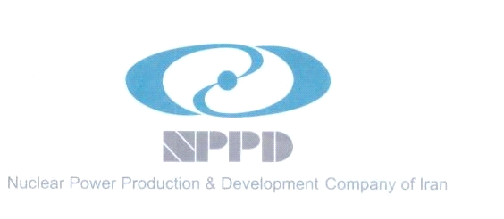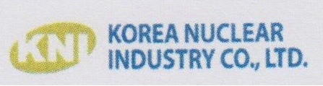

**Memorandum of Agreement ( MOA)**

Subject: Nuclear Power Construction Power Plant

Pursuant to the letter No. LTR-4100-9477184 dated at 21.01.2016 regarding the official confirmation of KEPCO and the proposal for each approach of IPP and EPC-F, the Iranian party welcomes the official confirmation of KEPCO for each approach of IPP and EPC-F. The proposal for each approach were delivered to the Iranian Party.

~~Based on the assessment result by the Iranian Party~~ In the event that The Iranian side concludes to accept the Korean side proposal, both sides ~~agreed~~ agree that Iranian Party endorse two potential nuclear sites for the construction of nuclear power plants with Korean nuclear technology namely APR1400.

Assumed 4 or 6 units will be installed at each site, both sides recognize this agreement will strongly support the national long term plan of 20,000MW nuclear infrastructure with close cooperation with Korean nuclear industry.

Signed By:

----------------------------------------------------------------------

Name: Dr. M. Ahmadian

Managing Director

Nuclear Power Production & Development Company of Iran (NPPD)

-------------------------------------------------------------------------

Name: Seok Hun Kim

Chairman

Korea Nuclear Industry Co., LTD