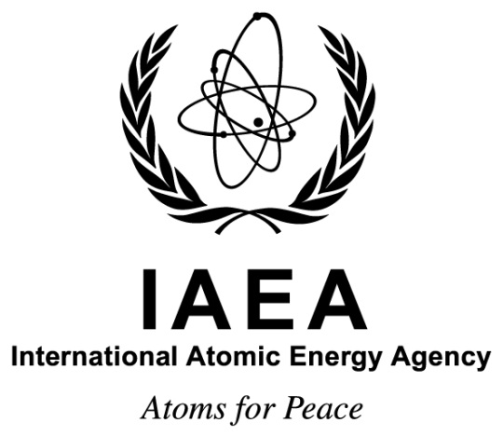

**Consultancy Meeting**

**on**

**Exploring Agency Support for Expanding and Replacing Nuclear Power Programs**

**IAEA Headquarters  
Vienna, Austria**

**23–25 October 2018**

**Ref. No: EVT1803499**

**Information Sheet**

# Background

To satisfy growing energy demand, address energy security issues and mitigate environmental concerns, several countries with operational nuclear power plants (NPPs) give high priority to retain or expand their existing nuclear power programs, despite lessons learned from the 2011 Fukushima accident.

According to PRIS data, as of 2018, two thirds of the countries currently operating NPPs are considering or planning to add one or more reactor units. Additionally, a large majority – more than 85% – of NPP construction worldwide is taking place in countries with existing nuclear power programs.

# Objectives

The purpose of the event is to provide a forum for relevant experts to discuss the needs of Member States (MS) with operating NPPs that are currently constructing or considering new NPPs in the future. Discussions during the event will be aligned to produce the specified output as listed in Section D below.

The objectives of the event are to:

* Help the IAEA understand specific challenges countries with existing nuclear power programs might face when initiating new nuclear power projects; and
* Explore how the IAEA might best align existing, or develop new, support mechanisms to help MS overcome identified challenges.

The event should focus on identifying the gap between existing IAEA support and the needs of relevant stakeholders in MSs.

# Scope

Discussions should consider all aspects of NPP project initiation and implementation, including all the relevant:

* Stakeholder organisations: utility/owner-operator, regulator, government, TSO, NEPIO, etc.
* Infrastructure: hard and soft
* Activities: Research & Development, technical support, regulation, engineering, procurement, contracting, Human Resource Development, etc.

# Expected Output

Participants will prepare a concise report including:

* Identified challenges faced by various stakeholders planning or implementing new NPP projects in MSs with existing nuclear power programs;
* Recommendations of which existing IAEA support mechanisms may add near-term, high-impact value to identified stakeholders supporting new NPP projects in MSs with existing nuclear power programs;
* Recommendations (including prioritisations where possible) of new support mechanisms the IAEA should develop to help these stakeholders;
* Identified gaps (if any) in existing IAEA support and appropriate corrective actions the IAEA should complete to ensure optimised support for MSs with existing nuclear power programs; and
* Elaboration of how these challenges will influence infrastructures established in replacing and expanding countries.

# Working Language

English.

# Venue

The event will be held at the IAEA’s Headquarters in Vienna, Austria and will start on Tuesday, 23 October 2018 at 9:30 a.m. in Room MOE12, Building M of the Vienna International Centre (VIC). Participants are advised to arrive one hour prior to the convening time of the event to allow for timely registration. Participants will need to present an official photo identification document to be admitted to the VIC premises.

The following IAEA web page can be accessed for more detailed information on Vienna and the VIC:

<http://www-pub.iaea.org/iaeameetings/GeneralInfo/Guide/VIC>

# Visas

Participants who require a visa to enter Austria should submit the necessary application to the nearest diplomatic or consular representative of Austria at least four weeks before they travel to Austria. Since Austria is a Schengen State, persons requiring a visa will have to apply for a Schengen visa. In States where Austria has no diplomatic mission, visas can be obtained from the consular authority of a Schengen Partner State representing Austria in the country in question.

# Organization

Subsequent correspondence on scientific matters should be sent to the Scientific Secretary and correspondence on other matters related to the event to the Administrative Secretary.

|  |  |
| --- | --- |
| **Scientific Secretary**  **Vincent Roué** Division of Nuclear Power Department of Nuclear Energy Vienna International Centre PO Box 100 1400 VIENNA AUSTRIA Tel.: +43 1 2600 24518 Fax: +43 1 2600 29598 Email: [V.Roue@iaea.org](mailto:V.Roue@iaea.org) | **Administrative Secretary**  **Tin Ling Loi** Division of Nuclear Power Department of Nuclear Energy Vienna International Centre PO Box 100 1400 VIENNA AUSTRIA Tel.: +43 1 2600 22792 Fax: +43 1 2600 29598 Email: [T.Loi@iaea.org](mailto:T.Loi@iaea.org) |