**621-12-TM-44989**

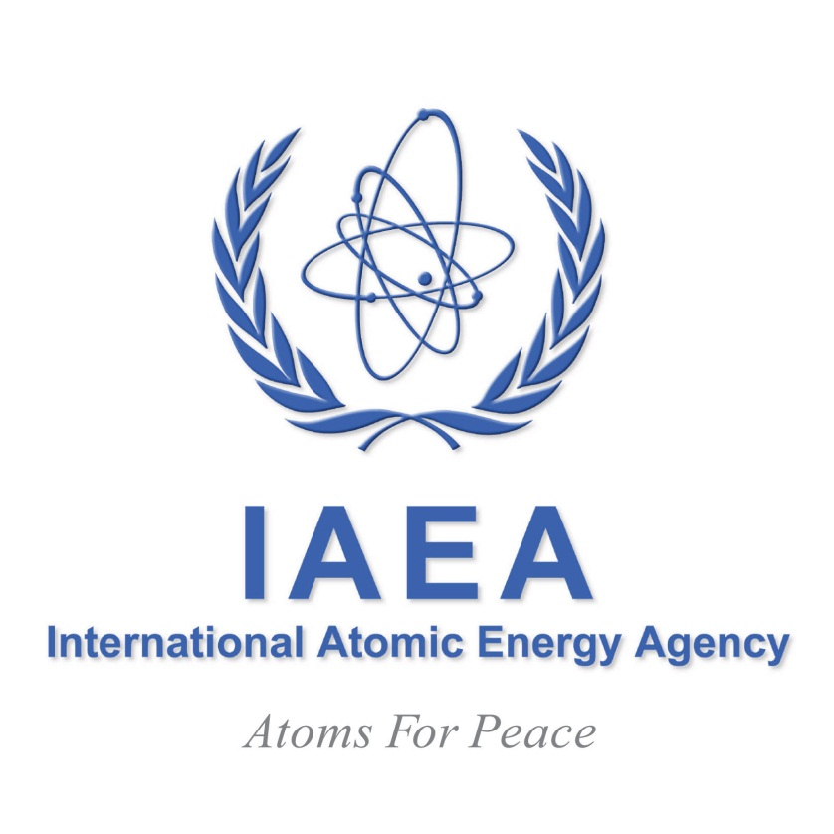

**TECHNICAL MEETING**

**ON**

**TOPICAL ISSUES OF INFRASTRUCTURE DEVELOPMENT:**

**NUCLEAR POWER PROJECT DEVELOPMENT IN EMERGING NUCLEAR POWER STATES**

**INFORMATION SHEET**

**11–14 FEBRUARY 2013**

**IAEA Headquarters,**

**Vienna, Austria**

1. **BACKGROUND**

The increased demand for the introduction of nuclear power in a significant number of countries prompted the International Atomic Energy Agency (IAEA) to develop a publication entitled *Milestones in the Development of a National Infrastructure for Nuclear Power* (IAEA Nuclear Energy Series No. NG-G-3.1, Vienna, 2007). This publication impresses on Member States the need to develop a clear strategy and to plan properly, to enhance human resources and infrastructure across a number of areas, that are necessary for the implementation of a successful nuclear power program. It identifies 19 separate infrastructural issues to be addressed by a Member State embarking on the construction of a new Nuclear Power Plant (NPP). A similar document SSG-16 provides a road map of the different safety guides that provide guidance on the different safety aspects associated with all stage of the nuclear power program.

Since 2006, the IAEA has organized an annual Technical Meeting (TM) on *Topical Issues of Infrastructure Development* aimed at providing a platform for exchanging best practices in developing the required infrastructure and identifying the main issues that need to be considered when introducing nuclear power (NP). Previous meetings focused on knowledgeable decision-making and awareness building, infrastructure development and implication of Fukushima.

The 4 day meeting this year will enable participants to share their experience in introducing and developing the nuclear power programme, with special emphasis on the nuclear power project and development of related infrastructure. The Technical Meeting (TM) on *Topical Issues of Infrastructure Development* that is planned from 11-14 February 2013 will therefore focus on issues related to (i) building knowledgeable and responsible Owner-Operators able to manage the NPP project, (ii) establishing operational independent regulatory bodies able to define the rules for safety, security and safeguards including licensing process and other key functions, (iii) strengthening international cooperation and “soft coordination” mechanisms in NP programmes and (iv) establishing self-evaluation methodologies and ensuring that IAEA review services that include INIR, IRRS, EPREV, IPPAS, ISSAS, Pre-OSART, etc. meet the needs of countries developing their infrastructure.

1. **OBJECTIVES**

The objective of the Infrastructure TM is to serve as a forum for sharing specific experience and information related to the management of a nuclear power project. This event will deal in particular with facilitating the development including creation and management of:

* A knowledgeable owner/operator organization that is able to finalize feasibility studies and lead pre-construction, construction, commissioning and operation activities for nuclear power plants; and
* Effectively independent and competent regulatory bodies with all the related processes and capacities once the decision to build a nuclear power plant has been taken by the country, taking into consideration the lessons learned from the Fukushima Daiichi nuclear accident.

The meeting is also intended to assist governments and/or nuclear energy programme implementing organizations in leading, demonstrating commitment to nuclear, providing resources (human, financial, etc.) and coordinating all the related activities for nuclear power, including establishing a comprehensive national policy, self-evaluating the nuclear power infrastructure, and hosting Integrated Nuclear Infrastructure Review missions and other assessment missions.

1. **TOPICS OF THE TECHNICAL MEETING**

* Systemic approach for leadership and management of NPP projects for coordinating, promotional and regulatory organizations.
* Preparing project activities; finalizing siting projects, feasibility studies, contracting and construction processes.
* Stakeholder involvement and communication on nuclear power : strategies and implementation
* Operational Soft-Coordination mechanisms.
* Evaluation of nuclear power infrastructure using IAEA reviews services such as INIR, IRRS, EPREV, IPPAS, ISSAS, Pre-OSART, etc.

1. **NATURE OF THE TECHNICAL MEETING**

The Technical Meeting will cover safety- and non-safety-related activities and will take the form of presentations, round/table discussions and break-out sessions with the following sequence:

1. Presentations of nuclear power project activities by participants from countries that are planning or building their first NPP;

2. Presentations of nuclear power project activities by participants from countries expanding their nuclear power programme;

3. Presentations by invited experts on lessons learned in relation to nuclear power project etc;

4. Presentations by potential NPP vendors/countries on the constraints of their standard designs in the light of the nuclear power infrastructure;

5. Presentations by representatives of countries with established nuclear power programmes and IAEA staff on issues related to NPP project;

6. Discussions between the representatives of countries considering the introduction or expansion of nuclear power and NPP vendors aimed at identifying respective expectations.

7. Presentations by TSO’s that provide NPP project support and services.

At the meeting, the IAEA will present a comprehensive and integrated approach for dealing with the nuclear power project and evaluation process for nuclear infrastructures, including recent and updated guidance documents covering the methodologies, tools and practices that should be applied when conducting the relevant activities.

To thoroughly cover these issues, participants will examine case studies, good practices and lessons learned during the process of implementing a nuclear power programme. The meeting will also be an excellent opportunity to discuss proven and modern approaches ‘face-to-face’, and to share information on needs and experience. Panel discussions on experience and future trends will also be included.

1. **PARTICIPATION**

The meeting is open to two participants per country from Member States that are considering and planning their first NPP or expanding an existing nuclear power programme.

1. **PARTICIPANTS’ QUALIFICATIONS AND EXPERIENCE**

The meeting is targeted at policymakers and senior managers engaged in the implementation of national nuclear power programmes and projects, senior managers who assist governments in developing a national strategy, future owner/operator organizations and regulatory bodies.

Senior managers and/or experts from operating organizations are invited to share their experiences related to the development of their respective national programmes and projects.

Senior managers from regulatory authorities and those involved in developing national capacities for 3S and emergency are also invited to present lessons learned in relation to NPP.

Potential NPP constructors and vendors in countries such as Argentina, Canada, China, France, India, Japan, the Republic of Korea, Romania, the Russian Federation, the United States of America etc. are also invited to share their views on those aspects of the NPP project.

1. **WORKING LANGUAGE**

The working language of the Technical Meeting will be English. No interpretation will be provided. The participants should have a working knowledge of English since the presentations and discussion will be conducted in that language only.

1. **ORGANIZATION OF THE MEETING**

Time for presentation at the plenary sessions will be limited to 15 minutes. Access to the Internet will be provided from a workstation installed outside the meeting rooms. The workstations and projecting tools will be available for presentations. Laptops/notebooks brought by the participants may be connected to the projecting tools (LCD data projector) in the meeting rooms.

1. **TARGET COUNTRIES**

The meeting is open to representatives of Member States that are embarking on nuclear power for the first time or expanding existing nuclear power programmes. The situation of the participating Member States may vary widely, with some being at an early stage of building the nuclear power infrastructure and some other already developing the national nuclear power project. Participants should be intimately familiar with the details of their respective countries’ national strategies for the introduction/expansion of nuclear power, as well as with issues related to the nuclear power project.

1. **ADMINISTRATIVE AND FINANCIAL ARRANGEMENTS**

Nominating Governments will be informed in due course of the names of the selected candidates and will at that time be given full details on the procedures to be followed with regard to administrative and financial matters.

The costs of the Technical Meeting are borne by the IAEA; no registration fee is charged to participants. Travel and subsistence expenses of participants will not be borne by the IAEA. Limited funds are, however, available to help cover the cost of participants from countries eligible to receive technical assistance under the IAEA’s technical cooperation programmes. Such assistance can be offered, upon specific request, to oneparticipant per country provided that, in the IAEA’s view, these participants will make an important contribution to the meeting. **The application for financial support should be made at the time of designation of the participants.**

The organizers of the Technical Meeting do not accept liability for the payment of any cost or compensation that may arise from damage to or loss of personal property, or from illness, injury, disability or death of a participant while he/she is travelling to and from or attending the meeting, and it is clearly understood that each Government, in nominating participants, undertakes responsibility for such coverage. Governments would be well advised to take out insurance against these risks.

1. **APPLICATION PROCEDURES**

Nominations should be submitted using the attached Participation Form. Completed forms should be endorsed by and returned through the normal official channels. They must be received by the IAEA not later than **22 November 2012**. Nominations received after that date or applications sent directly by individuals or by private institutions cannot be considered. Nominating Governments will be informed in due course of the names of the selected candidates and at that time full details will be given on the procedures to be followed with regard to administrative and financial matters.

**For Member States receiving technical cooperation assistance, applications for financial support should be made at the time of nominating the participant.**

As one of the main objectives of the Technical Meeting is information exchange among participants, in particular among those embarking on nuclear power for the first time or expanding their nuclear power programme, participants will be asked to prepare and submit a report on the status of nuclear power infrastructure and/or project in their countries, if possible together with a presentation that they can deliver during the Technical Meeting/Workshop itself, based on the attached format. This report should also be submitted at the time of application.

1. **VISAS**

Designated participants who require visas to enter Austria should submit the necessary application to the nearest diplomatic or consular representative of Austria as soon as possible.

1. **LOCAL ARRANGEMENTS**

The Technical Meeting will be held at the IAEA’s Headquarters in Vienna, Austria, specifically in the Press Room at the Vienna International Centre (VIC), and will start on **Monday, 11 February 2013** at 9.30 a.m. and end at 4 p.m. on **Thursday, 14 February 2013**. Participants are kindly requested to be at Checkpoint 1/Gate 1 of the VIC at least an hour before the meeting starts to allow adequate time for photo badges to be issued. Participants should bring some form of personal identification, such as a national passport, so that they can identify themselves to the Security Officers at Checkpoint 1.

The agenda for the meeting, together with information on local arrangements, will be sent to designated participants when the completed participation forms have been received.

1. **IAEA SECRETARIAT**

|  |  |
| --- | --- |
| **Scientific Secretary**  Mr Vincent Nkong Njock  Address: | **Technical Meeting Coordinator**  Mr Ioan Rotaru (IAEA Consultant)  Address: |
| International Atomic Energy Agency Vienna International Centre PO Box 100 1400 Vienna, AUSTRIA Tel: +43 1 2600 26720; Fax: +43 1 26007 Email: [V.Nkong-Njock@iaea.org](mailto:V.Nkong-Njock@iaea.org) | International Atomic Energy Agency Vienna International Centre PO Box 100  1400 Vienna, AUSTRIA Tel: +43 1 2600 26720; Fax: +43-1-2600 26007 Email: [nelu220846@yahoo.com](mailto:nelu220846@yahoo.com) |