|  |  |
| --- | --- |
| http://www.wanomc.ru/bitrix/templates/wano_public/images/logo.gif | Description: Description: Description: Macintosh HD:Users:apple:Documents:Manaenkov:REA:Logo REA:Struktur logo:Koncern:3 ver:REA3.jpg |

|  |  |
| --- | --- |
| **AGREED**  _______________ S.Vibornov  “___” __________ 2014  Deputy Director  WANO-MC | **APPROVED**  _______________ V. Khlebtsevich  “___” __________ 2014  Deputy Director for Production and NPP Operation – Emergency Preparedness and Radiation Protection Department Director  JSC Rosenergoatom |

**PARTICIPATION of the REGIONAL CRISIS CENTER IN KOZLODUY PLANT EMERGENCY DRILLS**

**25 November 2014**

**REPORT**

**participation of plant emergency assistance group (OPAS) and regional crisis center (RCC) in kozloduy plant (BULGARIA) *2014 PROTECTION* emergency DRILLS**

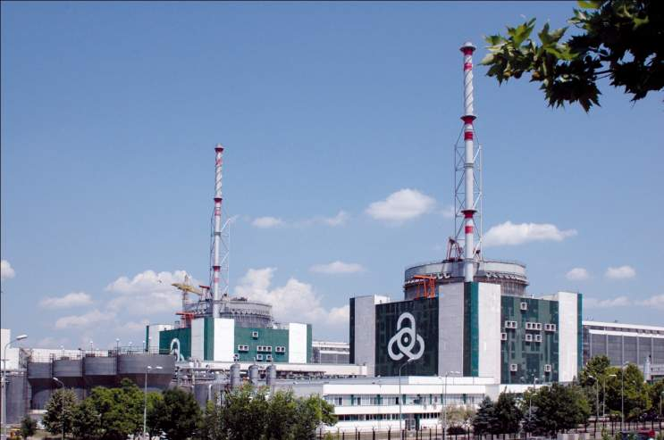

moscow 2014

**APPROVAL SHEET**

***For JSC Rosenergoatom***

Deputy Director, Emergency Preparedness and

Radiation Protection Department, Head of CC

and OPAS Group Operation Department

А.Markov

Head of Dispatcher Service, Scientific and

Engineering Center for Plant Emergency

Operations B.Pivnenko

Chief Technologist, Emergency Preparedness and

Radiation Protection Department V.Golubkin

***For WANO Moscow Center***

WANO-MC Programme Manager А.Lukianenko

WANO-MC Advisor S. Loktionov

***For VNIIAES***

Head of Emergency Response and

Radiation Protection Division

А. Kosov

Category II Engineer А.Orekhov

**CONTENTS**

Introduction 6

1 Drills’ participants 6

2 Simulated accident scenario 7

3 Analysis of emergency drills’ results 7

3.1 Information exchange 7

3.2 Expert/consultative and engineering support 8

4 Main conclusions 8

Annex 1 Accident evolution 10

Annex 2 Plan of RCC and TSC participation in Kozloduy plant drills 11

Annex 3 Information exchange chain 13

Annex 4 Draft format RCC-8 15

Abbreviations

|  |  |
| --- | --- |
| npp | Nuclear Power Plant |
| WANO-MC | WANO Moscow Center |
| vver | Water-Moderated Water-Cooled Power Reactor |
| VCC | Video-Conference Communication |
| CC | Crisis Center |
| ki | National Research Center *Kurchatov Institute* |
| ED | Emergency Drills |
| rcc | Regional Crisis Center |
| TSC | Technical Support Center |
|  |  |
|  |  |
|  |  |

Introduction

Kozloduy plant (Bulgaria) emergency drills were conducted from 09:00-17:00 (Moscow time) on 25 November 2014 to exercise the actions per Procedure for RCC operation and RCC Regulations on information exchange among the members of the WANO-MC VVER Regional Crisis Center when responding to a simulated accident at Kozloduy plant.

Mr. A. Markov, Deputy Director, Rosenergoatom (REA) Emergency Preparedness and Radiation Protection Department, Head of the Crisis Center (СС) and OPAS Group Operation Department, took the lead of the drills on behalf of the RCC.

Drills’ objectives:

* to immediately notify the RCC members about a plant simulated accident per RCC Regulations on information exchange among the members of the WANO-MC VVER Regional Crisis Center
* to exercise the interaction among Kozloduy plant, RCC, TSCs, Rosatom Emergency Response Center and RCC member OU/NPPs when responding to a simulated on-site/general emergency, and
* to exercise actions to be taken by the RCC and TSC duty dispatcher services when responding to a simulated accident within the framework of the RCC

1. Drills’ participants

*For the Russian Federation*

- JSC Rosenergoatom, OPAS Group

- Duty Dispatcher Division of the Scientific and Engineering Center for Plant Emergency Operations

- TSCs (OKB *Gidropress*, Scientific and Engineering Center *Kurchatov Institute*, JSC VNIIAES, Scientific and Production Association *Taifun*)

- Rosatom Emergency Response Center

- JSC *Konsist-OS* Technical Support Group

*For foreign companies*

- Bulgaria (Kozloduy NPP)

- Finland (Fortum, Loviisa NPP)

- Slovakia (Slovenske Elektrarne, Mochovce NPP)

- Ukraine (NNEGC Energoatom)

- China (JNPC)

- Hungary (Paks NPP);

- Armenia (Armenian NPP)

- Czech Republic (JSC CEZ, Temelin NPP)

- Iran (Bushehr NPP)

-  *International companies*

World Association of Nuclear Operators, Moscow Center

1. Simulated accident scenario
   * 1. The simulated accident of the *2014 Protection* emergency drills had the following scenario:

* Loss of ultimate heat sink at Units 5 and 6
* Loss of off-site power with all fixed diesel generators de-energized
* Primary-to-containment coolant leak at Unit 6, reactor core uncovering and fuel leaks
  + 1. Accident evolution is described in Annex 1.
    2. Plan of RCC and TSC participation in the drills is given in Annex 2.

1. Analysis of emergency drills’ results
   1. Information exchange
      1. During the emergency drills, the participants exercised the actions per procedures of information exchange in case of plant safety significant events, on-site/general emergencies following the RCC Regulations on information exchange among the members of the WANO-MC VVER Regional Crisis Center (hereinafter referred to as the Regulations on information exchange).
      2. E-mail and fax were used as the main communication channel during the drills, with all the messages duplicated by the CC ftp-server. Videoconference communication was arranged with the plant Emergency Response Center, Rosatom Emergency Response Center and Technical Support Centers (Kurchatov Institute, OKB *Gidropress* and SPA *Taifun*)
      3. 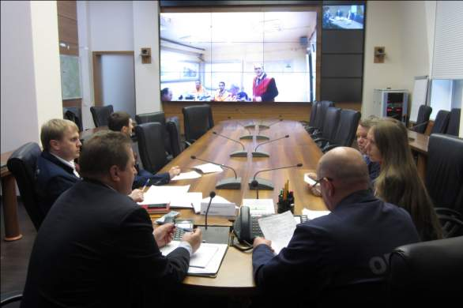During the emergency drills, the RCC received 8 messages, with 4 messages (simulated accident occurrence and evolution) sent to all participants.

Information exchange chain is given in Annex 3. The information exchange analysis suggests that the timelines of information exchange were in principle consistent with the Regulations on information exchange.

* + 1. The participants shared the following emergency drills’ findings.
* Drills’ completion/accident elimination notification format is missing from the Regulations on information exchange. Draft format RCC-8 is given in Annex 4.
  + 1. The following deficiencies were also revealed after getting the information exchange formats completed:
* When notifying the RCC, the plant used the old versions of the formats given in the Regulations on information exchange. The updated formats can be found on the WANO-MC site, RCC section
* The process of notifying the RCC about multi-unit events had not been fully tuned up. All the plant emergency messages (formats 2, 3 and 3a) describing the conditions of the affected Units made it impossible to see the condition of each individual Unit. This deficiency attributed to the Regulations on information exchange lacking the multi-unit emergency procedure.
* Radioactive release direction arrow was not used in formats RCC-3a
* *Extreme external conditions* cell was left blank in format RCC-2
* Plant messages containing the unknown abbreviations (*ZNZM* and *ZPZM*) delayed the translation process.
  + 1. Armenian, Loviisa and Kudankulam plants did not confirm the receipt of the messages.
  1. Expert/consultative and engineering support
     1. To exercise expert/consultative and engineering support in case of a plant general emergency, Expert Group for Radiation Safety and Protective Measures and Expert Group for Reactor Facilities of the OPAS Group, Kurchatov Institute, OKB *Gidropress*, SPA *Taifun* and VNIIAES were involved in the drills.
     2. Although there was no plant request for expert/consultative and engineering support, the drills’ coordinator instructed the SPA *Taifun* experts to predict the trans-boundary release transfer. As predicted, radionuclides are expected to reach, within three days, such countries as Bulgaria, Romania, Serbia, Hungary and Croatia. There will be no trans-boundary release transfer to the Russian Federation in case of a radiation accident at Kozloduy plant.

1. Main conclusions
2. Following the drills’ results, one should make a conclusion that the main purpose of the emergency drills aimed at information exchange among the RCC, Kozloduy plant and TSCs was accomplished.
3. The RCC duty shift and plant individual responsible for the interaction with the RCC exercised the actions per RCC Regulations on information exchange.
4. Within the framework of the emergency drills, the duty shift ensured clear and prompt information exchange among all the RCC members, with all the members, except for the Armenian, Loviisa and Kudankulam plants, confirming the receipt of the plant simulated accident messages forwarded during the drills. The RCC/plant information exchange was provided as planned.
5. One should recognize videoconference communication between the RCC and Kozloduy plant Emergency Response Center as good practices derived from the drills, which contributed to higher efficiency of information exchange and ensured profound understanding of the plant simulated accident. The participants found it worthwhile to use videoconference within the framework of the RCC during OU/NPP drills and exercises in the future.
6. The Regulations on information exchange should specify the procedure for notifying the RCC about multi-unit events.
7. The RCC should continue its drills to improve information exchange processes and skills.

Annex 1  
Accident evolution

Table P.1 – Kozloduy plant simulated accident evolution

|  |  |
| --- | --- |
| Time | Event |
| 08:00:00 | Loss of off-site power with 6 kV bus de-energized |
| 08:05:00 | Loss of all fixed diesel generators and ultimate heat sink |
| 08:15:00 | Plant chief duty attendant classifying the plant condition as a general emergency to deploy emergency plan at the plant |
| 08:20:00 | Plant chief duty attendant notifying the staff in charge of preventive actions and immediate response about general emergency |
| 09:00:00 | Duty emergency group coming to its workplace in the Emergency Response Center |
| 09:00:00 – 18:00:00 | Eliminating accident consequences. Notifying all parties concerned by the accident notification diagram (Figure P.1) |
| 11:00:00 | Radioactivity release to the environment, caused by the rupture of 6TL42S02 and 6TL42S03 valves |
|  | Fire on fuel and oil storage facilities |
| 11:20:00 | Схема.jpgExtinguishing fire on fuel and oil storage facilities |
| 17:00:00 | Confining the source of radioactivity release to the environment |

Figure P.1 – Accident notification diagram

Annex 2  
Plan of RCC and TSC participation in Kozloduy plant drills

| **No.** | **Time\*** | **Simulated event evolution, actions** | **Participants** |
| --- | --- | --- | --- |
|  | H+0:00 | Emergency drills with an initiating event at Kozloduy plant (Bulgaria) started | All participants |
|  | H+0:30 ÷ H+2:00 | Plant safety significant event message (format RCC-2) received | CC Shift Supervisor  Kozloduy plant |
|  | H+0:35 ÷ H+2:05 | RCC acknowledging the receipt of safety significant event message | CC Shift Supervisor |
|  | H+0:50 ÷ H+2:20 | Safety significant event message (format RCC-2) translated | RCC Operation Group |
|  | H+0:55 ÷ H+2:25 | Notifying REA management about Kozloduy plant safety significant events per notification diagram (A. Shutikov) | CC Shift Supervisor |
|  | H+0:55 ÷ H+2:35 | Notifying RCC member OU/NPPs about Kozloduy plant safety significant events | CC Shift Supervisor |
|  | H+0:40 ÷ H+2:10 | On-site/general emergency message (format RCC-3) received | CC Shift Supervisor  Kozloduy plant |
|  | H+0:45 ÷ H+2:15 | RCC acknowledging the receipt of on-site/general emergency event message | CC Shift Supervisor Kozloduy plant |
|  | H+0:50 ÷ H+2:20 | On-site/general emergency message translated | RCC Operation Group |
|  | H+0:55 ÷ H+2:25 | Notifying REA management about Kozloduy on-site/general emergency events per notification diagram (V. Asmolov, A. Shutikov, V. Khlebtsevich) | CC Shift Supervisor |
|  |  | Taking a decision on putting the RCC on high alert | A. Shutikov |
|  | H+1:00 ÷ H+1:30 | Putting the RCC and TSCs on high alert. Videoconference communication among CC, OKB *Gidropress*, Kurchatov Institute, SPA *Taifun*. Participants getting together in the CC and TSCs | CC Shift Supervisor Participants |
|  | Not later than  H+2:30 | Notifying RCC member OU/NPPs about on-site/general emergency | CC Shift Supervisor RCC member OU/NPPs,  TSCs |
|  | As prepared | Receiving Kozloduy plant data on monitoring of plant condition and radiation situation on the site and in the area of plant location (format RCC-3а) | CC Shift Supervisor Kozloduy plant |
|  | As received | Forwarding Kozloduy plant data on monitoring of plant condition and radiation situation on the site and in the area of plant location (format RCC-3а) to TSCs and RCC member OU/NPPs | CC Shift Supervisor, TSCs, RCC member OU/NPPs |
|  | If Kozloduy plant decides to make a request | Receiving a request for expert/consultative and engineering support in case of an on-site/general emergency (format RCC-4) | CC Shift Supervisor Kozloduy plant |
|  | Within 25 minutes of receipt | Translating the request for expert/consultative and engineering support in case of an on-site/general emergency (format RCC-4) | RCC Operation Group |
|  | Within 10 minutes after translation | Sending the request for expert/consultative and engineering support in case of an on-site/general emergency to TSCs (OKB *Gidropress*, Kurchatov Institute and SPA *Taifun*) | CC Shift Supervisor, TSCs |
|  |  | Expert Group for Radiation Safety and Protective Measures and Expert Group for Reactor Facilities, experts from the TSCs addressing the Kozloduy plant request for expert/consultative and engineering support to formulate recommendations | Expert Groups, TSCs |
|  | As prepared | Translating experts’ responses to expert/consultative and engineering support request into English | RCC Operation Group, CC Shift Supervisor |
|  | As prepared | Sending experts’ responses to expert/consultative and engineering support to Kozloduy plant | CC Shift Supervisor Kozloduy plant |
|  |  | Emergency drills completed | All participants |
| * tentative time subject to be adjusted as the drills go depending on the simulated accident evolution | | | |

Annex 3  
Information exchange chain

Table P.3.1 – RCC receiving information from emergency drills’ participants   
(Incoming messages)

|  |  |  |  |  |
| --- | --- | --- | --- | --- |
| No. | Sender | Data communication channel | Message | Sending time (Moscow) |
|  | Kozloduy plant | E-mail,  Fax | Format RCC-2. Plant safety significant event message | 11:34 |
|  | Kozloduy plant | E-mail,  Fax | Format RCC-3. On-site/general emergency message | 12:20 |
|  | Kozloduy plant | E-mail,  Fax | Format RCC-3a. Status update of on-site/general emergency message | 13:35 |
|  | SPA *Taifun* | Fax,  ftp-server | Format 3. Meteorological conditions | 13:53 |
|  | SPA *Taifun* | Fax,  ftp-server | Format 6.Trans-boundary radioactive cloud transfer in case of a radiation accident at Kozloduy plant (Bulgaria) | 13:58 |
|  | Kozloduy plant | E-mail,  Fax | Format RCC-3a. Status update of on-site/general emergency message | 15:30 |
|  | Kozloduy plant | E-mail,  Fax | Format RCC-3a. Status update of on-site/general emergency message | 16:30 |
|  | Kozloduy plant | E-mail,  Fax | Format RCC-3a. Status update of on-site/general emergency message | 18:20 |

Table P.3.2 – RCC sending information to emergency drills’ participants

(Outgoing messages)

|  |  |  |  |  |
| --- | --- | --- | --- | --- |
| No. | Sender | Data communication channel | Message | Sending time (Moscow) |
|  | Kozloduy plant | E-mail,  Fax | Format RCC-7. **Confirmation of the message received by the RCC from the affected NPP** | 11:32 |
|  | Member OU/NPPs, TSCs | E-mail,  Fax,  ftp-server | Format RCC-2. Plant safety significant event message | 12:00 |
|  | Member OU/NPPs, TSCs | E-mail,  Fax  ftp-server | Format RCC-3. On-site/general emergency message | 12:38 |
|  | Member OU/NPPs, TSCs | E-mail,  Fax,  ftp-server | Format RCC-3a. Status update of on-site/general emergency message | 14:15 |
|  | Member OU/NPPs, TSCs | E-mail,  Fax,  ftp-server | Format RCC-3a. Status update of on-site/general emergency message | 17:05 |
|  | Member OU/NPPs, TSCs | E-mail,  Fax,  ftp-server | Format RCC-8. Exercise completion notification | 17:05 |

Annex 4  
Draft format RCC-8

