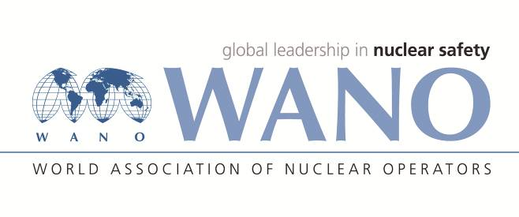 | WANO Moscow Centre  Russia, 109507, Moscow, 25 Ferganskaya St.  Tel. +7 495 376 15 87  Fax: +7 495 376 08 97  info@wanomc.ru

REQUEST
for technical and organizational information via WANO

- NPP/Organization:
South-Ukraine NPP (SUNPP)
- Information request subject:
Diagnosis of a primary coolant water leakage into the secondary circuit and identification the damaged steam generator by the parameters of steam volumetric activity or absorbed dose rate near the steam pipeline.
- Information request goal:
Obtaining Information from other NPPs on the request subject to learn the available experience and assess the possibility of its application at SUNPP
- Problem description:
At Ukraine NPPs one of the parameters used to diagnose the mode of a primary coolant water leakage into the secondary circuit is the absorbed dose rate (ADR) near the steam pipeline. At the same time, the ADR value at which the initialization of the algorithm for overcoming the leakage mode is necessary requires clarification.
In accordance with WANO report WER MOW 2019-088 on the event that took place 08.02.2019 at Kudankulam NPP, Unit 2, (Actuation of Emergency Protection (EP) on sensing high Gamma activity in Steam Generator-2 pipe line spuriously) the following corrective actions were developed:
- Feasibility to be studied for:
- deletion of EP actuation on SG gamma signal >1E-06 Gy/hr ;
- providing window alarm on SG gamma signal very high OR introducing time delay for EP actuation on SG gamma radiation level >1E-06 Gy/hr.
- Specific issues:
- Whether EP actuation on SG gamma-signal is provided at your NPPs? At what levels of the parameter?
- What levels of gamma activity in the damaged SG steam pipeline are used for warning alarm and for protective measures initiation in the case of the primary coolant water leakage into the secondary circuit?
- What technical facilities (monitors) are used for measuring gamma activity in the SGs?
- Which of the planned corrective measures were implemented at Kudankulam NPP?
- Have you implemented any changes related to the event at Kudankulam NPP at your plants?
- Organizations that are expected to address this request:
Belorussia NPP, Tainwan NPP, Kudankulam NPP, Busher NPP
- Department initiating this request:
SUNPP Safety Analysis Service
- Contact data of the request initiator:
Position: Head of the Safety analysis Service
Full name: Malik Pavel
Tel.: +38 05136 42200
p_malik@sunpp.atom.gov.ua

WANO MC representative
at SUNPP N. Bukhanko

