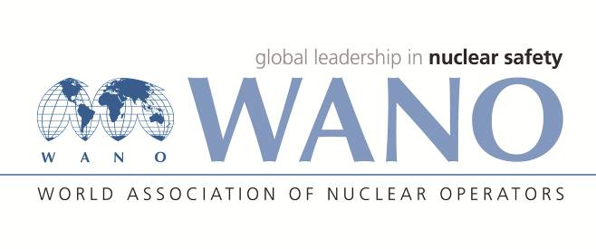 | World Association of Nuclear Operators  Moscow Centre  WANO – MC  25 Ferganskaya, Moscow, 109507, Russia  Phone. +7 495 376 15 87  Fax: +7 495 376 08 97  info@wanomc.ru

REQUEST
to provide technical and organizational information via WANO.
Dear Colleagues,
Khmelnitski NPP is asking to share your plant information regarded to the application of protection equipment against foreign materials during repair accompanied with opening of equipment.
Detailed questions:
- NPP/Organization: Khmelnytski NPP»
- The topic of information request: information about application of protection equipment against foreign materials to cover heat-insulating materials, equipment components during repair accompanied with opening of equipment.
- The goal of information request: obtain relevant information from other NPPs.
- Problem description: During repairs accompanied with the opening of equipment KhNPP is using polyethylene film to prevent intrusion of foreign objects into the internal cavities of dismantled equipment components and to maintain cleanliness and orderliness when stacking dismantled thermal insulation.
- Specific questions:
- What kind of materials is used at your plant to cover dismantled equipment components, and dismantled thermal insulation?
- What kind of material is used at your plant to cover spent fuel pool when performing works overhead or in the vicinity to the spent fuel pool?
- What kinds of requirements are enforced / specified to the materials providing fire safety?
- Proposed organizations for sending this request:
WANO Moscow center nuclear power plants

Russian:

З А П Р О С
на получение технической и организационной информации
по линии ВАО АЭС
Уважаемые коллеги,
Хмельницкая АЭС просит поделиться информацией по опыту применения защитных средств для предотвращения попадания посторонних предметов во время проведения ремонта со вскрытием оборудования.
Конкретные вопросы:
- АЭС/Организация: ОП «Хмельницкая АЭС»
- Тема информационного запроса:
информация о применении защитных средств от предотвращения попадания посторонних предметов для накрытия теплоизолирующих материалов, составных частей оборудования во время проведения ремонта со вскрытием оборудования.
- Цель информационного запроса:
получение надлежащей информации от других АЭС.
- Описание проблемы:
На ОП ХАЭС во время проведения ремонтных работ со вскрытием оборудования для предотвращения попадания посторонних предметов во внутренние полости демонтируемых составных частей оборудования, а также для поддержания чистоты и порядка при складировании демонтируемой теплоизоляции для их накрытия применяется полиэтиленовая пленка.
- Конкретные вопросы к станциям, которые применяют такую технологию:
- Какие материалы применяются на вашей АЭС в качестве накрытия демонтированных составных частей оборудования, демонтируемой теплоизоляции?
- Какие материалы применяются на вашей АЭС для накрытия бассейна выдержки при проведении работ над/вблизи БВ?
- Какие предъявляются / устанавливаются требования к материалам для обеспечения пожарной безопасности?
- Предложения по организациям, в которые адресован настоящий запрос:
Все станции-члены WANO

Bushehr NPP Answers and Recommendations in this regard:
Ответы и рекомендации АЭС Бушер в этой связи:

1— At the BNPP, coatings made of polyethylene are used for protection and coating of thermal insulations assembled from different parts of equipment. These coatings have colors different from other polyethylene and nylon materials used at the plant site and to avoid mistake and error in displacement of these coatings in workplaces, every coated set has its special label that shows the technical specifications of the equipment based on which the thermal insulation has been assembled.

2— At the BNPP, taking protective measures to prevent fall of foreign materials into the fuel pool and observing all the preventive measures have always been considered as a principle, therefore, the probability of fall of foreign materials into the fuel pool is reviewed and analyzed accurately and expertly prior to performing all the Maintenance and Repairs (M&R) activities within the relevant boundary.
Based on the results obtained from the reviews, preventive measures and necessary actions would be taken. FME job position being permanently established in the reactor central hall location, using coded tools in all work activities and recording and controlling them in the relevant logbooks, and concerned experts and supervisors constantly overseeing the activities are some of most important measures and actions implemented.
Furthermore, in line with taking preventive measures in the BNPP reactor central hall, there would be no M&R or equipment displacement activity carried out during any of the operating modes within an unsafe boundary adjacent to the fuel pool and/or over the pool surface. In more complex and rare cases and special circumstances, if it would be necessary to carry out displacement from the mentioned boundary, this activity would be defined as a nuclear hazardous work and in the first stage, instructions for implementation of this work will be developed and it will be approved by the Plant Chief Engineer, Deputy for Safety and the regulatory organization. This activity will be performed under full, constant and double supervision of all the responsible people and concerned individuals in this area.
Using physical protection to prevent the fall of foreign materials into the fuel pool (in the shape of cap/plug of perimeter fence) has many risks on its own and the components making this physical protection can be considered foreign materials that may fall into the pool during the assembly, disassembly or displacement done as required due to conditions of the refueling machine at the pool location and other operational activities.

3—

**- Specific responses and comments:

--
--
--

