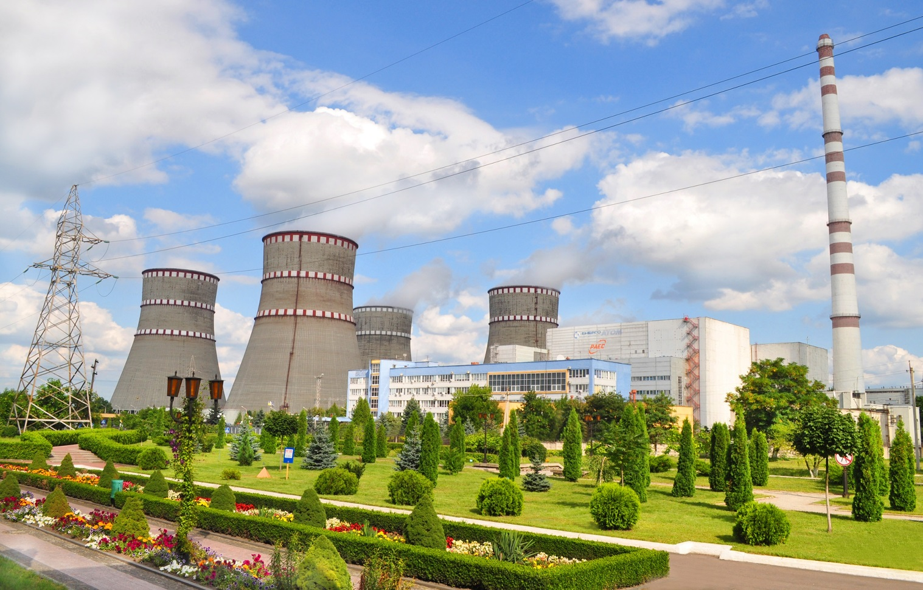**First bulletin**

**THE SIXTH INTERNATIONAL SCIENTIFIC AND PRACTICAL CONFERENCE**

**“SAFETY AND EFFICIENCY OF NUCLEAR ENERGY”**

**ODESA NATIONAL POLYTECHNIC UNNIVERSITY**

***September 4-6, 2018, Odesa, Ukraine***

*Devoted to 100th anniversary of Odesa National Polytechnic University foundation*

**Organized by:**

**State Enterprise “NNEGC “Energoatom”**

**Odesa National Polytechnic University**

*In association with*

**National Academy of Science of Ukraine**

Main Conference objectives are: discussion of strategic direction of the development of nuclear energy complex of Ukraine, perspective areas of nuclear technologies, enhancement of nuclear and radiation safety, arrangement and planning of NPP units maintenance and control, retraining and skills upgrading of professionals/personnel of nuclear energy sector of Ukraine.

**Conference Themes include:**

- strategy of the development of nuclear energy complex of Ukraine in the context of world trends;

- enhancement of safety, reliability and efficiency of nuclear power installations operation;

- state-of-the-art methods of diagnostics, technical and maintenance service of nuclear power installations equipment;

- management of equipment aging, lifetime extension, decommissioning of nuclear power installations;

- utilization of up-to-date chemical technologies at NPP;

- RAW and nuclear fuel management;

- training specialists/personnel for nuclear energy sector of Ukraine.

**Organizing Committee Co-Chairmen**

Iurii Nedashkovskyi – President of SE “NNEGC “Energoatom”

Gennadii Oborskyi – Doctor of Engineering,professor, Rectorof Odessa National Polytechnic University

**Program Committee Chairman**

Viktor Voievodin – director of Institute of Solid State Physics, Materials Science and Technologies (ISSPMT) of National Science Center “Kharkiv Institute of Physics and Technology”, associate member of the National Academy of Sciences (NAS) of Ukraine.

Organizing Committee work group Secretariat:

Viktor Kolykhanov (ONPU) +38 067 948 87 40

Taisiia Gablaia (ONPU) + 38 067 922 02 14

Volodymyr Shvytai (SE “NNEGC “Energoatom”) +38 050 380 58 40

**Venue**

A Conference Hall of Odessa National Polytechnic University (1 Shevchenko, Ave, 3rd floor).

**Call for papers**

May 1 – submission of conference application form (Abstract Submission for speakers);

June 15 – inclusion of the speech to the Conference program;

July 15 – complete paper submission;

September 1 – sending invitations to conference participants, conference fee payment.

September 3 – arrival of participants;

September 4 – registration, opening, Session 1;

September 5 – Session 2;

September 6 – Session 3; closing.

Detailed information about the Conference Application Form, complete paper requirements, and payment details can be found at the official site of ONPU.

The languages of the Conference are Ukrainian, English and Russian.

**Conference fee**

Participant Conference fee comprises publishing and organizing expenses for information package, conference equipment, coffee breaks and social program.

Conference fee:

600 UAH – Ukrainian citizens;

100 €– foreign citizens.

It is possible to pay the Conference fee while registering under advanced request submitted by September 1.

Post-graduate students as well as students aren’t charged a conference fee.

**Accommodation**

Regarding the room reservation in Odesa hotels for participants of the conference on special preferential prices, contact the company "EVENT TOUR SERVICE":

tel.: +380 (44) 592 41 67, +380 (044) 223 70 75.

Е-mail: [service@estour.com.ua](mailto:service@estour.com.ua).

**CONFERENCE ORGANIZING COMMITTEE ADDRESS**

ONPU, 1, Shevchenko, Ave

Odesa, Ukraine, 65044

tel.: +38 (067) 948-87-40, +38 (048) 705-86-88

e-mail: [npp.safety@i.ua](mailto:npp.safety@i.ua)