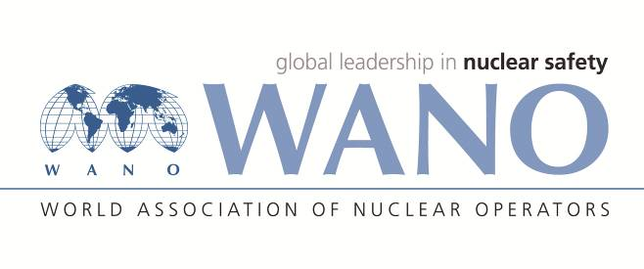 | World Association of Nuclear Operators  Moscow Centre  WANO – MC  25 Ferganskaya, Moscow, 109507, Russia  Phone. +7 495 376 15 87  Fax: +7 495 376 08 97  info@wanomc.ru
REQUEST
to provide technical and organisational information via WANO

- NPP/Organisation: SE Rivne NPP/SE “NNEGC “Energoatom”.

- Topic of information request:
The arrangement of telephone communication at NPPs to minimise phone calls at the MCR under abnormal and/or emergency plant conditions.
- Goal of information request:
To study the risk prevention experience on “Distraction of attention of the MCR personnel due to phone calls of managers and regulatory authorities during work in a compressed time frame under abnormal conditions and during prevention and elimination of an emergency situation.
- Problem description:
Under abnormal and/or emergency plant conditions, the number of phone calls at the MCR’s phones, which are also used for a direct contact with field operators, increases significantly. It leads to distraction of the senior MCR personnel (Unit Shift Supervisor, Reactor Department Shift Supervisor and Turbine Department Shift Supervisor) to explain the causes of the current situation.
- Specific questions:
- What technical (communication) means, can be used to prevent the risk of distraction of the senior MCR personnel who are pressed for time under abnormal and/or emergency plant conditions?
- What types of digital automatic-telephone systems are used at your NPPs?
- What are the examples of organizational barriers to minimise phone calls at the MCR?
- Proposed organisations for sending this request: All WANO regional centers.
- Department – request initiator: Communication Systems Department

