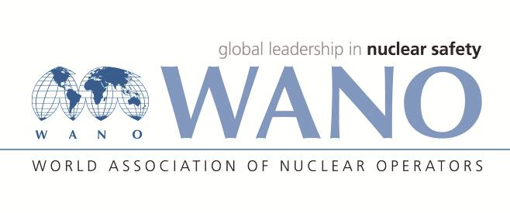 | Moscow Centre  World Association of Nuclear Operators  WANO– MC  Russia, 109507, Moscow, 25 Ferganskaya Str.  tel. +7 495 376 15 87  Fax: +7 495 376 08 97  info@wanomc.ru

I N Q U I R Y
about acquiring technical and organisational information
requested by WANO

- NPP/Organisation: Kozloduy NPP
- Inquiry subject: Assess the fuel rod cladding condition as per the radioactive noble gases activity (Kr and Xe isotopes) in the WWER primary coolant.
- Inquiry objective: Kozloduy NPP would like to receive information from other NPPs and use it to assess the fuel rod cladding condition as per the radioactive noble gases activity (Kr and Xe isotopes).
- Issues: Kozloduy NPP does not have a methodology for controlling the fuel rod cladding condition as per the radioactive noble gases activity (Kr and Xe isotopes).
- Specific questions:
- Is the fuel rod cladding condition controlled as per the radioactive noble gases activity (Kr and Xe isotopes) and what methodology is used?
- Are there any criteria to assess the fuel rod cladding condition as per the radioactive noble gases activity (Kr and Xe isotopes)?
- Suggested organisations to receive this inquiry:
All WANO centres having information on the water-water energy reactors’ operation.
- Administrative unit – inquiry initiator: Kozloduy NPP
- Inquiry initiator contact details: Veselin Nikolov, contact person for WANO
- Date of inquiry: 02 March 2020
Accountable person Surname, name, father’s name
Responsible person
Surname, name, father’s name
Telephone:

