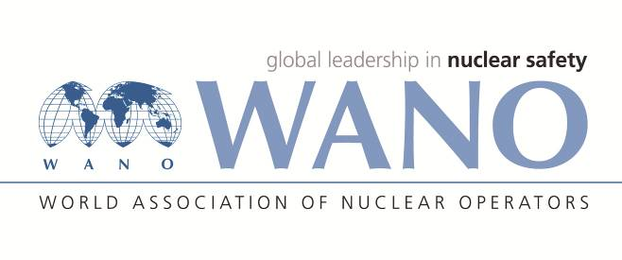 | World Association of Nuclear Operators  Moscow Centre  WANO – MC  25 Ferganskaya, Moscow, 109507, Russia  Phone. +7 495 376 15 87  Fax: +7 495 376 08 97  info@wanomc.ru

REQUEST
to provide technical and organizational information via WANO

- NPP/Organization: MVM Paks NPP
- The topic of information request: Mounting materials (anti-seize compounds) used for reactor vessel bolts and for the bolts of temperature and flux measurement penetrations.
- The goal of information request: Getting information from other plants regarding the topic of request.
- Problem description:
In MVM Paks NPP previously we used for the maintenance of VVER-440 V-213-CS type reactor equipment BOSTIK NG-165 mounting anti-seize compounds (with satisfaction) among others in the following locations:
• for the M140x6 mm thread reactor vessel bolts,
• for the M36x4 mm thread bolts of the temperature and flux measurement penetrations, etc.
However, for some years now, we are not able to procure it and to the best of our knowledge, it cannot be imported into the EU because the product does not comply with the current REACH regulation in all respects. We have not yet found the ideal mounting material. In course of our tests performed so far, we have had reservations about each material during disassembling and cleaning activities.
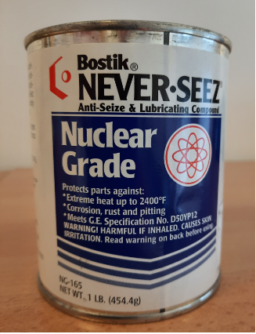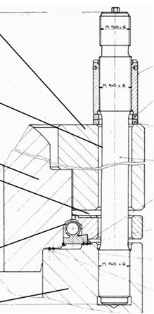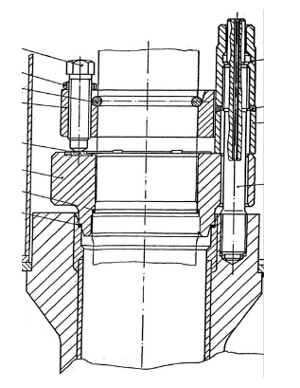
- Specific questions:
We would like to know what mounting material (anti-seize compound) is used at these similar nuclear power plants in the indicated mounting locations and what is the experience gained?
- Proposed organizations for sending this request:
All WANO regional centres
- Department – request initiator: Reactor and equipment maintenance section
- Contact details of the requester: László SCHAN, area manager, schan@npp.hu
- Date of request: 28.02.2022

WIO at Paks NPP Jelena Hadnagy

