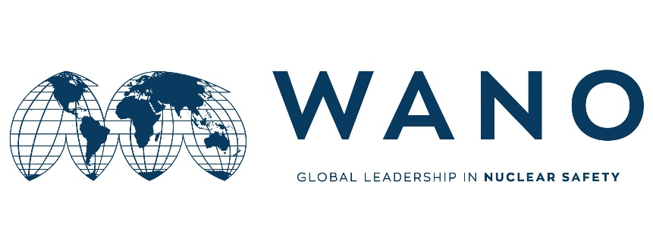 | Moscow Centre  WANO MC  25 Ferganskaya, Moscow, 109507, Russia  Phone: +7 495 376 15 87  Fax: +7 495 376 08 97  info@wanomc.ru

MSM expert personal form

General information

MSM place: the Kalinin NPP
MSM topic: Organization of observations and condition of operating documentations
MSM date:
MSM working language: Russian
MSM leader (MC coordinator):
Phone number:
e-mail:

Expert data

Name
Surname
Date of birth
Place of birth
Citizenship
Passport number
(please send the scan copy)
Passport issue date
Passport expire date
Job Title
Station
Company / Organization
Work Address
Telephone
Home address
Fax
Work e-mail
Personal e-mail
Mobile phone
Laptop brand and serial number
Size of clothing
Shoes
Height
Presentation title

Technical experience in the MSM area
__________________________________________________________________
__________________________________________________________________
__________________________________________________________________
__________________________________________________________________

Foreign languages knowledge

Native language(s)
Foreign languages | Poor | Medium | Good | Excellent
English
Others: 1)
2)
3)

