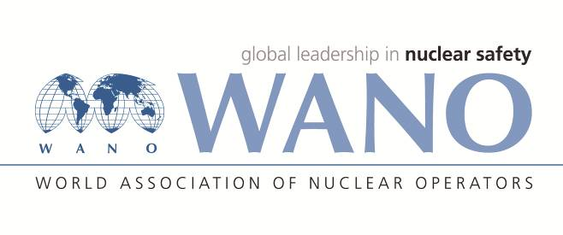 | Московский центр  Всемирная Ассоциация Организаций, эксплуатирующих Атомные Электростанции  ВАО АЭС – МЦ  Россия, 109507, Москва, Ферганская ул., 25  Тел. +7 495 376 15 87  Факс: +7 495 376 08 97  info@wanomc.ru

REQUEST
for technical or organizational information through WANO

- NPP/Organization: SE “Rivne NPP” / SE NNEGC “Energoatom”

- Information request topic: causes of failures of air-operated valves’ control units
- Information request purpose: operating experience exchange on air-operated valves’ control units
- Description of the problem: Rivne NPP operates several air-operated valves with control units manufactured by the Kiev Central Valves Designing Bureau (KTsKBA, Ukraine) of the following types:
- UF96569-012.00.00-01;
- UF96557-008.00.00;
- UF96557М-008.00.00-01;
- UF96558-006.00.00;
- UF96559-008.00.00
Spontaneous AOV position change was observed several times when there were no control signals from the switches and/or automation and interlocks.
- Specific questions:
- Do you operate AOV control units of the above types at your plants?
- Have you experienced failures/malfunctions of AOV with the above types of control units? If yes, what were the causes of failures/malfunctions?
- Organizations to be requested:
WANO MC
- Department initiating the request: Reliability, service life, and lifetime extension department

