PERSONAL DATA
Gender: Female Male |  | 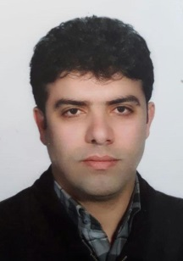
Family name (as in Passport): Sabili
First name (as in Passport): Ramin
Father’s name: Anamollah
Date of birth: 29/12/1980
Place of birth: Tehran | Country of birth: Iran
Nationality: Iranian | Previous Nationality : Iranian
Passport No: E32871764 | Place of issue: Tehran
Passport Type: Ordinary UNO Service Diplomatic
Date of issue: 17/01/2015 | Valid until:17/01/2020
Country of residence: Iran
Company/Inst. Name: NPPD.CO/ No. 8, Tandis St. Africa Ave. Tehran.
Address of organization/company: AEOI, end of Amir Abad , Tehran
Telephone: +98-021-2488-2808 | Fax:+98-021-22058479
E-mail Address: ramin.sabili@gmail.com

Other information
Place where entry visa to Iran will be applied for (Iranian Embassy/ Consulate):

Visa Type: Single Double Multiple
Dates of last entry to Iran:
Date | Name and signature
9 July 2017 | Ramin Sabily
Note: Please attach a copy of your passport to this form and send to us.

