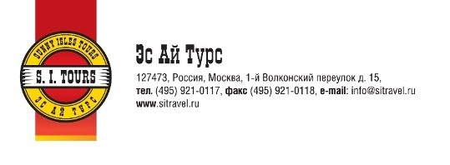 |  |  |  | Voucher  Reservation number :
Guest Name: |  | Reservation, confirmation and payment: |  | Date, Signature, Stamp  Nov. 02, 2021
Mr. Hadnagy Lajos |  | «S. I. Tours»    Tel. +7-495-921-01-17  Contact person: Julia Zlobina |  | Date, Signature, Stamp  Nov. 02, 2021
 |  | Holiday Inn Moscow Tagansky 4*  2, Simonovsky val Moscow Russia, 109044.  +7 (495) 287-14-00 (phone)  +7 (495) 287-14-01 (fax)  frontdesk.tagansky@ihg.com |  | Date, Signature, Stamp  Nov. 02, 2021
 |  |  |  | Insurance: No
Transfer: | No | Accommodation  type | standart room with daily breakfast | Insurance: No
Arrival Date: | 07.11. 2021 | Accommodation  type | standart room with daily breakfast | Insurance: No
Departure Date: | 09.11. 2021 |  |  | Insurance: No
07.11.2021 – 19:00 - Dinner  08.11.2021 - 19:00 - Dinner |  |  |  | Insurance: No

