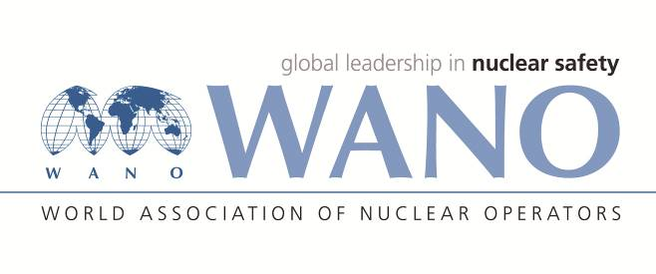 | World Association of Nuclear Operators  Moscow Centre  WANO – MC  25 Ferganskaya, Moscow, 109507, Russia  Phone. +7 495 376 15 87  Fax: +7 495 376 08 97  info@wanomc.ru

REQUEST
to provide technical and organisational information via WANO

- NPP/Organisation: Kudankulam NPP

- The topic of information request:
- Drying of steam Generator tubes is required for In – Service – Inspection (ISI) of SG tubes by Eddy Current test (ECT) Method. KKNPP-1&2 is supplying air of 60-65 deg for drying the SG tubes. Information of Provision, methods or scheme of SG tubes drying used in other VVER plants having horizontal steam generators is required for adopting similar set up in KKNPP 1 & 2 for taking up effective tube drying prior to proceeding for In – Service – Inspection (ISI) of SG tubes by Eddy Current (ECT) Method.
- Information of methods for Steam Generators primary hot & cold collector decontamination for Visual Testing (VT) as part of ISI is also required.
- The goal of information request: Getting relevant information from other member plants
- Problem description:
- There is no designed facility for Steam Generators Tube drying before taking up In – Service – Inspection of SG tubes by Eddy Current Method. Simple hot sir supply at 60-65 Deg C is not effectively drying the tubes.
- ISI equipments probes are damaged while checking the healthiness of tubes with water in it.
- Data interpretation and flaw detection (if any) in the tubes becoming difficult while doing Eddy Current test (ECT) with some amount of water in tubes.
- There is no standard method available for decontamination of Steam Generators primary hot & cold collector.
- Without proper decontamination, data interpretation about the healthiness of tube weld inside collector is difficult.
- Specific questions:
- What kind of steam generator drying set up is used in Information of Provision, methods or scheme of SG tubes drying used in other VVER plants having horizontal steam generators for effective drying of SG tubes before going for eddy current test during RSD shutdown?
- How decontamination of SGs collectors (primary side) is done for taking of visual examination during RSD shutdown?
6.Proposed organisations for sending this request:
WANO-MC
7.Department – request initiator: WIO-MC
8.Contact details of the requester:
Sanjeev Bhardwaj , +91-9489080628, sbhardwaj@npcil.co.in
9.Date of request:19.08.2020

