|  |  |  |  |  |  |  |  |  |  |  |  |  |  |  |  |  |  |
| --- | --- | --- | --- | --- | --- | --- | --- | --- | --- | --- | --- | --- | --- | --- | --- | --- | --- |
| **APPROVED BY**   |  |  | | --- | --- | | EDIS Co. Managing Director | | | __________ M. Feiz | | |  |  | | “___” ___________ 2021 | | | **APPROVED BY**   |  |  | | --- | --- | | JSC ETC GET Managing Director | | | __________ A.O. Kovalevich | | |  |  | | “___” ___________ 2021 | | |

**Technical Assignment**

Providing services for FSS

DSShA.161458.хх.TA.хх

Moscow 2021

SECTION 1. NAME OF WORKS PERFORMED

|  |
| --- |
| Performance of loading and unloading, rigging, installation, commissioning and modification of a Full-scale simulator (FSS) for the Training Center (TC) of BNPP-2. |

SECTION 2. GENERAL PROVISIONS, GROUNDS

|  |
| --- |
| Subsection 2.1 Data on facility, design documentation, type, procedure for arrangement of installation, commissioning, repair works during the construction, modification, modernization, reconstruction or repair of FSS construction facilities and engineering systems |
| Facility for installation is a full-scale simulator with software and hardware simulator complex which is designed for training and maintaining competence of operating personnel of NPP main control room (MCR) using full-scale mathematical model of power unit operating in real time.  Works carried out by the Contractor shall include as follows:  - transporting from the End-User's warehouse to the place of permanent placement of equipment.  - loading and unloading on the BNPP territory when carrying out acceptance activities on takeover of equipment at the installation site (list of installed equipment, Section 3.2) (addresses and places of equipment installation, Section 5). Works are carried out by the contractor’s manpower and resources;  - rigging on moving the equipment handed over for installation from the location of acceptance activities to the premises of permanent placement (placement of equipment, Section 5). Works are carried out by the contractor’s manpower and resources;  - installation of equipment specified in Section 3.2 according to the placement layout, including external and internal control unit electrical installation, assembly of individual devices and racks (Appendices 2 and 3). Installation is carried out under the supervision of Client representatives;  - checking the operability of the assembled equipment. The operability shall be confirmed by Client representatives responsible for installation and adjustment supervision of equipment;  - FSS commissioning and modification under the supervision of Client representatives;- disposal of packaging materials and waste as a result of work performance. Works are carried out by the Contractor’s manpower and resources.  The Client notifies the Contractor to start the works at least seven (7) working days before readiness of permanent placement of equipment. |

SECTION 3. REQUIREMENTS FOR WORKS PERFORMED

|  |
| --- |
| Subsection 3.1 Work goal |
| The purpose of the works performed is as follows:  - installation, preparation of equipment for software installation, commissioning and confirmation of operability of the assembled equipment as a training equipment for NPP operating personnel. |

|  |
| --- |
| Subsection 3.2 Scope of work performed |
| List of equipment handed over for loading and unloading, rigging, installation and commissioning activities to the site specified in Section 5 is given in Table No. 1.  Consuming materials required for installation activities are supplied by the Contractor on its own.  Preparatory works (construction works) in the premises for placement of equipment are carried out by the NPPD. The Client ensures that the premises are ready enough for installation activities prior to the start of works performance.  Preparatory finishing works are performed by the NPPD in such a way that allows carrying out installation of equipment and required utilities without the need for refinishing repairs. Unless it is possible to carry out hidden installation (including installation of utilities) without violation of finishing repair, the Contractor carries out installation on top of finishing repair.  Data provided in Table No.1 is given based on GET ETC JSC expert review of data from Kudamkulam (India) FSS and at the time of conclusion of the contract can be changed.  *Table No.1*   |  |  |  |  |  |  |  |  |  |  | | --- | --- | --- | --- | --- | --- | --- | --- | --- | --- | | Item No. | Name of equipment | | Q-ty | Height,  m | Width,  m | | Depth,  m | Weight,  kg | | | 1 | Simulation server | | 1 | о,з | 0,6 | | 1 | 20 | | | 2 | UULS server | | 1 | 0,3 | 0,6 | | 1 | 20 | | | 3 | Network segments gateway and network service server | | 1 | 0,2 | 0,6 | | 1 | 20 | | | 4 | Remote access gateway | | 1 | 0,2 | 0,6 | | 1 | 20 | | | 5 | Storage server | | 1 | 0,2 | 0,6 | | 1 | 20 | | | 6 | Printer A3 | | 2 | 0,9 | 0,65 | | 0,65 | 80 | | | 7 | Workstation PC type 1 | | 18 | 0,35 | 0,15 | | 0,35 | 6 | | | 8 | Workstation PC type 2 | | 2 | 0,35 | 0,15 | | 0,35 | 6 | | | 9 | Workstation PC type 3 | | 6 | 0,35 | 0,15 | | 0,35 | 6 | | | 10 | Workstation PC type 4 | | 2 | 0,35 | 0,15 | | 0,35 | 6 | | | 11 | Monitor 21" type 1 | | 43 | 0,4 | 0,55 | | 0,2 | 4 | | | 12 | Switch | | 4 | 0,1 | 0,5 | | 0,4 | 5 | | | 13 | Monitor 24” type 2 | | 2 | 0,4 | 0,55 | | 0,2 | 4 | | | 14 | Service rack 42U 600*1075 | | 1 | 2,1 | 0,65 | | 1,1 | 110 | | | 15 | Panel 1U 10-pack Black Universal Filler Panel | | 3 | 0,1 | 0,5 | | 0,5 | 15 | | | 16 | Panel 2U Universal Locking Drawer | | 2 | 0,2 | 0,6 | | 0,6 | 10 | | | 17 | Filter 10000 Rack 1U Monitor Utility Shelf | | 2 | 0,1 | 0,1 | | 0,1 | 9 | | | 18 | Socket strip 3.6kVA | | 1 | 0,1 | 1 | | 0,1 | 3 | | | 19 | Control console 1U Rackmount Console Kit | | 1 | 0,2 | 0,6 | | 0,6 | 6 | | | 20 | KVM switch | | 1 | 0,1 | 0,6 | | 0,2 | 6 | | | 21 | UPS configurable cabinet | | 1 | 1,65 | 0,42 | | 0,62 | 110 | | | 22 | Battery kit | | 4 | 0,2 | 0,2 | | 0,6 | 14 | | | 23 | Power module 6.7 kVA | | 3 | 0,5 | 0,2 | | 0,6 | 8 | | | 24 | Monitor 27" Type 3 | | 3 | 0,5 | 0,65 | | 0,2 | 5 | | | 25 | Components | | 5 | 0,5 | 0,5 | | 1 | 15 | | | 26 | Unify OpenStage 40Т ice blue system phone ( L30250-F600-C111) | | 4 | 0,2 | 0,4 | | 0,4 | 2 | | | 27 | Exchange OpenScape Business X5/W | | 1 | 0,4 | 0,7 | | 0,5 | 10 | | | 28 | MTSD DS-6 Desktop intercom for 16 buttons | | 3 | 0,2 | 0,4 | | 0,4 | 2 | | | 29 | Extension, Зm | | 5 | 0,1 | 0,1 | | 0,5 | 1 | | | 30 | | Switch 24G-PoE+ (185 W) | 2 | 0,1 | | 0,6 | 0,4 | | 5 | | 31 | | Dome camera | 4 | 0,2 | | 0,2 | 0,2 | | 2 | | 32 | | Cantilever to the wall | 3 | 0,2 | | 0,2 | 0,2 | | 3 | | 33 | | Acoustic system | 3 | 0,3 | | 0,3 | 0,2 | | 5 | | 34 | | Audio interface Tascam US-16x08 | 3 | 0,1 | | 0,6 | 0,4 | | 5 | | 35 | | Radio system | 7 | 0,1 | | 0,4 | 0,4 | | 3 | | 36 | | Cabinet 19" 9U | 1 | 0,2 | | 0,5 | 0,7 | | 23 | | 37 | | Socket strip | 3 | 0,1 | | 0,1 | 0,5 | | 1 | | 38 | | MCR board simulator 11CWF01 | 1 | 2,37 | | 0,8 | 1,27 | | 215 | | 39 | | MCR board simulator 11CWF02 | 1 | 2,37 | | 0,8 | 1,27 | | 190 | | 40 | | MCR board simulator 11CWF03 | 1 | 2,37 | | 0,8 | 1,27 | | 210 | | 41 | | MCR board simulator 11CWF04 | 1 | 2,37 | | 0,8 | 1,27 | | 220 | | 42 | | MCR board simulator 12CWF01 | 1 | 2,37 | | 0,8 | 1,27 | | 215 | | 43 | | MCR board simulator 12CWF02 | 1 | 2,37 | | 0,8 | 1,27 | | 190 | | 44 | | MCR board simulator 12CWF03 | 1 | 2,37 | | 0,8 | 1,27 | | 210 | | 45 | | MCR board simulator 12CWF04 | 1 | 2,37 | | 0,8 | 1,27 | | 220 | | 46 | | MCR board simulator 13CWF01 | 1 | 2,37 | | 0,8 | 1,27 | | 215 | | 47 | | MCR board simulator 13CWF02 | 1 | 2,37 | | 0,8 | 1,27 | | 190 | | 48 | | MCR board simulator 13CWF03 | 1 | 2,37 | | 0,8 | 1,27 | | 210 | | 49 | | MCR board simulator 13CWF04 | 1 | 2,37 | | 0,8 | 1,27 | | 220 | | 50 | | MCR board simulator 14CWF01 | 1 | 2,37 | | 0,8 | 1,27 | | 215 | | 51 | | MCR board simulator 14CWF02 | 1 | 2,37 | | 0,8 | 1,27 | | 190 | | 52 | | MCR board simulator 14CWF03 | 1 | 2,37 | | 0,8 | 1,27 | | 210 | | 53 | | MCR board simulator 10CWG01 | 1 | 2,37 | | 0,8 | 1,27 | | 215 | | 54 | | MCR board simulator 10CWG02 | 1 | 2,37 | | 0,8 | 1,27 | | 190 | | 55 | | MCR board simulator 10CWG03 | 1 | 2,37 | | 0,8 | 1,27 | | 220 | | 56 | | MCR board simulator 10CWG04 | 1 | 2,37 | | 0,8 | 1,27 | | 215 | | 57 | | MCR board simulator 10CWG05 | 1 | 2,37 | | 0,8 | 1,27 | | 190 | | 58 | | MCR board simulator 10CWG06 | 1 | 2,37 | | 0,8 | 1,27 | | 210 | | 59 | | MCR board simulator 10CWG07 | 1 | 2,37 | | 0,8 | 1,27 | | 195 | | 60 | | MCR board simulator 10CWG08 | 1 | 2,37 | | 0,8 | 1,27 | | 195 | | 61 | | MCR panel simulator 10CWA10 | 1 | 0,82 | | 1,22 | 1,28 | | 167 | | 62 | | MCR panel simulator 10CWA20 | 1 | 0,82 | | 1,22 | 1,28 | | 162 | | 63 | | MCR panel simulator 10CWA11 | 1 | 0,82 | | 1,1 | 1,2 | | 71 | | 64 | | MCR panel simulator 10CWA12 | 1 | 0,82 | | 1,1 | 1,2 | | 71 | | 65 | | MCR panel simulator 10CWA30 | 1 | 0,82 | | 1,22 | 1,28 | | 162 | | 66 | | MCR panel simulator 10CWA40 | 1 | 0,82 | | 1,22 | 1,28 | | 167 | | 67 | | MCR panel simulator 10CWB10 | 1 | 0,82 | | 1,22 | 1,28 | | 171 | | 68 | | MCR panel simulator 10CWB20 | 1 | 0,82 | | 1,22 | 1,28 | | 175 | | 69 | | MCR panel simulator 10CWB11 | 1 | 0,82 | | 1,1 | 1,2 | | 173 | | 70 | | MCR panel simulator 10CWB30 | 1 | 1,26 | | 0,6 | 1,28 | | 167 | | 71 | | MCR panel simulator 10CWB12 | 1 | 0,82 | | 1,1 | 1,2 | | 173 | | 72 | | MCR panel simulator 10CWB40 | 1 | 0,82 | | 1,22 | 1,28 | | 167 | | 73 | | MCR panel simulator 10CWD10 | 1 | 0,82 | | 1,22 | 1,28 | | 85 | | 74 | | MCR panel simulator 10CWD20 | 1 | 0,82 | | 1,22 | 1,28 | | 167 | | 75 | | MCR panel simulator 10CWD30 | 1 | 0,82 | | 1,22 | 1,28 | | 182 | | 76 | | MCR panel simulator 10CWH10 | 1 | 0,82 | | 1,22 | 1,28 | | 162 | | 77 | | MCR panel simulator 10CWH20 | 1 | 0,82 | | 1,22 | 1,28 | | 167 | | 78 | | MCR panel simulator 10CWH30 | 1 | 0,82 | | 1,22 | 1,28 | | 167 | | 79 | | MCR panel simulator 10CWH40 | 1 | 0,82 | | 0,61 | 1,28 | | 95 | | 80 | | MCR panel simulator 10CWH50 | 1 | 0,82 | | 0,61 | 1,28 | | 95 | | 81 | | FS I&C rack simulator 10CKY01 | 1 | 1,98 | | 0,6 | 0,8 | | 138 | | 82 | | FS I&C rack simulator 10CKY02 | 1 | 1,98 | | 0,6 | 0,8 | | 138 | |
| Subsection 3.3 Requirements for drawing up and structure of work execution plan (WEP), in case of installation activities and requirements for development of work programs on pre-commissioning and commissioning activities |
| WEP structure mandatorily includes as follows:  - list of tools and equipment imported (brought in) to the BNPP territory, indicating their quantity;  - routes of delivery and export of equipment and materials for works performance, indicating the places of unloading and temporary storage;  - measures to exclude damage of the BNPP’s property;  - in case of damage of the BNPP’s property, the Contractor performs replacement and accepts losses at its own expense;  - measures to eliminate violations of requirements of fire, process and environmental safety, OHS, indicating the responsible persons;  - measures for daily restoring order at the workplaces after works completion. |

SECTION 4. LIST OF DESIGN AND DETAILED DESIGN DOCUMENTATION

|  |
| --- |
| - Equipment Layout Plan (Appendix 1);  - Board General View (Appendix 2);  - Control Panel General View (Appendix 3).  Any other necessary documentation for installation, commissioning and modification shall be delivered by Client and the Contractor shall prepare the As-Built documentation after job done.  The documentation shall comply with the requirements of the MC. |

SECTION 5. PLACE OF WORKS PERFORMED

|  |
| --- |
| 1. TC building at the construction site of BNPP-2. |

SECTION 6. REQUIREMENTS AND CONDITIONS FOR DEVELOPMENT OF ENVIRONMENTAL MEASURES AND ACTIVITIES

|  |
| --- |
| While performing works it is required to:  Comply with environmental, sanitary and other requirements of Main Contract between NPPD and ZAO ASE for Construction of BNPP-2 (MC) in the field of environmental protection at the production territory of the BNPP provided for contractual works performance. |

SECTION 7. REQUIREMENTS FOR QUALITY OF WORKS PERFORMED

|  |
| --- |
| Quality of works shall comply with GOST and SNiP applicable in the MC. The Contractor is obliged to perform all works in accordance with the technical assignment, valid standards, technical specifications, SNiP and GOST. The Contractor is responsible for quality of the works performed. Quality of works performed shall be confirmed by the representative of the Client that performs the installation and commissioning supervision. |

SECTION 8. REQUIREMENTS FOR SPECIAL WORKING CONDITIONS

|  |
| --- |
| Works are carried out on the territory of the BNPP. Works performance shall not hinder or make difficulties in work or jeopardize the BNPP’s employees. Compliance with the rules of engagement and use of non-resident manpower, established by the legislation of the Islamic Republic of Iran.  The Contractor shall guarantee the completion of works within the time frames specified by WEP and this technical assignment. If in case of identification of the scope of work and/or materials that were not taken into account by the Client when elaborating the technical assignment, but required for completion of the whole complex of works in accordance with the subject of the contract between Client and Contractor, these works shall be performed by the Contractor in full scope in compliance with the terms and conditions of the contract documentation within agreed price by parties. Arrangement of works shall ensure that all organizational, technical and process solutions are focused on achieving the final result – putting the facility into operation with the required quality and within the specified deadlines. The Contractor that performs the works shall provide the facilities with all types of material and technical resources in strict compliance with the process sequence of works performance within the time frames specified in WEP and this technical assignment, ensure the supply, acceptance, unloading, warehousing and storage of materials, equipment, items and inventory.  When arranging and carrying out works, the requirements of state standards, construction code and regulations, sanitary regulations and norms, inter-industry and industry-specific (as appropriate) regulatory legal acts shall be met in accordance with the MC.  Requirements for ensuring installation works performance according to the MC that regulates the performance of works that affect capital construction facilities safety.  Open storage and incineration of garbage is prohibited. Garbage collection shall be carried out in bags or special containers with the subsequent removal.  Works are carried out only in the designated work area. Works are carried out with the minimum required number of technical means and mechanisms that is required to reduce noise, dust and air pollution.  After works completion, the working area is eliminated, garbage and materials are removed. |



SECTION9. REQUIREMENTS FOR THE RESULTS OF WORK AND ACCEPTANCE PROCEDURE

|  |
| --- |
| Acceptance of actually performed works is carried out in accordance with the detailed design documentation, regulatory and technical documents (SNiP, СP, GD, GOST, etc.) and the terms and conditions of the MC. Work Inspection Report is drawn up for each certain type of work by Client representative`s supervisors.  The completed works are issued by the relevant acceptance certificates of works completed between Contractor and Client, indicating the cost of works. |

SECTION 10. REQUIREMENT FOR THE FORM OF INFORMATION SUBMITTED

|  |
| --- |
| All required documentation shall be submitted in electronic form, in pdf. |

SECTION 10. LIST OF ABBREVIATIONS & DEFINITIONS

|  |  |  |
| --- | --- | --- |
| Item No. | Abbreviation | Interpretation |
| 1 | MC | Main Contract between NPPD and ZAO ASE for Construction of BNPP-2 |
| 2 |  |  |
| 3 |  |  |

|  |  |
| --- | --- |
| No. | Definition |
| 1 | *Client: Russian Principal of EDIS Co.* |
| 2 | *Contractor: EDIS Company* |

SECTION 11. LIST OF APPENDICES

|  |  |  |
| --- | --- | --- |
| Item No. | Name of Appendix | Page number |
| 1 | Equipment Layout Plan | 9 |
| 2 | Board General View | 10 |
| 3 | Control Panel General View | 11 |

**Signatures of the Parties:**

|  |  |
| --- | --- |
| **The Client:**  ___________________ / - /  L.S. | **The Contractor:**  ___________________ /- /  L.S. |

Appendix 1

to Technical Assignment

**Equipment Layout Plan**

1. **Equipment Layout Plan (FSS for Kudankulam)**

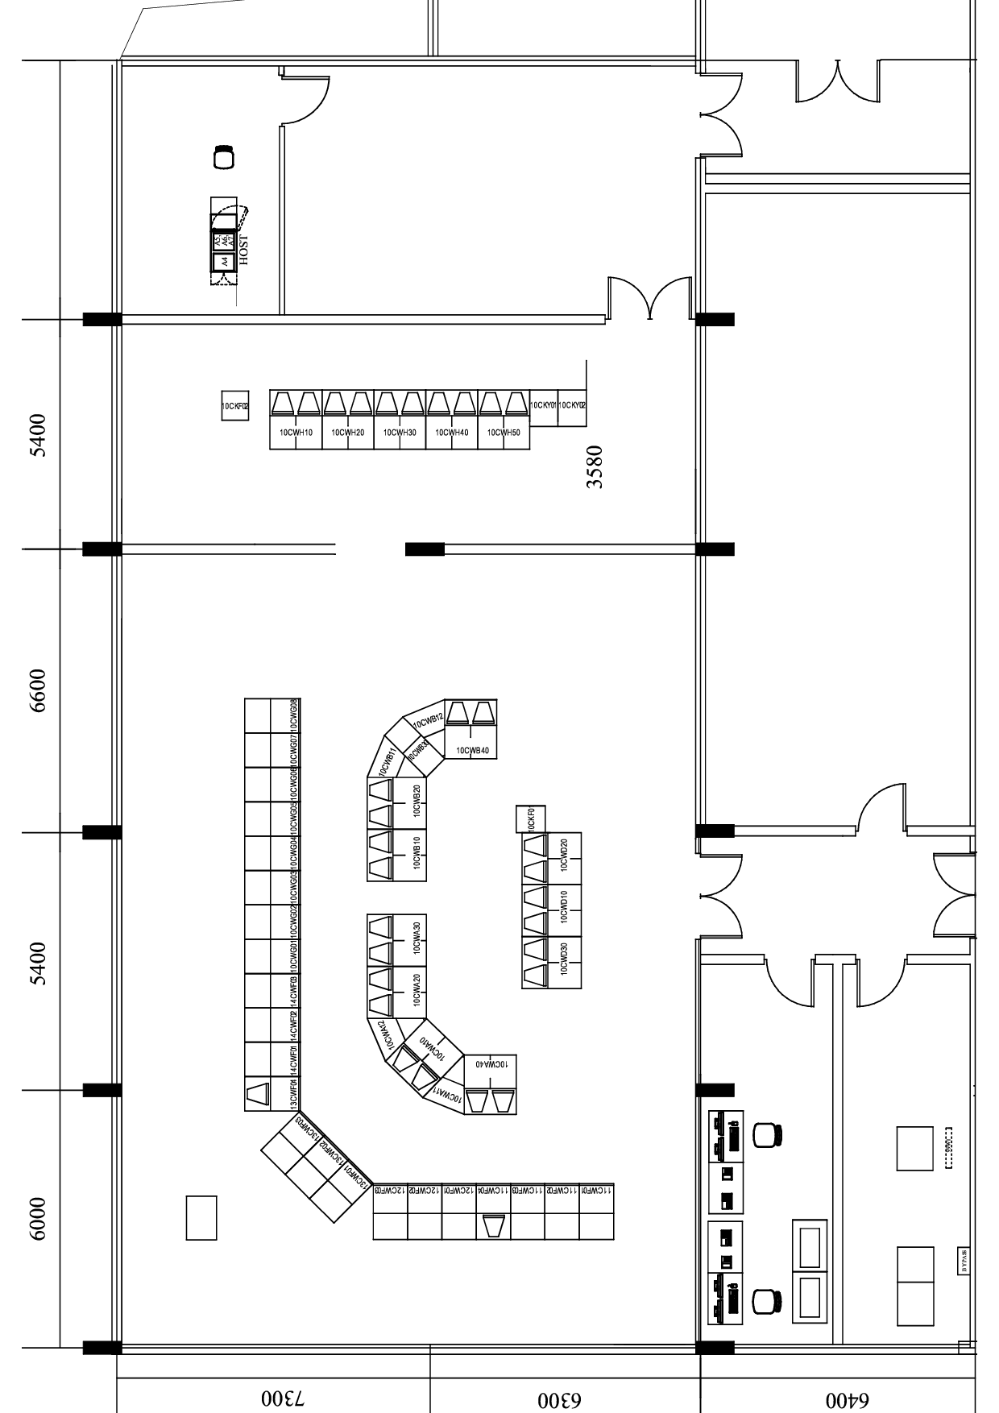

**Signatures of the Parties:**

|  |  |
| --- | --- |
| **The Client:**  ___________________ / - /  L.S. | **The Contractor:**  ___________________ /- /  L.S. |

Appendix 2

to Technical Assignment

**Board General View**

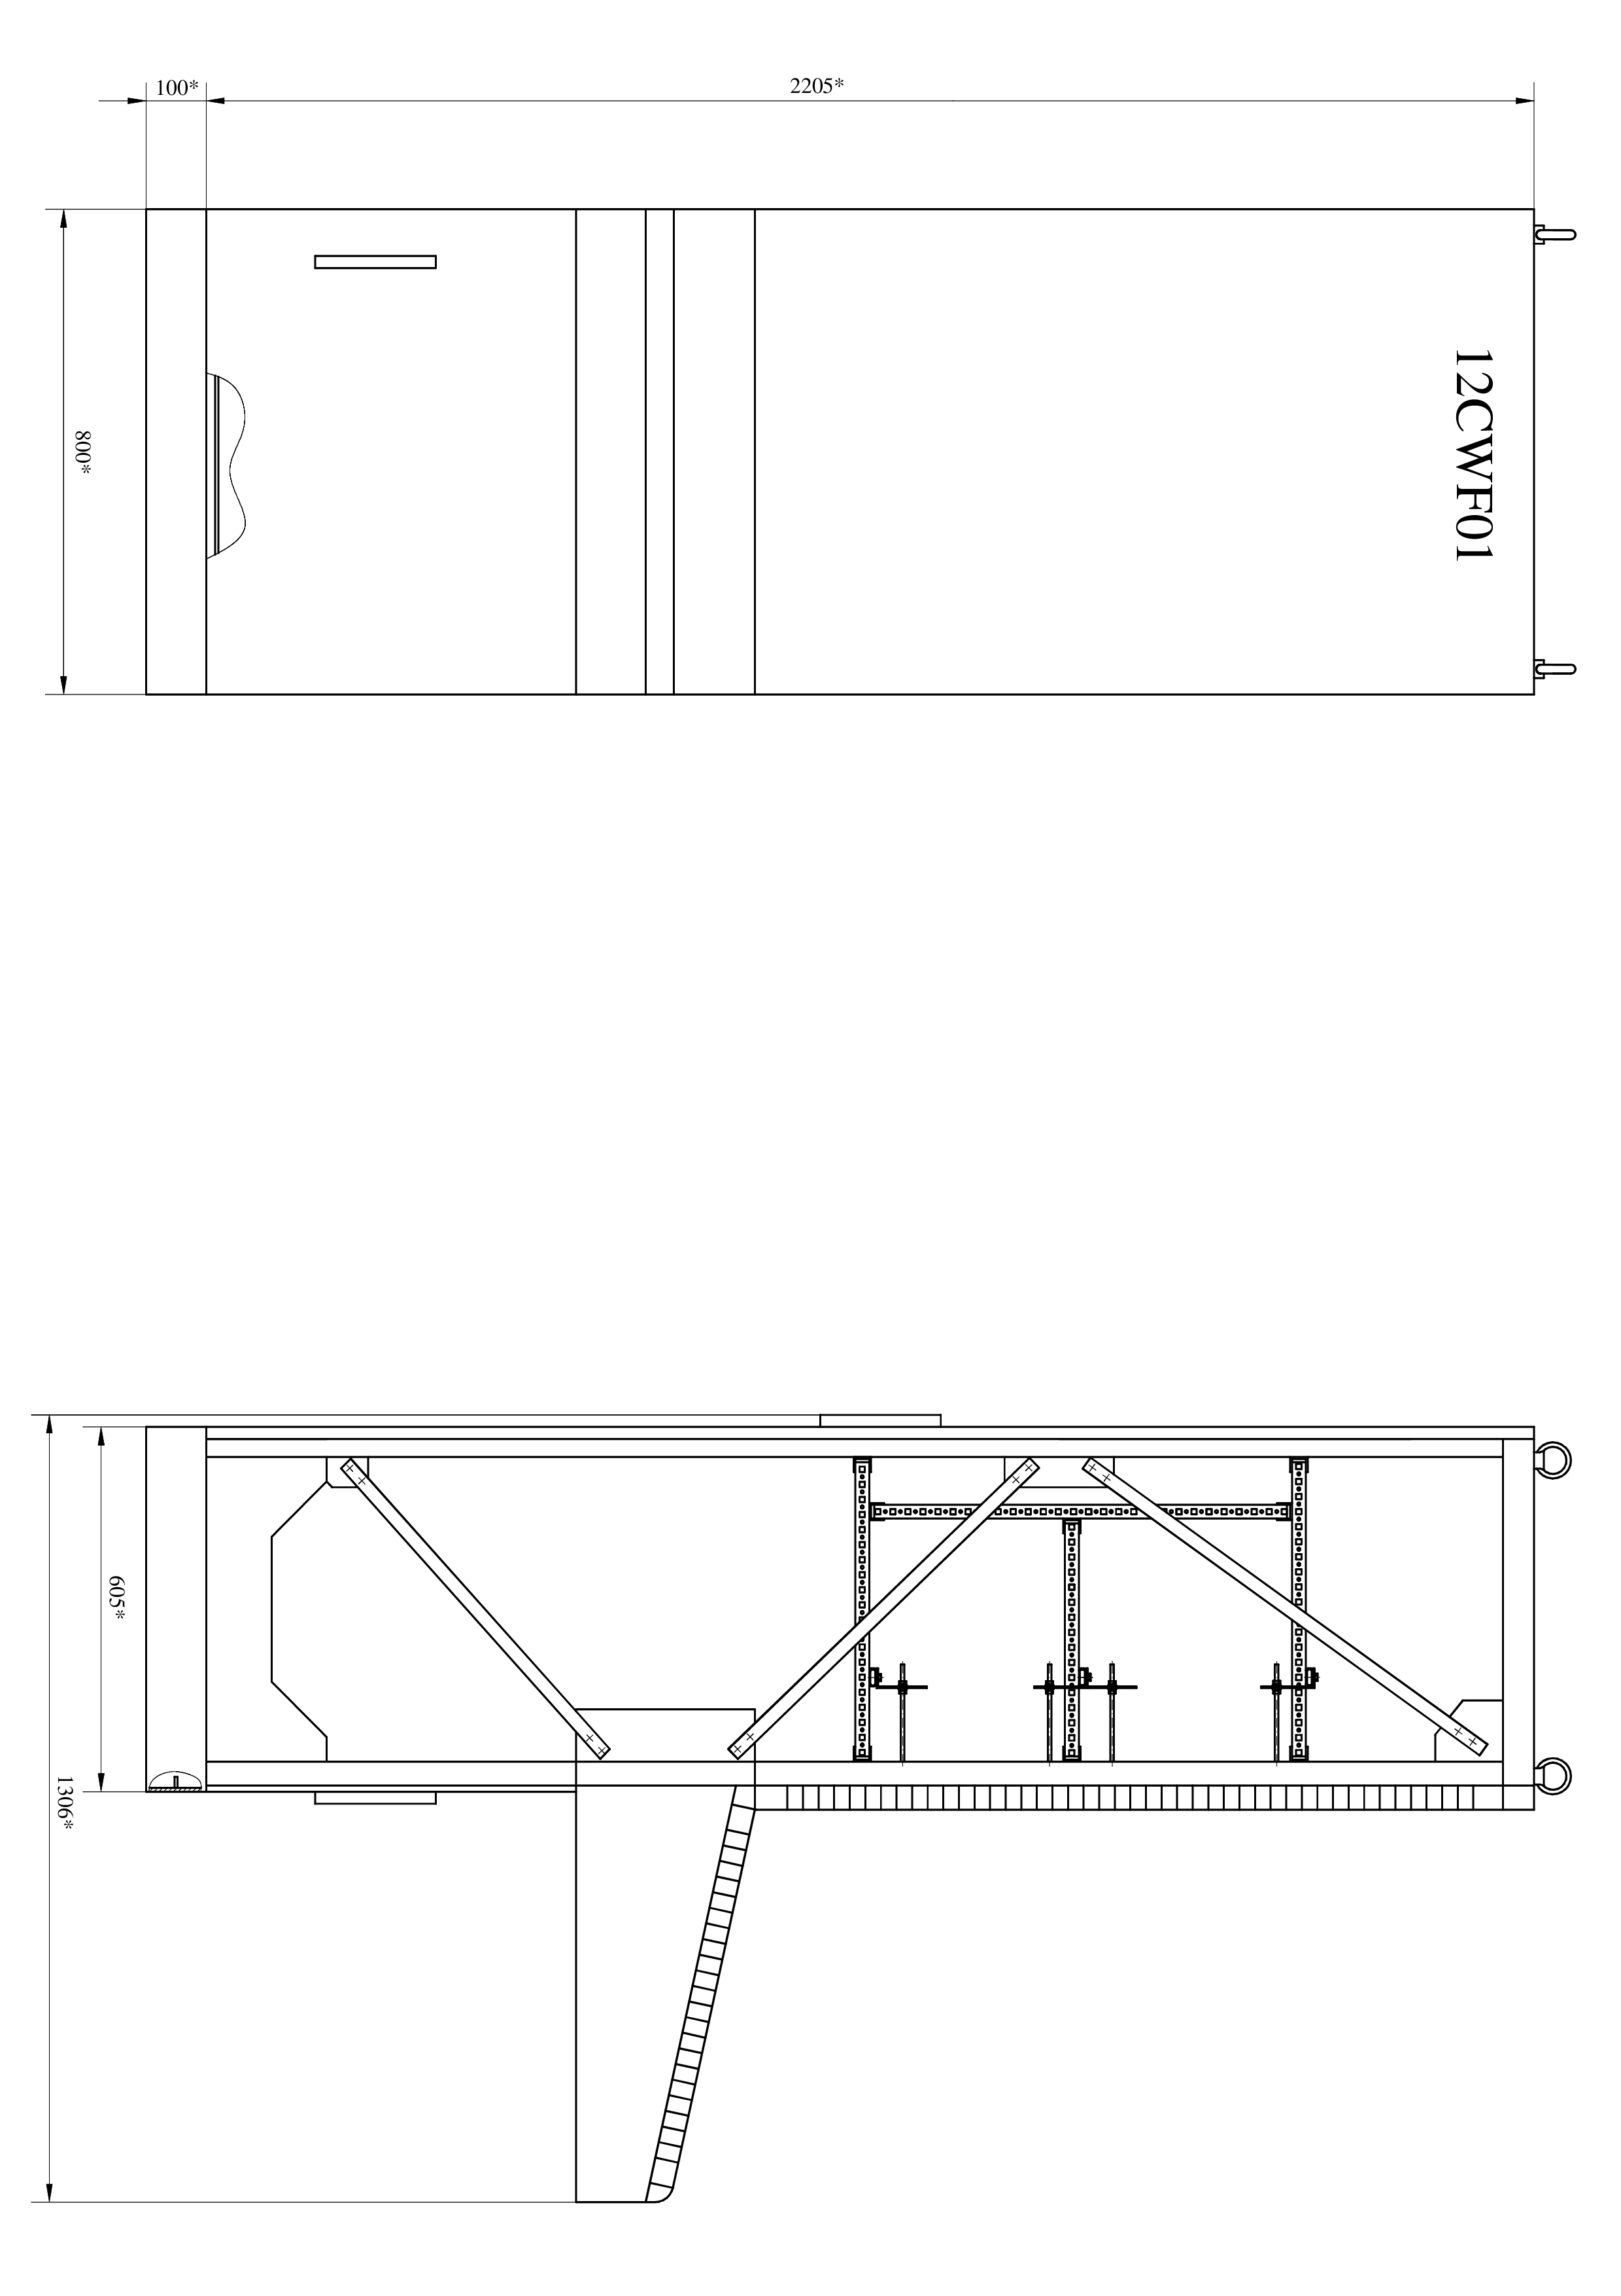



**Signatures of the Parties:**

|  |  |
| --- | --- |
| **The Client:**  ___________________ / - /  L.S. | **The Contractor:**  ___________________ /- /  L.S. |

Appendix 3

to Technical Assignment

**Control Panel General View**

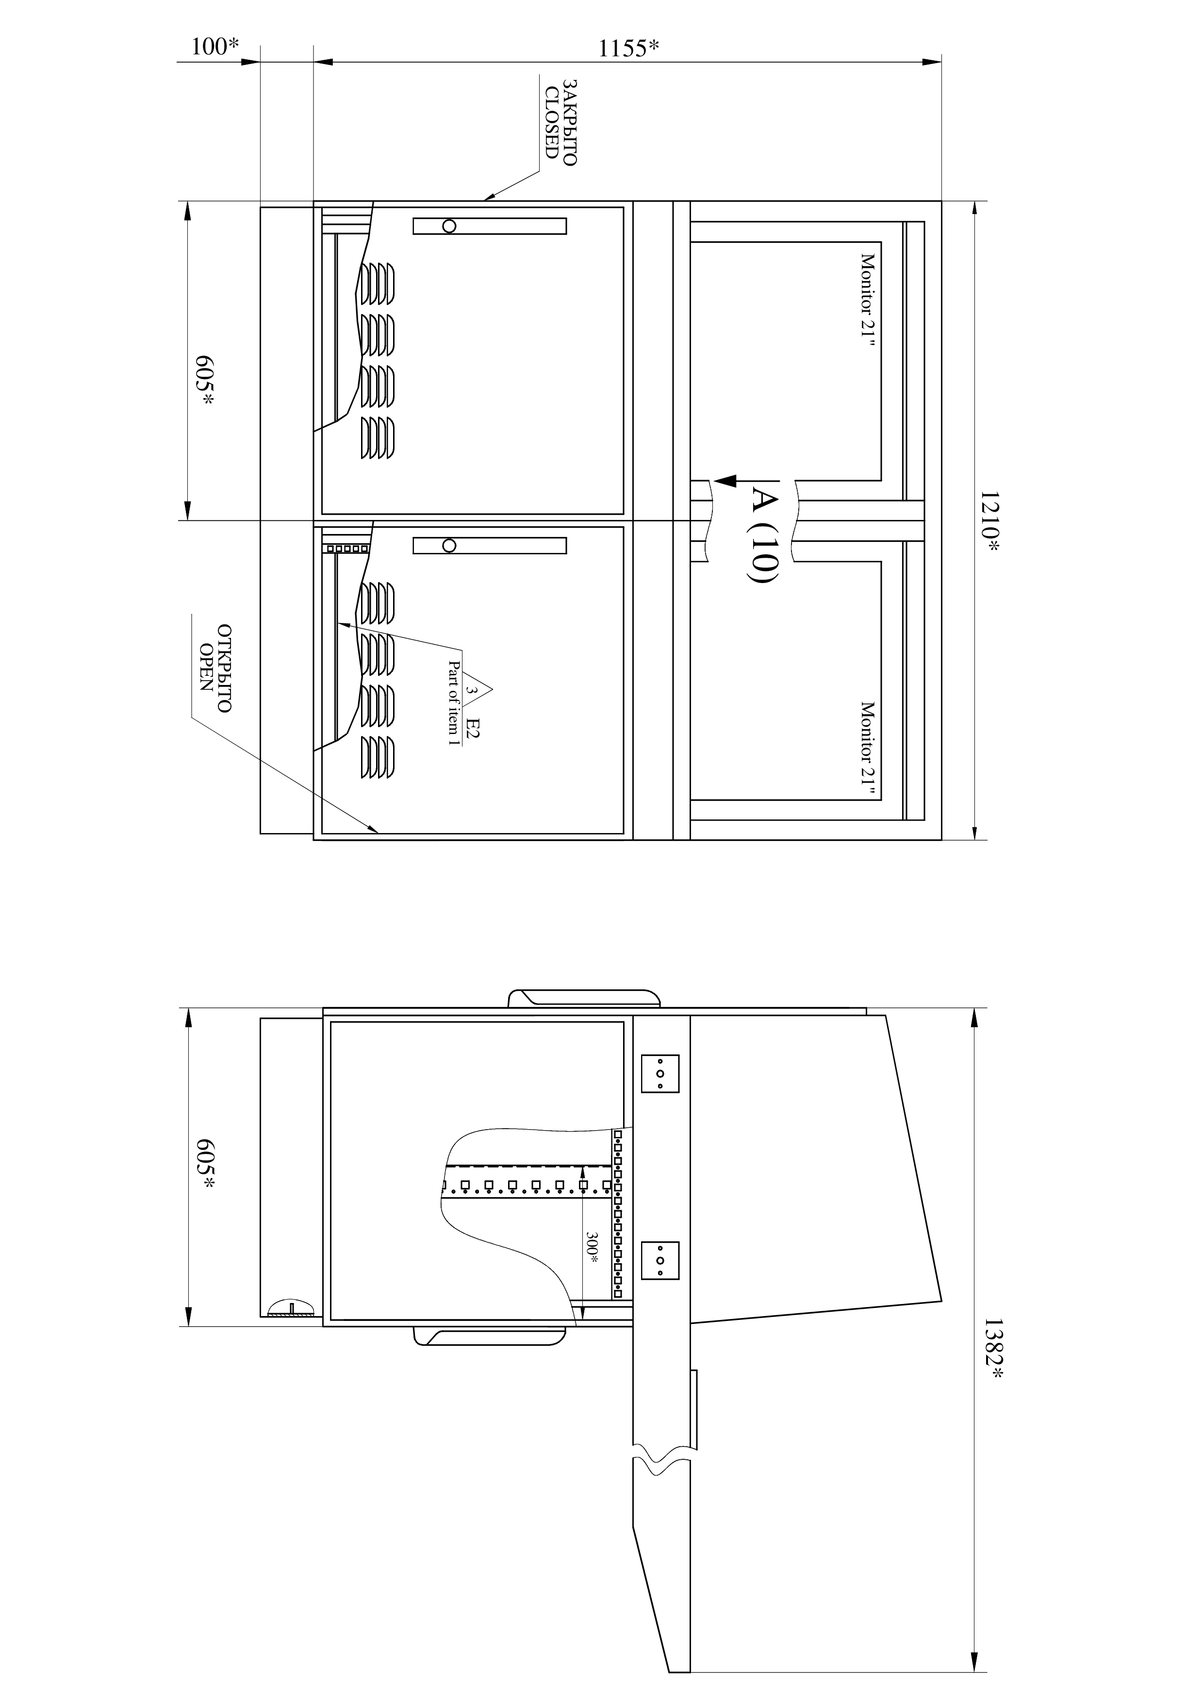

**Signatures of the Parties:**

|  |  |
| --- | --- |
| **The Client:**  ___________________ / - /  L.S. | **The Contractor:**  ___________________ /- /  L.S. |