LENINGRAD NPP OSART TEAM ARRIVAL
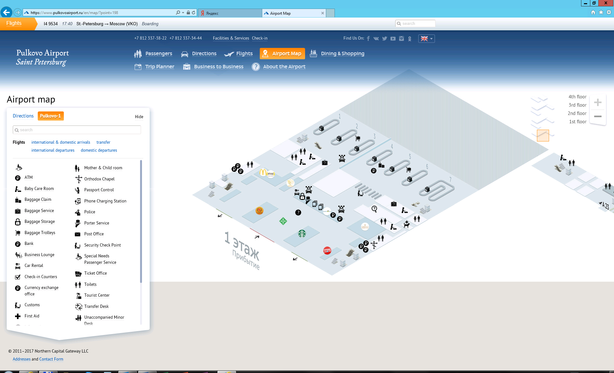
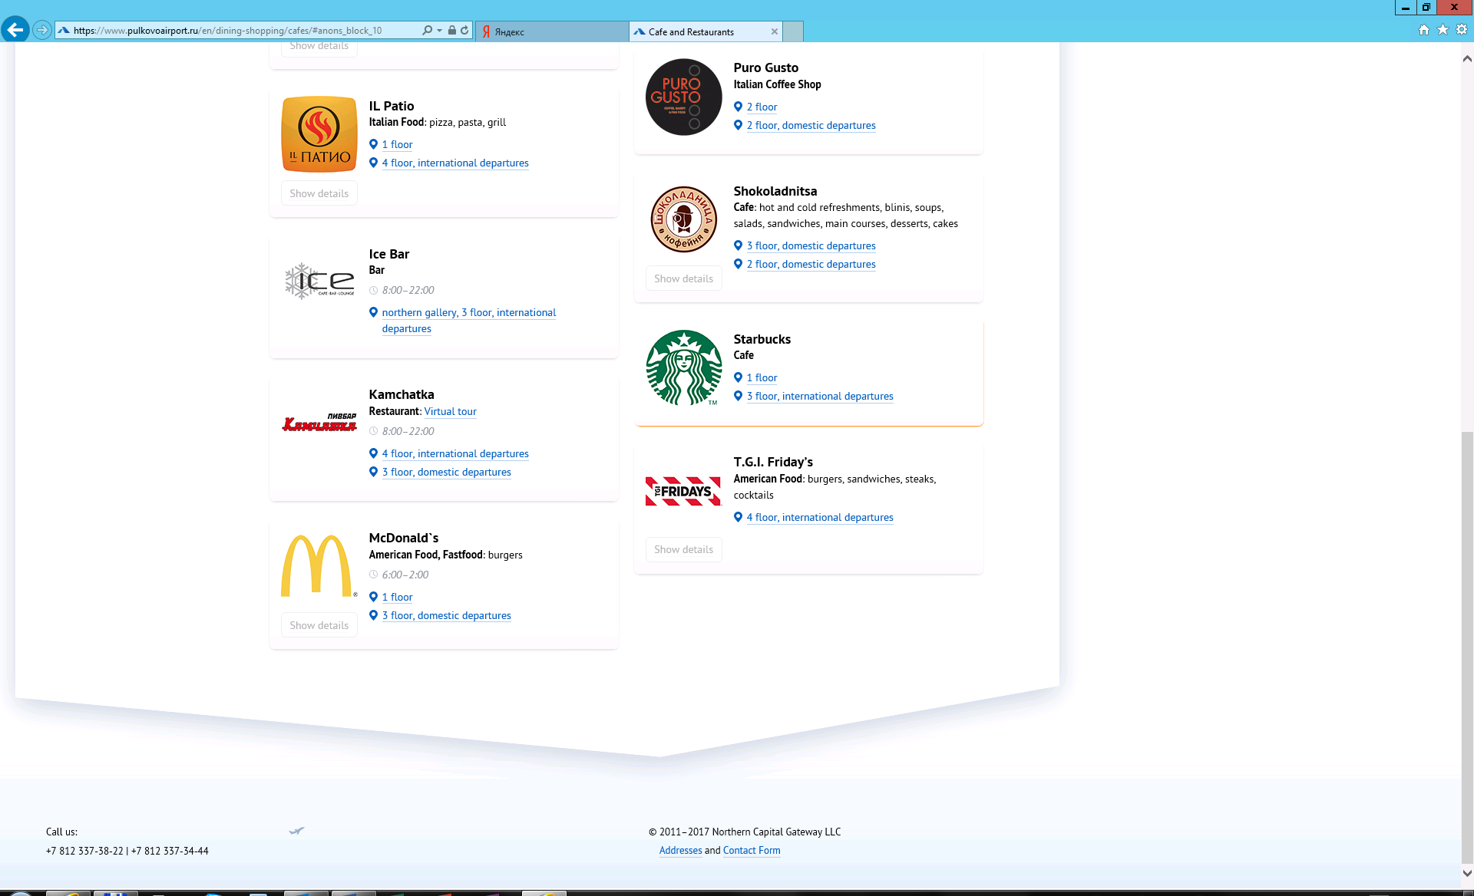
Name | Surname | Date | Time | Meeting point
November, 11 (Saturday)
Augustin | Osusky | 11.11.2017 | 15:25 | Exit from arrival area
Marcos | Do Amaral | 11.11.2017 | 17:35 | Meeting point – “Starbucks” café  18.50
Jürgen | Gillis | 11.11.2017 | 18:20 | Meeting point – “Starbucks” café  18.50
Ronald | Bailey | 11.11.2017 | 20:45 | Meeting point – “Starbucks” café  21.15
November, 12 (Sunday)
Hedayat | Abbaspour | 12.11.2017 | 11:35 | Meeting point – “Starbucks” café  16.00
Dmytro | Zavialov | 12.11.2017 | 13:55 | Meeting point – “Starbucks” café  16.00
Nils | Glanneskog | 12.11.2017 | 15:10 | Meeting point – “Starbucks” café  16.00
Constantin-Cǎtǎlin | Sima | 12.11.2017 | 15:20 | Meeting point – “Starbucks” café  16.00
David | Andrews | 12.11.2017 | 15:25 | Meeting point – “Starbucks” café  16.00
Jean-Luc | Bretelle | 12.11.2017 | 15:25 | Meeting point – “Starbucks” café  16.00
Fuming | Jiang | 12.11.2017 | 15:35 | Meeting point – “Starbucks” café  16.00
Vesselina | Ranguelova | 12.11.2017 | 15:35 | Meeting point – “Starbucks” café  16.00
Vitaly | Parhomenko | 12.11.2017 | 17:25 | Moscow railway station, phone number of our representative will be sent later  17.40
Nadezda | Bila | 12.11.2017 | 16:35 | Meeting point – “Starbucks” café  19.00
Wuping | Li | 12.11.2017 | 18:25 | Meeting point – “Starbucks” café  19.00
HOST PLANT PEER – ALEKSEI – +7-921-346-48-24
Ground floor, Arrival area

