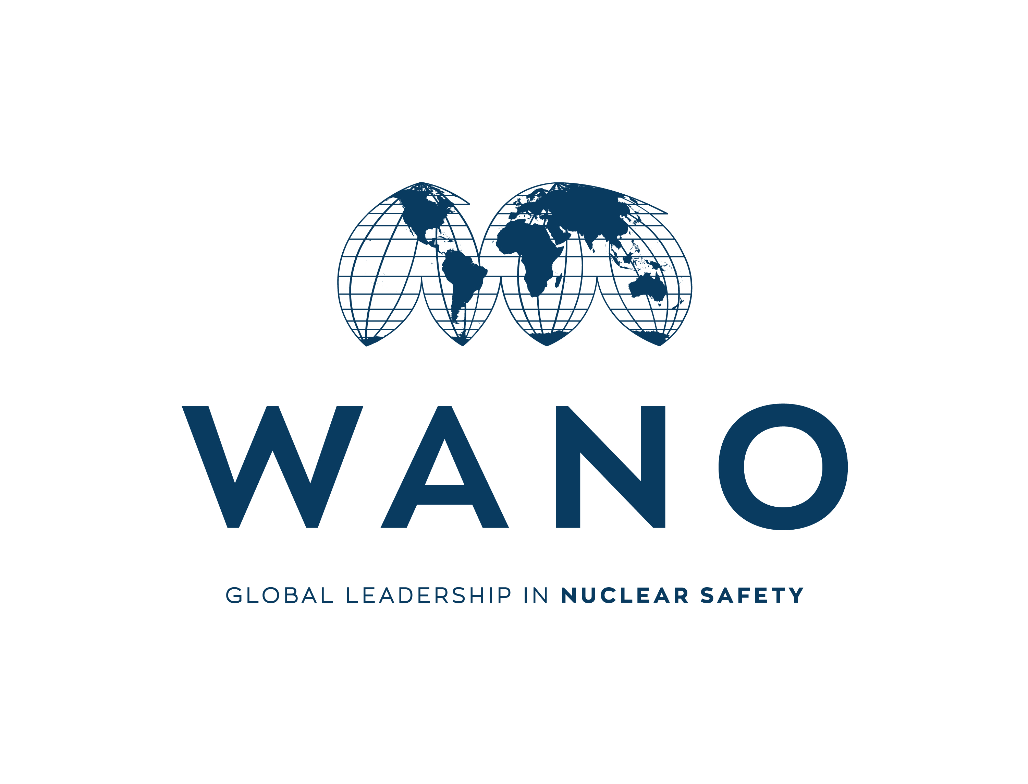



**WANO MC WIO**

**Video Conference Agenda**

**Virtual Meeting**

*To join the meeting please use the following link:*

*Russian channel:* [*https://call.lifesizecloud.com/125862*](https://call.lifesizecloud.com/12586254)*60*

*English channel:* [*https://call.lifesizecloud.com/12586254*](https://call.lifesizecloud.com/12586254)

**8 December 2021**

**VC**

| **time** | **activity** | **responsible person** |
| --- | --- | --- |
| **11:00**  **11:05** | **Meeting opening** | MC Leadership |
| **11:05**  **11:15** | **Introduction of participants** | Conference participants |
| **11:15**  **11:45** | **WANO Moscow Centre Values** | **Tatiana Melnitskaya**  chief expert on international safety culture activities  ano dpo "rosatom technical academy" |
| **11:45**  **12:15** | **WANO MC activities in 2021**  **WANO MC business plan 2022** | MC Programme Leaders  **Lev Zavialov**  MC Development Coordinator |
| **12:15**  **12:25** | **Break** |  |
| **12:25**  **12:50** | **Implementation of the WANO initiative Action for Excellence**  **Update on five AfE streams** | **Andrey Podoprigora**  Operational Safety Analysis Programme Leader  **Sergey Loktionov**  Industry Learning and Development Programme Leader  **Vadim Tarykin**  WANO MC On-Site Reps Leader  **Anatoly Zinchenko**  Peer Review Programme Leader  **Andrey Prokhodtsev**  Member Support Missions Programme Leader  **Tatiana Chudakova**  Corporate communications  Programme Leader |
| **12:50**  **13:00** | **Questions from conference participants** | All participants |
| **13:00**  **13:05** | **Adjourn** | WANO MC Leadership |