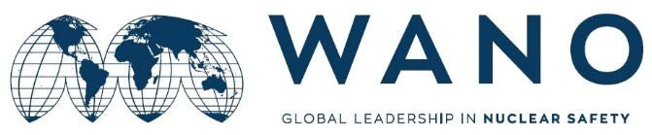**REGISTRATION FORM**

**WANO MC WORKSHOP**

Video Conference

**Raising Awareness of Nuclear Safety Culture and the Commitment of Leadership**

24-27May, 2022

|  |  |
| --- | --- |
| First name and family name: | KARIM RAHIMZADEH KACHOOEI |
| Organization, NPP: | NPPD Co. of Iran, Bushehr NPP |
| Work position: | Manager of Human Resources Development |
| Mobile phone: | +98 901 717 3527 |
| Work phone: | +98 77 3111 2100 |
| Email: | Rahimzadeh@nppd.co.ir |

|  |  |
| --- | --- |
| Please specify the title/subject of your presentation and send the electronic versions in English to the coordinators by**5 May2022**  Electronic versions of the presentations (MS Power Point, not more than 3 Mb). | **To Be Announced Later** |
| **Working language (Russian/English)** | Russian |

Please send the completed registration form and consent to personal data processing to the coordinators: [*lesin@wanomc.ru*](mailto:lesin@wanomc.ru) and [*szlamai@paks2.hu*](mailto:szlamai@paks2.hu)by **18 April, 2022.**

Attachment: Consent to personal data processing - to be completed and signed.

|  |  |  |
| --- | --- | --- |
| **WANO MC coordinator: NPP Paks II coordinator:** | | |
| Sergey Lesin  Tel.: +7 495 221 03 07  Fax: +7 495 376 08 97  Email:[*lesin@wanomc.ru*](mailto:lesin@wanomc.ru) | Ilona Sarokne Szlama  Теl.: +36 202 802 970  Email: *szlamai@paks2.hu* |  |