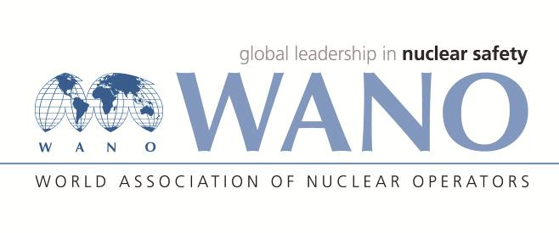 | World Association of Nuclear Operators  Moscow Centre  WANO – MC  25 Ferganskaya st, Moscow, 109507, Russia  Phone. +7 495 376 15 87  Fax: +7 495 376 08 97  info@wanomc.ru

REQUEST
to provide technical and organizational information via WANO.

Dear colleagues,
Bohunice NPP is asking to share our plant experience regarded to using unmanned aerial vehicles (drones) to survey inaccessible places.

- NPP/Organization: Bohunice NPP, Slovenske Elektrarne, Slovakia
- Information request topic: Using of unmanned aerial vehicles (UAV) also known as drones at NPP to perform survey of inaccessible places.
- Information request objective: Bohunice NPP consider to use drones for performing specific surveys of inaccessible areas, including inside building like turbine hall or hermetic zone.
- Problem description:
In some cases it is difficult to reach some specific plant areas that it is needed to perform the examination for various reasons (visual situation, measurement, etc.)
- Specific questions:
- Do you use UAV inside the NPP area?
- What kind of purpose do you use UAV for? Do you use drones inside the buildings? Do you use UAV during outage or also during normal operation or only during emergency?
- What type of UAV do you use? And what added technical equipment is installed on UAV? (e.g. camera, infrared camera, dosimeter…)
- What kind of problems do you face with using UAV?
- Organizations proposed for distribution of this request:
WANO MC NPPs in operation

Russian:
Уважаемые коллеги,
АЭС Богунице обращается с просьбой поделиться опытом по использованию беспилотных летательных аппаратов (дронов) для обследования труднодоступных мест на АЭС Бушер.

Ответы и рекомендации АЭС Бушер в этой связи:
Bushehr NPP Answers and Recommendations in this regard:

1—

2—

3—

4—

5—

00- Specific responses and comments:

