Attachment 15
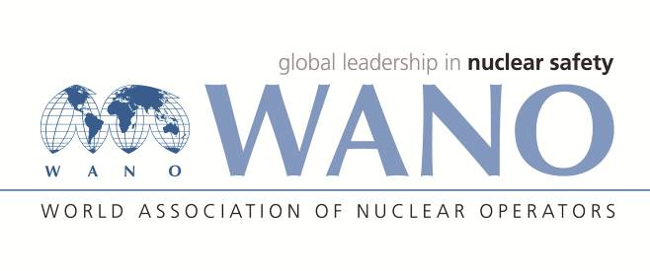 | Moscow Centre  World Association of Nuclear Operators  WANO– MC  Russia, 109507, Moscow, 25 Ferganskaya Str.  tel. +7 495 376 15 87  Fax: +7 495 376 08 97  info@wanomc.ru

I N Q U I R Y
about acquiring technical and organisational information
requested by WANO

- NPP/Organisation: Kozloduy NPP
- Inquiry subject:
Operating experience of cooling down the WWER-1000 reactor facility
- Inquiry objective:
Cooling down the pressurizer in the primary circuit with three (two) MCPs running and YD40D01 tripped.
- Issues:
The current procedure we use is the following: Tripping of YD20,30D01 during cooling down and further tripping off YD10,40D01 immediately before the TQ2 system planned cooldown. Cooldown with MCP in different combinations is recommended with the aim of tracking the Hide out return phenomenon and based on the current engineering chemistry analyses.
- Specific questions:
Have you experienced cooling down the pressurizer in the primary circuit with YD40D01 tripped and/or one MCP more?
- Suggested organisations to receive this inquiry:
WWER-1000 NPPs, which are members to WANO Moscow Centre only
- Administrative unit – inquiry initiator: Kozloduy NPP, Operations Division
- Inquiry initiator contact details:
- Date of inquiry:

