**Dear Mr. Ghazi,**

In accordance with your last E mail as well as our meeting in Bushehr we are free to offer you the following solution for procurement of our two sets of equipment as follows:

1. HRID SGIS (**S**team **G**enerator **I**nspection **S**ystem) which includes main manipulator and the following modules:
   1. Module for inspection of two steam generator tubes in parallel with additional feature of removing water from tubes with compressed air.
   2. UT module for inspection of collector upper weld
   3. Video inspection of steam generator tube sheet during bubble (aquarium) test

Delivery: 5 months after signing of Contract

Price: 687 000,00 Euro

1. HRID system for removing sludge from reactor pressure vessel bottom

Delivery: 5 months after signing of Contract

Price: 289 000,00 Euro

The price of both equipment is 687 000,00 + 289 000,00 = 976 000,00 Euro. For financing these projects HRID NDT has to take loan from the bank for the period of 5 years, because HRID NDT do not have any money reserves. In our bank, we can get such loan with the yearly interest rate of 5.6%. These same interest rate we apply also on your payments during 5 years’ period. Payments (instalments) will be every quarter (every 3 months) which we think is suitable in this case.

The advance payment after signing Contract will be 20% of contract price, or in Euro 195 200,00 Euro. The installment plan is given on next page (for calculation I used on www.Calculator.net Loan calculator). The summary of this plan is the following:

1. Advance payment is 20% of the Contract price what is 195 200,00 Euro
2. The amount which has to be paid in instalments after advance payment (3 months later) is 780 800,00 Euro
3. The calculation what we used is also used by our bank.
4. The payment (instalment) will be 45 031.22 Euro every 3 months.
5. Totally 20 instalments exist.

**Instalments plan**

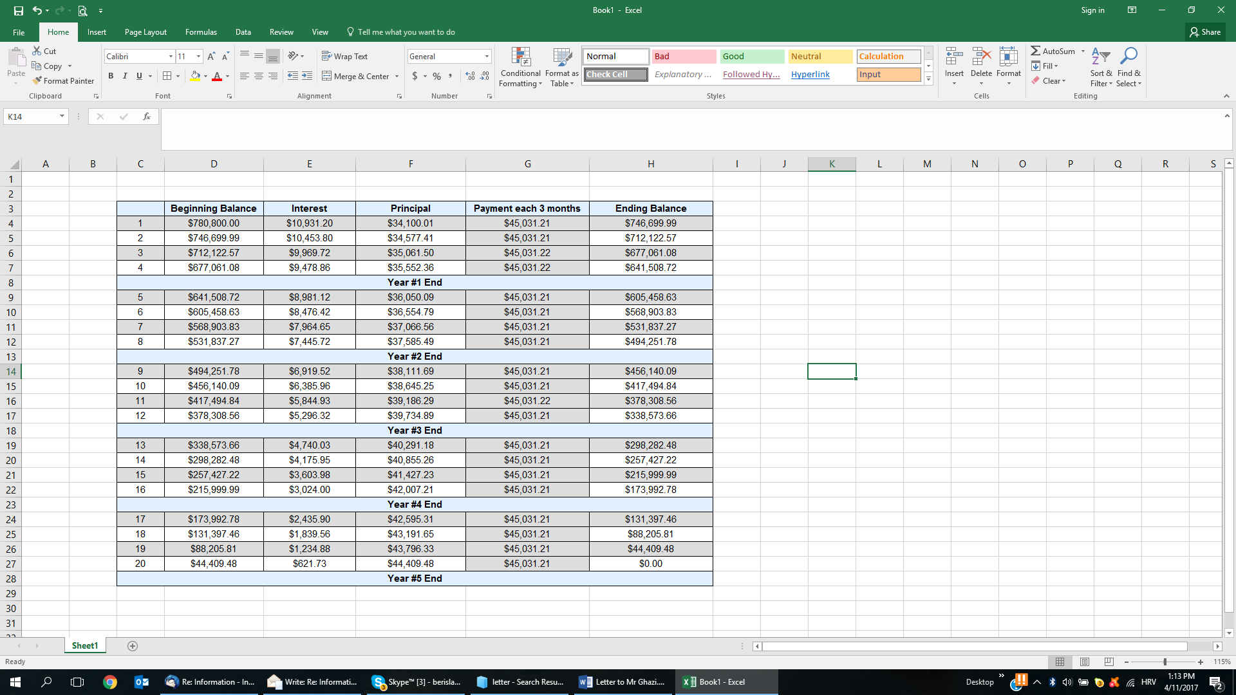

Please if you have any questions, remarks or new ideas contact me immediately.

Best regards,

Zagreb, 11.04.2017.

HRID Ltd.

Berislav Nadinic