Comparison between Rebar Thread Rolling Machine and cold foreign machine with Rebar cold pressing machine

- Introduction
For many years the use of mechanical couplers to join reinforcing bars has been regarded as a means of reducing the use of long bars. Engineers and contractors now recognize the benefits of using couplers to accelerate the speed of construction, increase productivity and simplify design details. Forging operations are widely used for manufacturing processes. Forging process is done hot, warm or cold. But for more strange, cold pressing method is bester. Now there are two devices for performing two methods, which are below the specifications and application as well as their standards has been posted.

- Technical Specifications of Devices

- Rebar Thread Rolling Machine and cold foreign machine
property | CBT40M Thread Cutting | 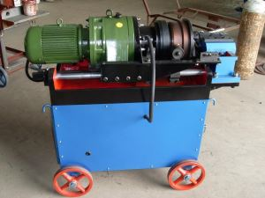 | property | CBT40M UPSETTING | 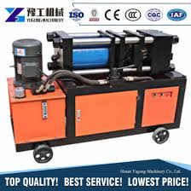
mm16-40 | Rebar Size |  | mm16-40 | Rebar Size
KW40 | Main Motor Power |  | KW40 | Main Motor Power
V380 | Electricity Power Source |  | V380 | Electricity Power Source
Liter/Min6 | Oil Pump Flux |  | Liter/Min6 | Oil Pump Flux
Mpa63 | Max Pressure |  | Mpa63 | Max Pressure
1225*570*1100 | Out Dimention |  | 1225*570*1100 | Out Dimention
590kg | Net Weight |  | 620kg | Net Weight

property | CBT40A Thread Cutting | 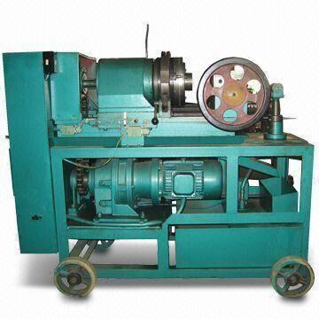 | property | CBT40A UPSETTING
mm16-40 | Rebar Size |  | mm16-40 | Rebar Size
KW40 | Main Motor Power |  | KW40 | Main Motor Power
V380 | Electricity Power Source |  | V380 | Electricity Power Source
Liter/Min6 | Oil Pump Flux |  | Liter/Min6 | Oil Pump Flux
Mpa63 | Max Pressure |  | 32Mpa | Max Pressure
1225*570*1100 | Out Dimention |  | 1225*570*1100 | Out Dimention
590kg | Net Weight |  | 1000kg | Net Weight

Size | 16 | 20 | 25 | 32 | 40
OD (mm) | 24 | 30 | 38 | 48 | 59
Thread larger Dia (mm) | 16.50 | 20.50 | 25.50 | 32.50 | 40.50
Coupler Cross section area (mm²) | 238.66 | 376.94 | 623.64 | 980.35 | 1446.29
C45 Min Tensile Strength (N/mm²) | 600 | 600 | 600 | 600 | 600
Coupler Load (KN) | 143.20 | 226.16 | 374.18 | 588.21 | 867.77
Rebar cross-section area (mm²) | 201.1 | 314.2 | 490.9 | 804.2 | 1257
BS 8110 with 400 rebar load(KN) | 86.88 | 135.73 | 212.07 | 347.41 | 543.02
ACI318 (Type 1) with 400 rebar load(KN) | 100.55 | 157.10 | 245.45 | 402.10 | 628.50
ACI318,(Type 2) with 400 rebar load(KN) | 106.58 | 166.53 | 260.18 | 426.23 | 666.21
Coupler Load(KN) with BS 8110, ACI 318 requirement Remark | Above | above | above | above | above

Specifications
- High Quality Automatic Forging Machine
- High efficient, more stable and safety
- 100% Bar Break Performance
- Rebar cold pressing machine
Pressing Machine is used to pressing cold pressing couplers to connect with the rebars.
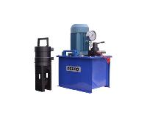 | LJY-32(16-32mm) |  | 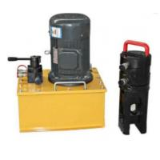 | LJY-40(36-40mm)
 | Motor Power | 3KW |  | 3KW
 | Max Oil pump Pressure | 70MPa |  | 70MPa
 | Clamps Tension | 65Ton |  | 80Ton
 | Oil Pipe Connector | M24*1.5 |  | M24*1.5
 | Oil Pump Weight | 80KG |  | 80KG
 | Clamps Weight | 35KG |  | 45KG

Size | 16 | 20 | 25 | 32 | 40
OD (mm) | 30 | 36 | 45 | 56 | 70
Thread larger Dia (mm) | 20.00 | 24.00 | 30.20 | 38.00 | 46.00
Coupler Cross section area (mm²) | 392.69 | 565.47 | 874.09 | 1328.85 | 2186.48
16Mn Min Tensile Strength (N/mm²) | 470 | 470 | 470 | 470 | 470
Coupler Load (KN) | 184.56 | 265.77 | 410.82 | 624.56 | 1027.65
Rebar cross-section area (mm²) | 201.1 | 314.2 | 490.9 | 804.2 | 1257
BS 8110 with 500 rebar load(KN) | 108.59 | 169.67 | 265.09 | 434.27 | 678.78
ACI318 (Type 1) with 500 rebar load(KN) | 125.69 | 196.38 | 306.81 | 502.63 | 785.63
Coupler Load(KN) with BS 8110, ACI 318 requirement Remark | Above | above | above | above | above

