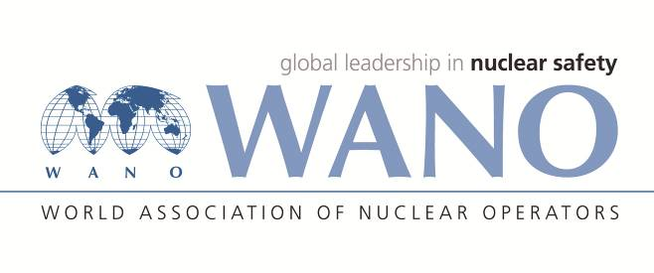 | World Association of Nuclear Operators  Moscow Centre  WANO – MC  25 Ferganskaya, Moscow, 109507, Russia  Phone. +7 495 376 15 87  Fax: +7 495 376 08 97  info@wanomc.ru
REQUEST
to provide technical and organizational information via WANO

- NPP/Organization: Jiangsu Nuclear Power Corporation, Tianwan NPP
- The topic of information request:
Please provide: limiting conditions for reactor coolant pump shutdown during VVER unit outage.
- The goal of information request:
We hope to know the limiting conditions for reactor coolant pump shutdown during VVER unit outage from power operation to maintenance cold shutdown, including the operation time of the reactor coolant pump, the limit value of primary circuit total radioactive data and the limit value of typical radionuclides (such as Co-58, Co-60, etc.).
Problem description:
The units of TNPS are mainly VVER units. During outage, from power operation to maintenance cold shutdown, the reactor coolant pump can be stopped after the primary circuit temperature meets the requirements. However, there are no clear requirements for the purification target of primary circuit radiation source item, which is not good to the collective dose control during outage. It is necessary to be benchmarked with international advanced VVER units.
- Specific questions:
Whether the following control objectives are set to control the radiation source item of the primary circuit during the annual refueling outage of VVER unit:
1）Whether the requirements for the operation time of the reactor coolant pump from the disconnection from the grid to the shutdown of the last reactor coolant pump are set? If any, what is the specific time and what is the basis for setting?
2)Whether the target or limit value of primary circuit radiation level is set when the last reactor coolant pump stops, including the specific targets and setting basis of primary loop total radioactive activity and concentration, and typical radionuclides (such as Co-58, Co-60, etc.)?
3)Whether the refueling outage types (annual refueling outage and four-year/ten-year refueling outage) are distinguished when setting objectives for 1) and 2) above?

- Proposed organizations for sending this request:
WANO-MC NPPs
- Department – request initiator:
Deputy director of health physics branch, Tianwan NPPP.
- Contact details of the requester:
Mr. Ding Changlong, Deputy director of health physics branch
Tel. (office): +86 518 82205556
E-mail. Dingcl@cnnp.com.cn
- Date of request: 27.08.2021

