**Attachment 2: Problem of HPEG Detector**

To measure gamma ionizing radiation in environmental sample, high purity detectors with a relative efficiency of 40% and 70% are used in the plant (technical specifications are mentioned in attachment 1). These detectors which are cooled using liquid nitrogen (LN2) or X-Cooler were manufactured by the ORTEC-company.

The one with 40% relative efficiency is n-type and its operating Voltage is -4800 volts. After applying the voltage to the detector and counting the background radiation (BKG) or the gamma radiation from radioactive sources, there is a lot of noise in the spectrum. Also, the peak resulting from the counting of the radioactive sources (such as Cobalt-60) do not have a good resolution, and a tail is formed on the right side of the peaks. By changing the voltage of the detector (from -4800 to -3000 or -2000 Volt), the noise still exists and does not disappear (see figures).

A similar problem is observed for the other one with a relative efficiency of 70%. Both 40% and 70% detectors were examined and repaired. In the case of 40% detector, the detector crystal was vacuumed in the specific condition (to 10e-6 Bar). High voltage filter and pre-amplifier were also replaced. After changing the high voltage filter and pre-amplifier, the device operates correctly for a few hours. But after a moment, the noise again appears in the spectra and the peak resolution is reduced. In addition, the beginning of the spectrum (energy range from 0 to 300 keV) is completely eliminated.

These detectors are powered by a UPS equipped with a stabilizer. We think that problem of the detector with lower efficiency is related to the high voltage filter while the problem in case of the detector with higher efficiency was resulted from both FET and high voltage filter.

It would be appreciated if you could give some recommendations for solving the problem

**Noise in HPGE detectors**

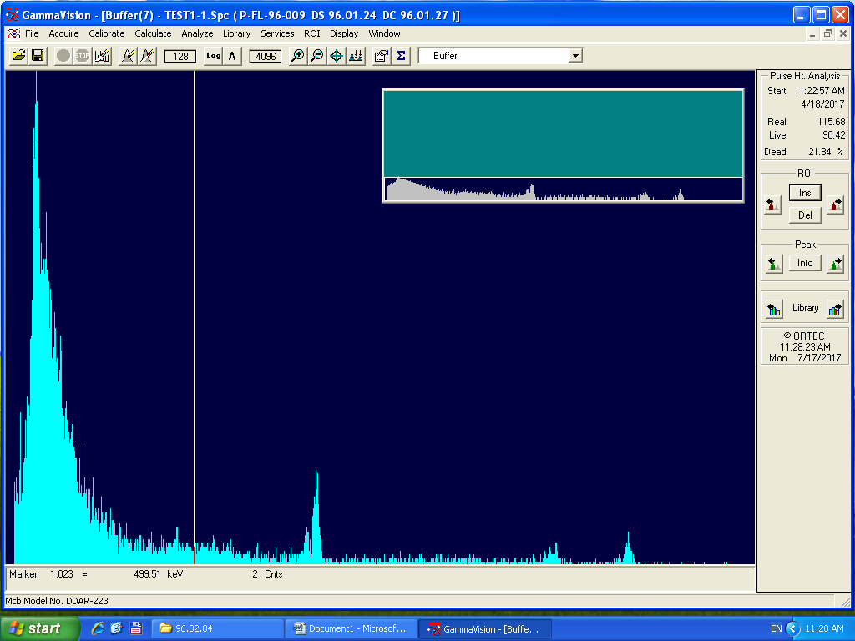

Co-60

HV=-4800

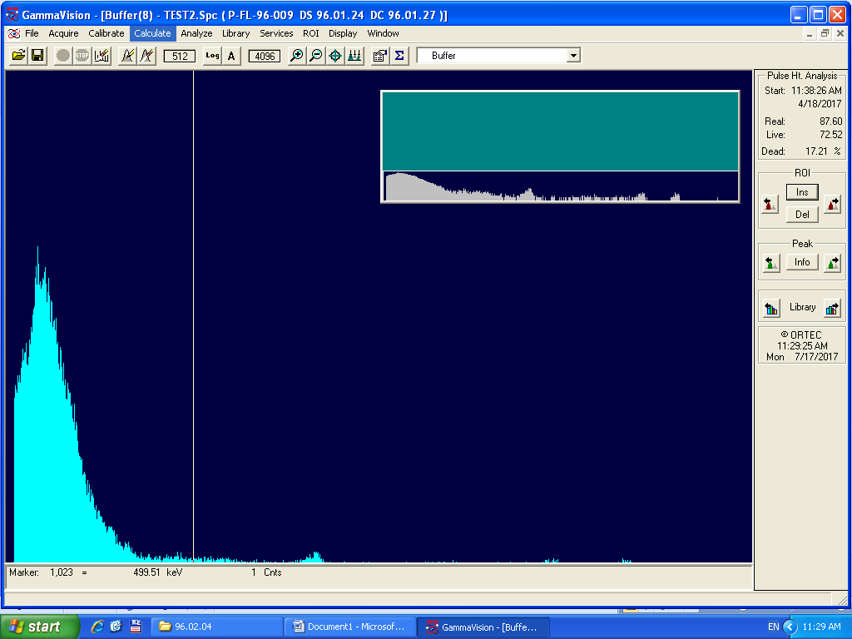

Co-60

HV=-4800

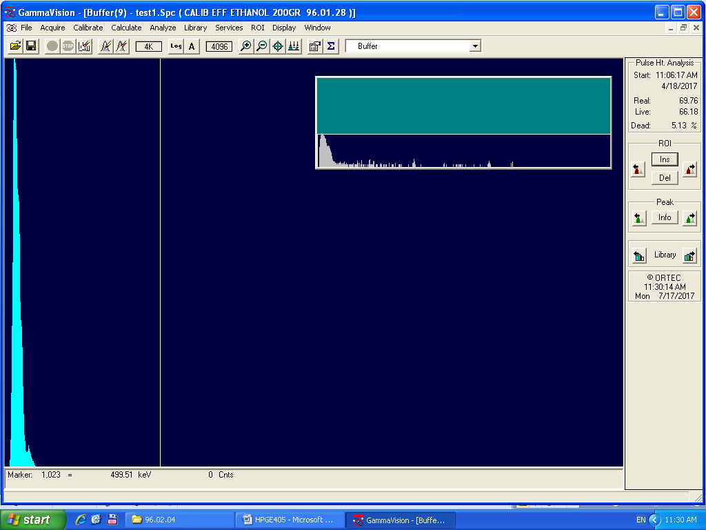

CO-60

HV=-4800

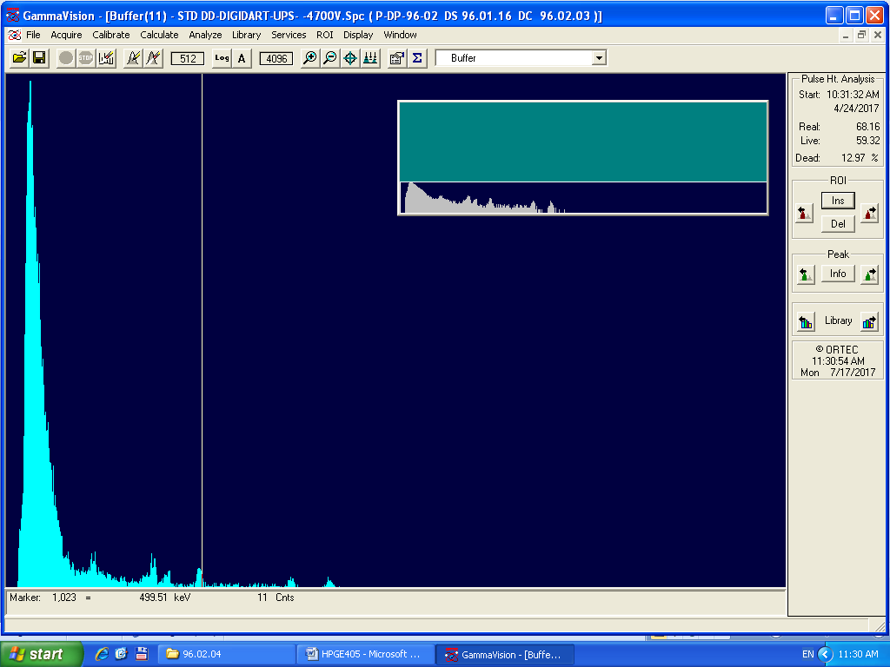

CO60

HV=-4800

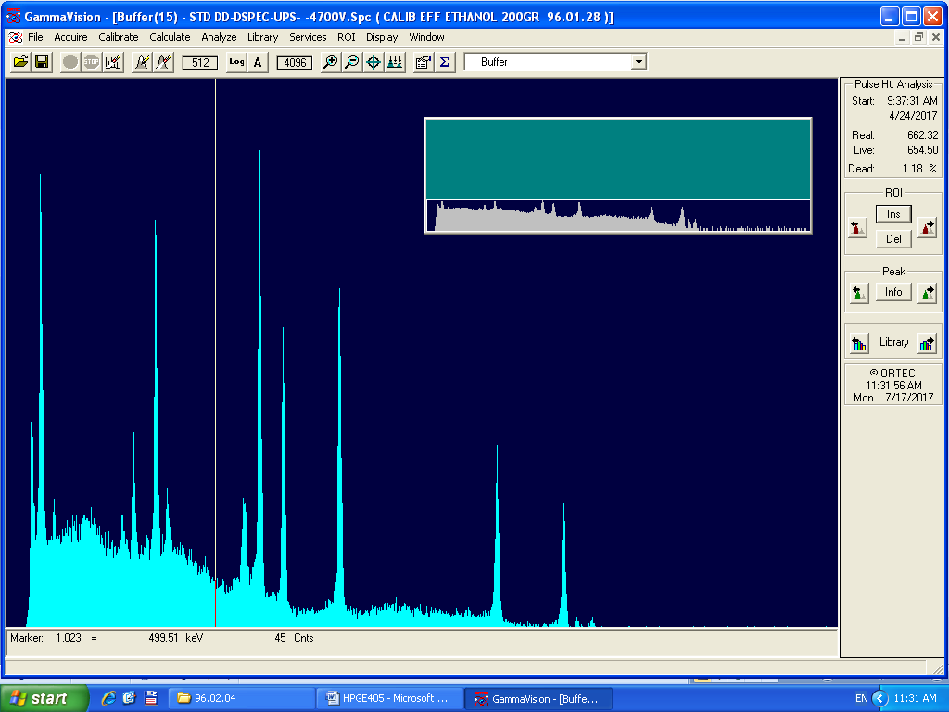

STD SAMPLE

HV=-4800

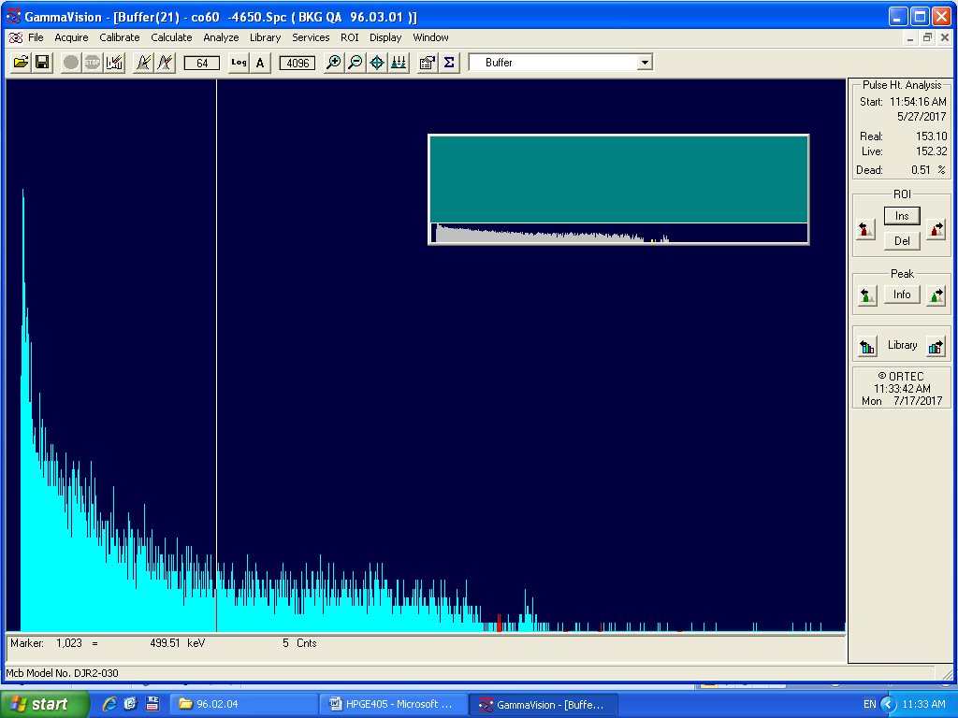

Co-60

HV: -4700

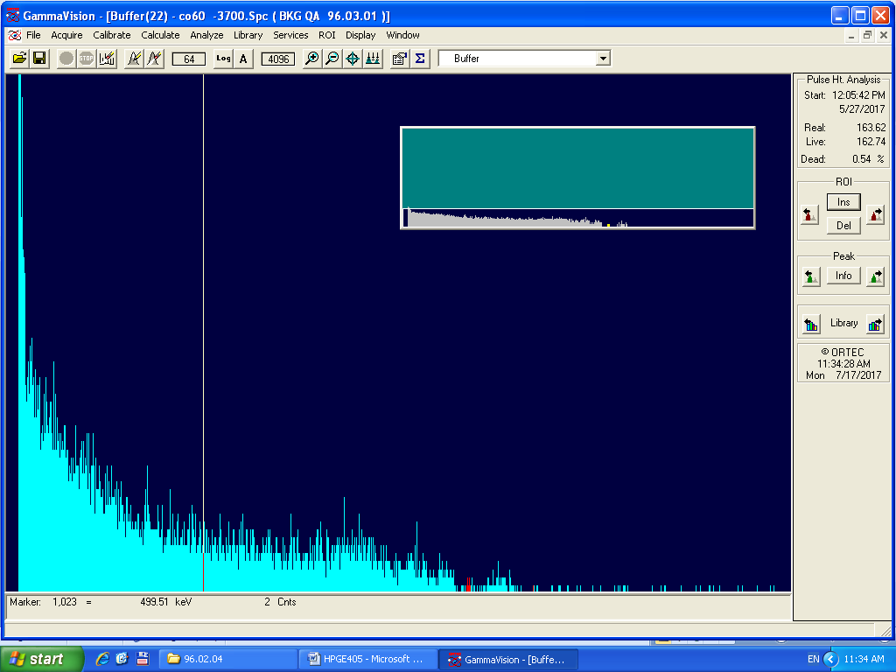

Co-60

HV:-3700

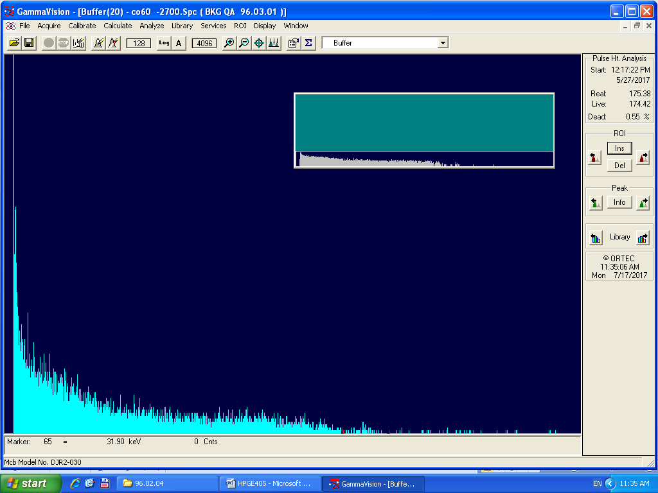

Co-60

HV:-2700