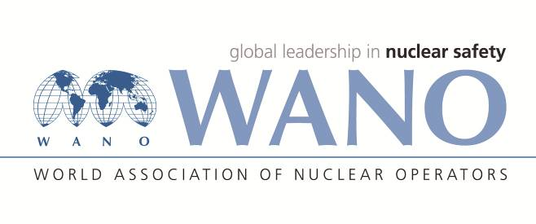 | World Association of Nuclear Operators  Moscow Centre  WANO – MC  25 Ferganskaya, Moscow, 109507, Russia  Phone. +7 495 376 15 87  Fax: +7 495 376 08 97  info@wanomc.ru

REQUEST
to provide technical and organizational information via WANO

- NPP/Organization: Kudankulam NPP

- The topic of information request:
Organization structure and manpower availability of 1000 MW PWR/VVER twin units
- The goal of information request: Getting relevant information from other member plants
- Problem description: The organization structure and manpower availability of KKNPP is to be compared with global practice for 1000 MW PWR type twin units across the world.
- Specific questions: Please provide details about the organization structure being followed and breakup of manpower available in different sections (like operations department, maintenance departments, technical departments etc.) in 1000 MW PWR/VVER type twin units. Please give the breakup of permanent and temporary/contract manpower employed. Please also provide the organization structure and manpower breakup details for refueling outage works.
- Proposed organizations for sending this request:
WANO-MC, PC, AC, TC
- Department – Request initiator: Planning Group
- Contact details of the Requester:
Sanjeev Bhardwaj , +91-9489080628, sbhardwaj@kknpp.com
- Date of request: 04.08.2018

