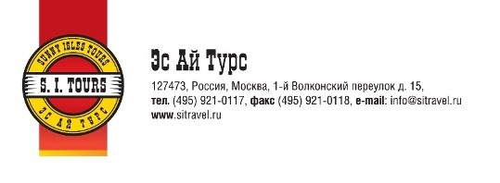 |  |  |  | Voucher  Reservation number :  -
Guest Name: |  | Reservation, confirmation and payment: |  | Date, Signature, Stamp  March.19, 2018
Mr. Hossein Derakhshandeh |  | «S. I. Tours»  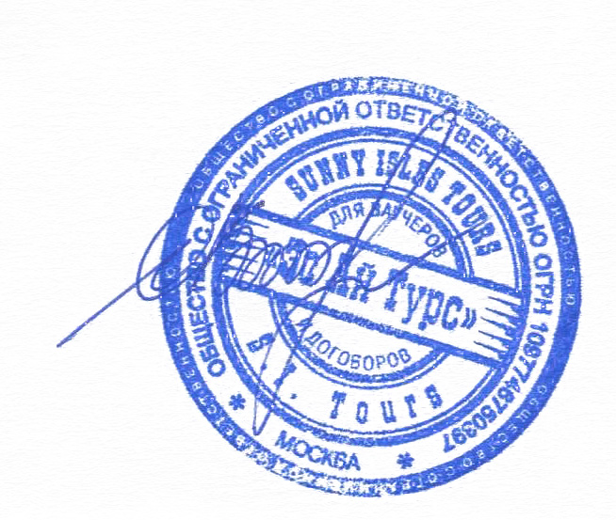  Tel. +7-495-921-01-17  Contact person: Julia Zlobina |  | Date, Signature, Stamp  March.19, 2018
 |  | Swissôtel Krasnye Holmy Moscow  bld.6, Kosmodamianskaya nab., Moscow  Tel: +7 495 787 9800 | |  | Date, Signature, Stamp  March.19, 2018
 |  |  |  | Insurance: No
Transfer: | No | Accommodation  type | 01 SGL with daily breakfast | Insurance: No
Arrival Date: | 09.04.2018 | Accommodation  type | 01 SGL with daily breakfast | Insurance: No
Departure Date: | 13.04.2018 |  |  | Insurance: No

