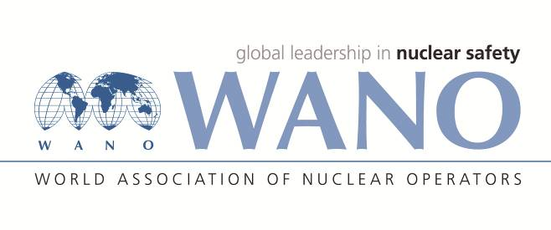 | World Association of Nuclear Operators  Moscow Centre  WANO – MC  25 Ferganskaya, Moscow, 109507, Russia  Phone. +7 495 376 15 87  Fax: +7 495 376 08 97  info@wanomc.ru

REQUEST
to provide technical and organizational information via WANO

1.NPP/Organization: Tianwan NPP

2.The topic of information request:
How to effective manage Nuclear Safety Commission at NPP
3.The goal of information request:
To collect information about practices in management of Nuclear Safety Commission at NPP
4.Problem description:
Nuclear Safety Commission at NPP was established years ago and always finds ways
to improve the management effectiveness, so Tianwan NPP would like to ask WANO members to share any information relating to the following questions, any information from you is appreciated.
- Introduce to us Nuclear Safety Commission staff composition at your plant, what’s their responsibility in this commission?
- Which department or branch is responsible for Nuclear Safety Commission, what’s his responsibility on managing/organizing Nuclear Safety Commission?
- What’s the functions/responsibility of Nuclear Safety Commission?
- What’s the frequency holding the Nuclear Safety Commission meeting? Through what ways to collect and determine the meeting topics?
- Does your pant establish criteria for holding an emergency Nuclear Safety Commission meeting? Would you like to share with us your criteria?
- How to manage the process of decision-making by Nuclear Safety Commission?
5.Proposed organizations for sending this request:
WANO-MC,PC,AC,TC.
6.Department – request initiator: Nuclear Safety Branch
7.Contact details of the requester:
Gao Haiyang, +86-518-82205808, gao@wanomc.ru
8.Date of request: 09.01.2020

