Support in the Stress Tests Exercise
IRN3.01/16 Lot 2

MINUTES OF THE 2nd PROGRESS MEETING
19. 06. 2019, Tehran, Iran

Content:

1. Place and time 3
2. Attendance: 3
3. Introduction 4
4. Course of meeting 4
4.1. Project status presentation, comparison of plans and achievements 4
4.1.1. Project milestones fulfilment 4
4.2. Status of Task1 5
4.3. Status of Task2 and further steps 5
4.4. Specific topics of discussions 6
4.5. EC evaluation of the progress of the project 6
4.6. Plans for future meetings and visits 6
5. Conclusions 7
Attachment 1 Agenda of Progress Meeting 9
Attachment 2 List of participants in Progress Meetings 10
Attachment 3 Presentations 11

Place and time
The 2nd progress meeting (PrM) of the Project INSC IRN3.01/16 Lot 2 “Support in the Stress Test Exercise” was held at the NPPD headquarters in Tehran, Iran on 19th of June 2019.

Attendance:
The meeting was attended by representatives of EC and its support centre JRC, by representatives of the End User, and by representatives of the Contractor. The list of attendees follows, see also sign-in sheet in Attachment 2.

European Commission representatives:

Mr. Xavier Pinsolle, EC Project manager, Security and Nuclear Safety Unit, Devco
Mr. Marc Noel, Expert, JRC

End User

NPP:
Mr. Ebrahim Deylami, Deputy Chief Engineer, ST NPP Project Manager
Mr. Ahmad Davarzani
Mr. Maziyar Behnam

TAVANA (TSO to NPPD):
Mr. Mohammad Hossein Raji, Head of Nuclear Engineering dpt.
Mrs. Elham Tavakoli, Head of DSA section
Mr. Mohamad Razaee
Mr. Ali Akbar Najafi
Mr. Ahmad Ramezani
Mr. Amin Golestani
Mr. Shahram Sheikhi
Mr. Mehran Sirouspour

Contractor (UJV):
Mr. Jozef Misak, Key- expert, Project Manager
Mr. Jiri Sedlak, Senior expert
Mr. Jan Maly, Key-expert
Mr. Stanislav Hustak, Key-expert
Mr. Jozef Balaz, Senior expert
Mr. Vaclav Hakl, Senior expert

Introduction
The meeting was conducted according to the adopted agenda, see the Attachment 1.
The objectives of the progress meeting were to enable timely and effective oversight and monitoring of the project progress, both in terms of its quality and compliance with the project schedule and goals.
All presentations delivered during the PrM are attached, see the Attachment 3.

Course of meeting

Project status presentation, comparison of plans and achievements
Current project status was presented. It was stated that the project is slightly (about 2 months) behind the intended schedule as agreed during KoM, but it is still well within the timeframe required by the TOR. The EC expressed their position that a small delay is acceptable if it is needed for achieving a good quality (quality first).

Project milestones fulfilment
Comparison of milestones schedule and real accomplishments up to the reference date T₀ + 17 can be seen from the following table:

Milestone | Delivery plan [month] |  | Reality
 | from | to
Kick-of-Meeting | T₀ + 4 | T₀ + 4 | T₀ + 4
1st Workshop (Iran) | T₀ + 6 | T₀ + 6 | T₀ + 6
1st Progress report | T₀ + 10 | T₀ + 10 | T₀ + 11
2nd Workshop (Iran) +  1st Progress meeting | T₀ + 10 | T₀ + 10 | T₀ + 11
Technical visit (EU) | T₀ + 9 | T₀ + 10 | T₀ + 9
Methodology report +  specific work plan | T₀ + 10 | T₀ + 10 | T₀ + 13
2nd Progress report | T₀ + 16 | T₀ + 16 | Expected  T₀ + 18
Self-assessment - draft | T₀ + 15 | T₀ + 17 | Expected  T₀ + 19

Status of Task1
The Task1 was concluded, no additional comments on the methodology report had been received from INRA.

Status of Task2 and further steps
Information about the current status of development of the SAST report was given (see Attachment). It was stated that the draft of the SAST report integrates chapters 1-6 and it is nearly finished for the review by the End-User. Chapter 7 summarising the recommendations of chapters 2-6 is drafted and needs to be integrated with the rest of the report. The current status of chapter 7 was presented and discussed in the plenary.
The draft of the report (in electronic) was handed over to the End-User for informative reading. More advanced integrated version of the report is expected to be made available at the UJV cloud by mid of June.
The End-User is expected to make comments preferably by the mid of August. Clarification of the particular requirements could be discussed electronically or via video conferences. Results of videoconferences with impact on the report shall be written in the minutes and disseminated accordingly.
The requirements are supposed to be discussed and agreed on within the End-user staff visit to EU or in a specific meeting.

Specific topics of discussions
The following specific topics were discussed:
End-User staff visit to EU and visas issue
End-User will send a list and personal data of visa applicants to EC (via UJV) and EC promised to perform supporting diplomatic actions to ease the visa issuance
Organization of a meeting with INRA
Arrangements of the INRA workshop on presentation of the SAST report was discussed:
    - The venue most likely will be INRA, Tehran
    - Draft of a presentation should be prepared by Contractor, presentations will be delivered by Tavana
    - UJV is ready to help with the workshop logistics as much as needed (necessary to know in advance)
    - No interpretation in Farsi is foreseen, but could be required
- Presentation at international conferences
  - Needs to be resolved in advance (abstract acceptance)
  - UJV should send an e-mail with details to Mr. Deylami
- STSA report format
  - UJV will suggest a template for the report

EC evaluation of the progress of the project
The EC representatives expressed satisfaction with the progress of the project.

Plans for future meetings and visits
A plan of the nearest future meetings and visits was presented and agreed during the Progress Meeting.
The list of meetings is presented in the table below.

Item Nº | Action | Place | Date
1 | 2nd technical visit of NPPD and TAVANA to EU | Czech Rep. | 26.-30.08. 2019
2 | Presentation workshop to INRA | Tehran, Iran | September/October 2019
3 | 3rd Progress meeting | TBD (NPP, Iran ?) | November/December 2019

Conclusions
The 2nd progress meeting was concluded with a general acceptance of the course of the project. There is no need to organize a Steering Committee meeting at the moment.

- Agenda of Progress Meeting

19.6. | Day 5: Progress Meeting
 | 9:00 | Current status of Project
 | 9:30 | Presentation of Task 1 report
 | 9:45 | Presentation of current status of self-assessment report (Chapters 1-6)
 | 10:15 | Presentation of current status of Action plan
 | 10:45 | Presentation of detailed structure of Chapter 7
 | 11:00 | Cofee break
 | 11:30 | Tentative NPPD course of actions (internal approval process of draft report, handover to INRA, etc.)
 | 12:00 | Co-ordination of activities with Lot-1
 | 12:30 | Discussion of selected concerns (Visits to EU, INRA feedback, presentation at conferences, etc.)
 | 13:00 | Lunch break
 | 14:00 | Presentation of draft of 2nd Progress report
 | 14:15 | Presentation of activities in next period
 | 14:30 | Discussion of particular issues of self-assessment report
 | 15:45 | Cofee break
 | 16:00 | Discussion of particular issues of self-assessment report
 | 16:30 | Minutes of Progress meeting presentation and aproval
 | 17:00 | Adjourn

- List of participants in Progress Meetings
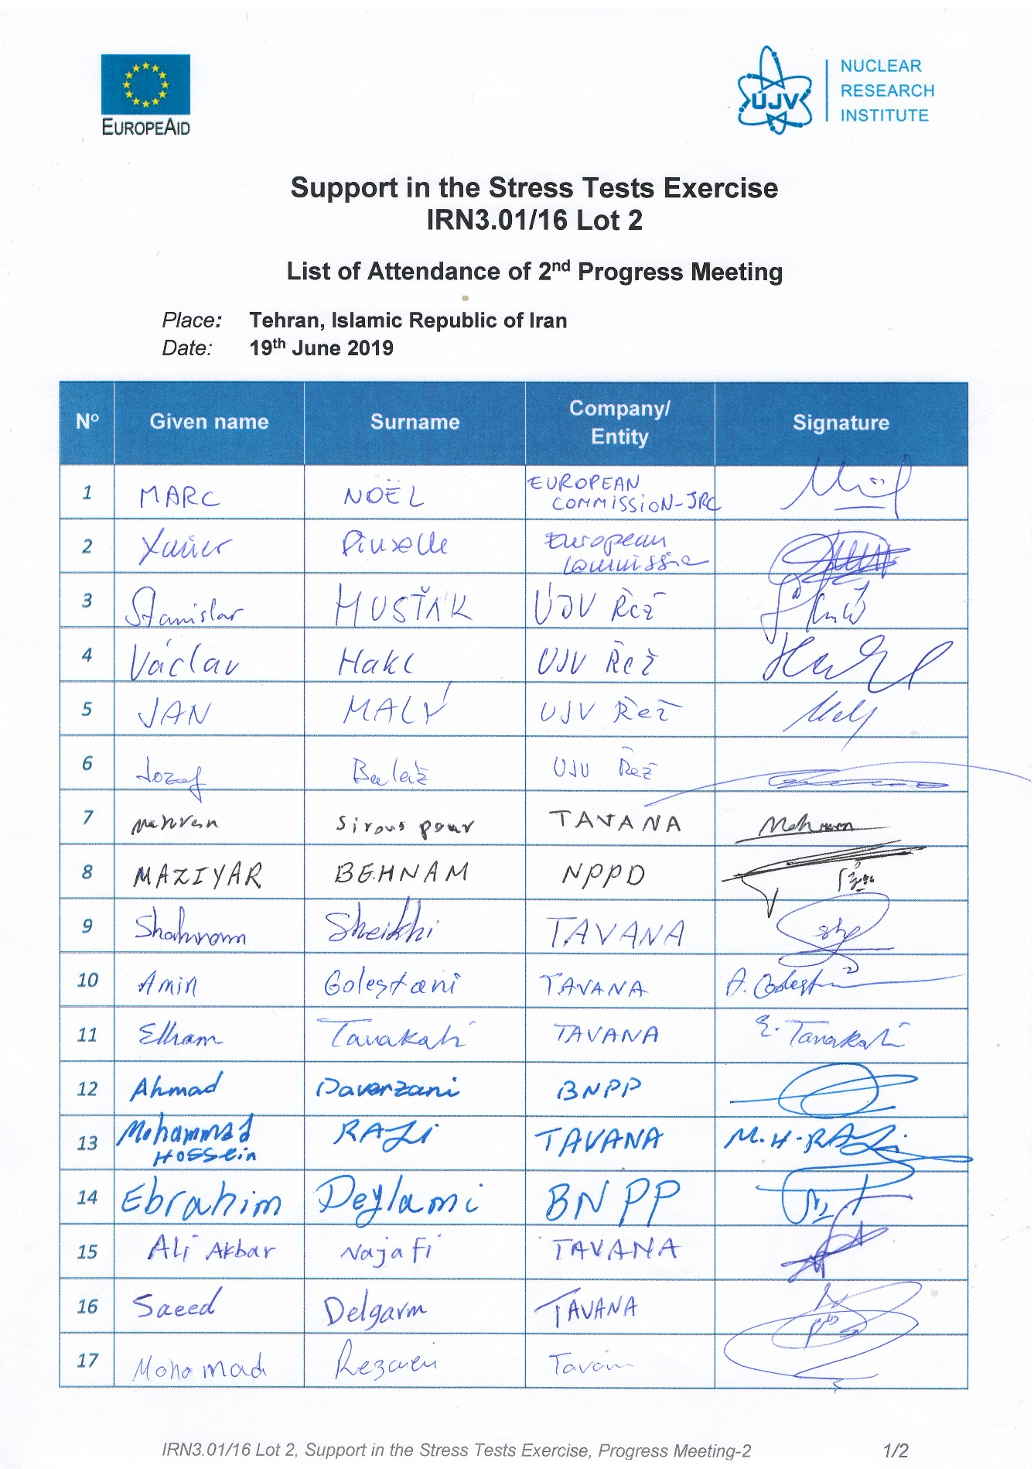
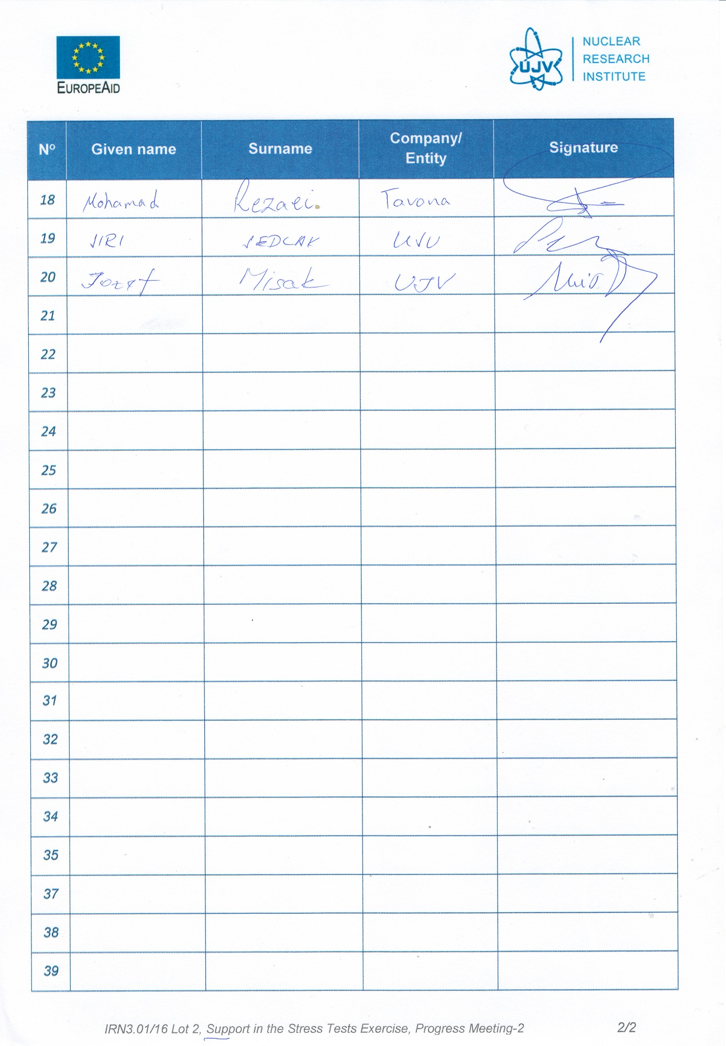
- Presentations

After-meeting comment: Not realised in the period indicated due to a visa problem.

