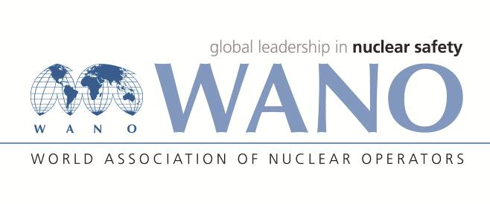 | World Association of Nuclear Operators  Moscow Centre  WANO – MC  25 Ferganskaya st, Moscow, 109507, Russia  Phone. +7 495 376 15 87  Fax: +7 495 376 08 97  info@wanomc.ru

REQUEST
to provide technical and organizational information
via WANO

- NPP/Organization: Mochovce NPP
- Information request topic:
Implementation of SOER 2013-2 recommendation 9: “Develop plans that address family/personal needs of responders who are unable to leave the site.”
- Information request objective: Obtaining information about SOER 2013-2 recommendation 9 implementation lessons learned.
- Problem description:
Mochovce NPP wants to get more information through benchmarking in SOER 2013-2 recommendation 9 implementation. We hope the collected international experiences could help us to obtain the optimal solution and finally close this problem.
- Specific questions:
- What specific measures and with what success has your power plant/company implemented in connection with recommendation 9 SOER 2013-2?
- Who informs his/her family members about the health status and situation of a particular accident response team member during the accident?
- Who and how maintains the current database with contact details of family members of accident response team?
- How is provided psychological help to accident response team members, or their families during emergent situation?
- How is provided media and legal protection to accident response team members in case of dealing with the consequences of an accident?
- How is provided compensation in the event of damage to health, death and other damage caused to accident response team member?
- Is the insurance of accident response team members carried out to ensure their personal or their family members compensation in case of negative impacts of the accident?

- Organizations proposed for distribution of this request:
All NPPs affiliated in WANO.
- Department – request initiator: Emergency Planning Department
- Contact details of the requester:
Name: Ing. Mariana Mancikova
Position: Head of Emergency Planning
Business telephone: +421910673150
e-mail: Mariana.Mancikova@seas.sk
- Request date: 16/11/2021

