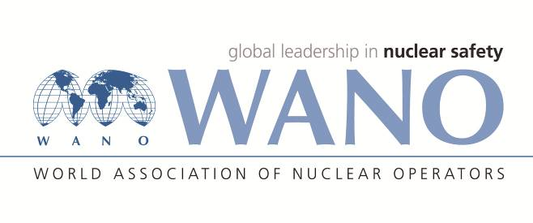 | World Association of Nuclear Operators  Moscow Centre  WANO – MC  25 Ferganskaya, Moscow, 109507, Russia  Phone. +7 495 376 15 87  Fax: +7 495 376 08 97  info@wanomc.ru

REQUEST
to provide technical and organizational information via WANO

- NPP/Organization: Kola NPP, “Concern Rosenergoatom”, Russia

- The topic of information request: Uninterruptible power supply (UPS) system PEW 1005-220/220-EAN manufactured by GUTOR. This UPS system is used at Kola NPP to supply power to pilot valves of the pressurizer and steam-generator safety valves. Operating experience.
- The goal of information request: Gain operating experience for UPS system PEW 1005-220/220-EAN.
- Problem description: Insufficient UPS reliability
- Specific questions:
1. What deficiencies have you experienced in the UPS operation and how did you correct them?
2. What spare parts are in need including those out of production?
- Proposed organizations for sending this request:
WANO MC members
- Department – request initiator: Kola NPP, I&C Department
Contact details of the requester:
Beschastnov Konstantin, I&C Department Head, Tel. (881532) 42385; E-mail: <BeschastnovKC@kolatom.murmansk.ru> ;
Vasiliev Andrey, ведущий инженер ЦЦР, тел. (881532) 42910; E-mail: <VasilievAN@kolatom.murmansk.ru>
- Date of request: 17.01.2019

