INVITATION FOR PARTICIPATION

IN THE TRADITIONAL INTERNATIONAL NUCLEAR CONFERENCE

BULGARIAN NUCLEAR ENERGY – NATIONAL, REGIONAL AND WORLD ENERGY SECURITY

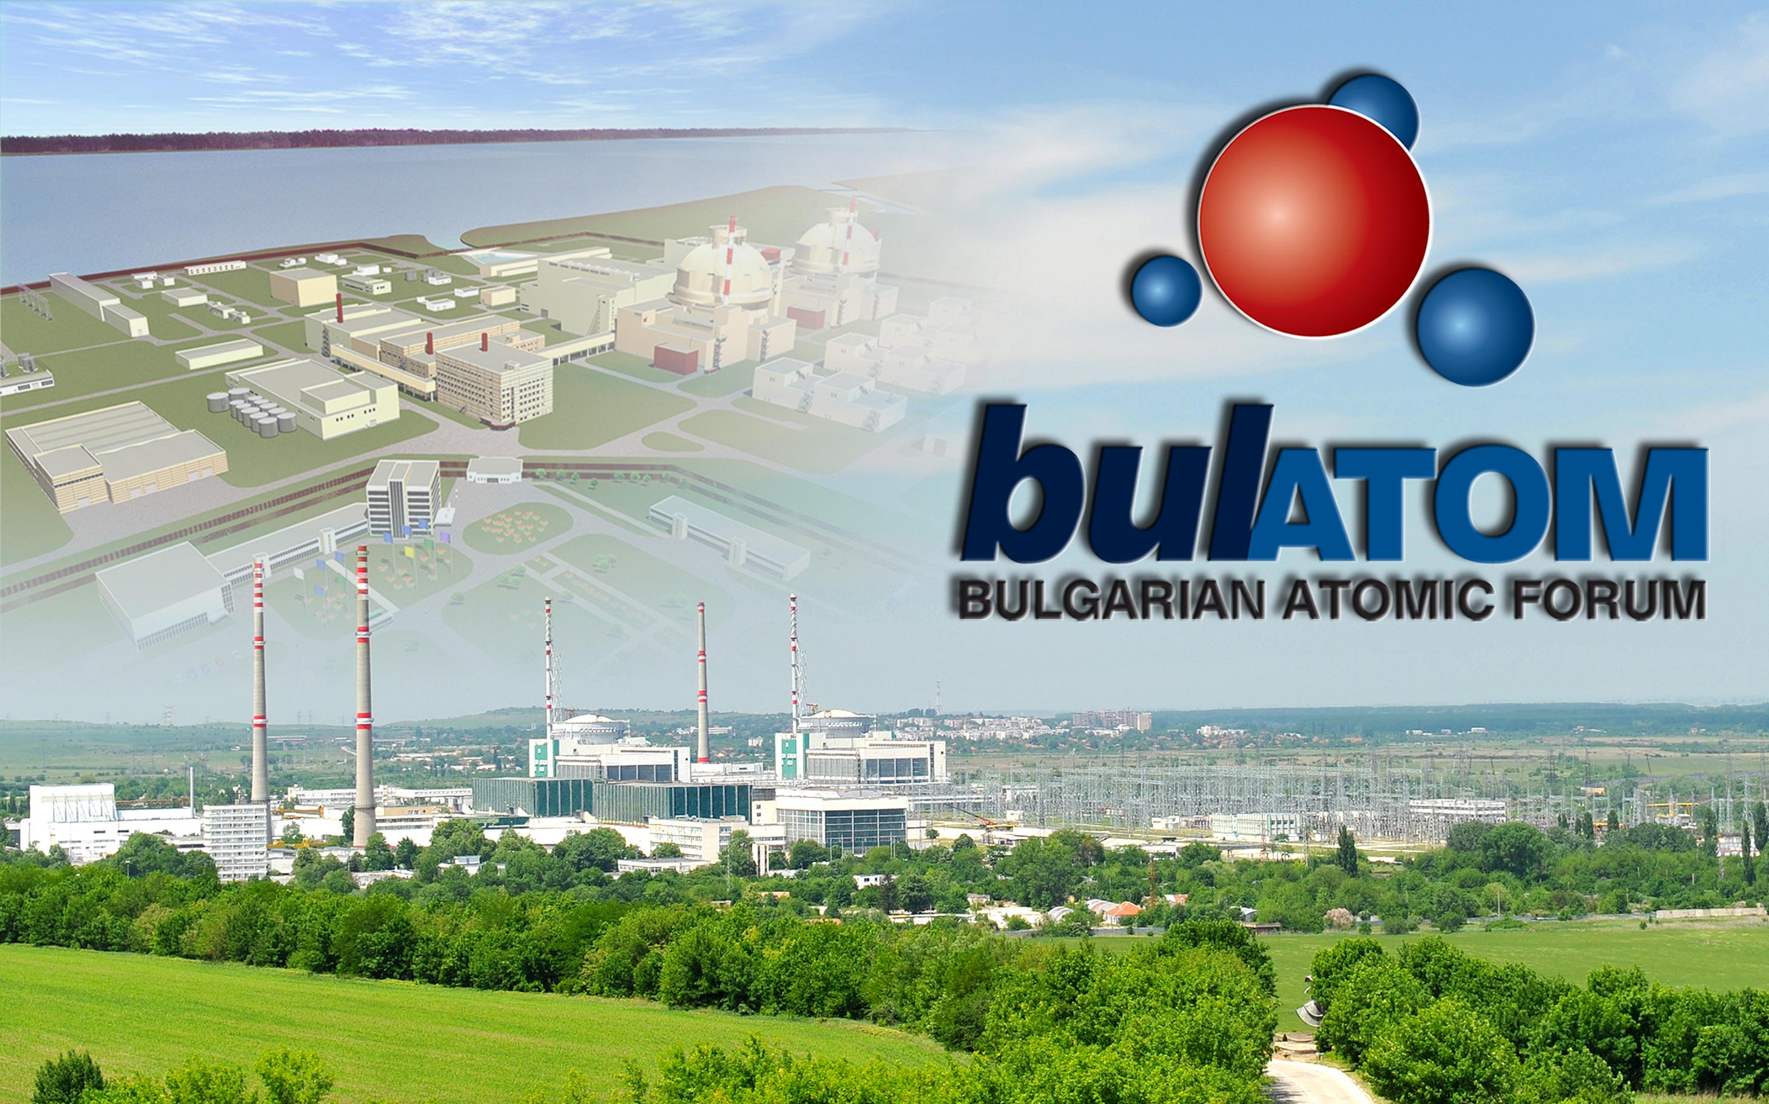

Under the patronage of the

MINISTRY OF ENERGY
&
BULGARIAN NUCLEAR REGULATORY AGENCY

15th June – 17th June, 2016
Riviera Holiday Club, Varna
CONTENTS

І. CONFERENCE SECTIONS …………………………………………………………………………………..………….p. 3

ІІ. PROGRAMME ………………………….……………………………………………………………..………………….p.3

ІІІ. COMMITTEES …………….………………………………………………………………………..…………………… p. 3

ІV. FOR AUTHORS ……………………………………………………………………………………..…………………… p. 4

V. VENUE ……………………………………………………………………………………………………..……………….. p. 5

VІ. REGISTRATION …………………………………………………………………………………………………………..p. 5

VІІ. ACCOMMODATION ……………………………………………………………………..…………………………… p.6

VІІІ. SOCIAL EVENTS………………….. ……………………………………………………………………..………….… p.8

ІХ. SPONSORSHIP ……………………………………………………………………………………….…………….…….. p.8

Х. CONTACT ……………………………………………………………………………………………….…….…………….. p. 9

І. CONFERENCE SECTIONS
FIRST CONFERENCE DAY
Plenary Session:
- Addresses
- Presentations on the real status of the NPP Projects in progress at the moment;
- Reports by their Excellences Ambassadors to Bulgaria.

SECOND CONFERENCE DAY
Section 1: Perspectives in the Development, Operation and Maintenance of Nuclear Installations - new approaches.
Section 2: Technologies and Practical Approaches to the Decommissioning of Nuclear Installations. Radioactive Waste and Spent Nuclear Fuel Processing and Storage - exchangе of information on the implementation of similar projects.

THIRD CONFERENCE DAY
Section 3: Lifetime Extension of Kozloduy NPP Units 5 and 6 – real status and exchange of information on the implementation of similar projects.

ІІ. PROGRAMME

Will be provided at a later stage.

ІІІ. COMMITTEES

1. ORGANIZING COMMITTEE

Chairperson: Bogomil Manchev – Bulgarian Atomic Forum
Members: Dimitar Angelov - Kozloduy NPP
Dilyan Petrov – SE Radioactive waste
Daniela Milcheva– Bulgarian Atomic Forum
Irena Jordanova– Bulgarian Atomic Forum

2. SCIENTIFIC COMMITTEE

Chairperson: Stanislav Georgiev – Bulgarian Atomic Forum
Members: Svetlozar Trayanov – SE Radioactive waste
Nayden Naydenov – Kozloduy NPP
Sabin Sabinov – WorleyParsons Nuclear Services

ІV. FOR AUTHORS

Report Requirements:
- The paper shall not exceed 12 pages (the presentation time shall be not more than 15-20 minutes);
- At submitting an application for report, the respective author needs to specify which section he/she would like to join and particular time of his/her presentation;
- The papers shall be in one of the conference working languages – Bulgarian, Russian or English, and submitted in electronic copy to e-mail address: info@bulatom-bg.org, Attention: Mr. Stanislav Georgiev – Chairperson of the Scientific Committee;
- All the reports will be available on Bulatom website (www.bulatom-bg.org) within three working days after the Conference.
Deadline for submitting papers and abstracts for the conference via mail | 21th May, 2016
Deadline for sending information to the speakers in which conference section their report is included | 1st June, 2016
Conference period | 15th June, 2016 – 17th June, 2016
Important Dates for Authors:

V. VENUE

Riviera Holiday Club is situated amidst a unique natural park of century-old trees on the Black Sea coast. It is located t 17 km to the north-east of the town of Varna, in the immediate vicinity of the Golden Sands Resort Complex and 27 km from the Airport of Varna.
A former government residence, now it offers five hotels and it is famous as a business tourism center.
The Conference will be held in the three conference halls of the Riviera Beach Hotel of Riviera Holiday Club.
www.rivierabulgaria.com

VІ. REGISTRATION

- CONFERENCE FEE
Participation Fee (EUR) | Before  30th April, 2016 | After  30th April, 2016
Bulatom Member | 500 | 550
Participant | 550 | 600

The participation fee includes: conference organization, participants’ access to the scientific sessions and presented reports (they will be available on Bulatom website within three working days after the Conference), conference materials, delegate set, three lunches (on 15th, 16th and 17th of June 2016) and cocktail on 15th of June 2016, coffee breaks.
The participation fee must be paid in advance by:
- Payment order to the bank account of Bulatom:
SWIFT BIC code of DSK: STSABGSF
Bank account (EURO) – BG03STSA93000022263573
You are kindly asked to fill in your name and “International Nuclear Forum” clearly on all bank documents. The original invoice will be handed to the respective participant during his/her registration before the beginning of the conference.
Only the payment of the participation fee via bank transfer is a guarantee for the delegate’s registration, and his/her accommodation in the hotel selected. The Organizing Committee is not responsible for hotel rooms’ reservation or participants’ registration without participation fee paid.
Payment in cash or by credit card on spot will only be allowed for conference participants, who have applied to participate after 8th of June, 2016.
- REGISTRATION
Registration for the conference can be done in two ways:
- Completing and sending the registration form till 21 May, 2016 via е-mail: info@bulatom-bg.org or fax: +359 2 439 03 02
- Online registration through Bulatom website: http://www.bulatom-bg.org/en/registration.html

The Registration desk will be on the first floor of the Riviera Beach Hotel. It will be open from 10:00 a.m. to 22:00 p.m. on 14.06.2016 and from 8:00 a.m. to 3:00 p.m. on the other days. All conference participants are requested, if possible, to arrive at Riviera Holiday Club and register on 14.06.2016. Registration of participants on 15th and 16th of June 2016, before the conference work commences, will be done as an exception.
3. CANCELLATION TERMS AND CONDITIONS
• Before April 30, 2016 - an amount equal to the participation fee minus 10% for administrative expenses will be reimbursed.
• Before May 21, 2016 - an amount equal to the participation fee after deducting the first night’s cost at the selected hotel and 50% of the participation fee for administrative expenses will be reimbursed.
• After May 21, 2016 – the participation fee will not be reimbursed.
Annulment requests will be valid only if sent in written form to the Organizing Committee by e-mail or post (the sending date or the postal stamp date will be considered).

VІІ. ACCOMMODATION

The conference participants have rooms booked at preferential prices in the three categories of the hotels at the Riviera Holiday Club and the Training and Recreation Centre "Republika" (Golden Sands Resort) within a walking distance from the conference venue.
The table below shows the availability of different categories of rooms in the different categories of hotels and their prices. Please note that the information is daily updated.
Prices in EUR:
 | Standard Room |  |  | Luxury Room |  |  | Suite
Category of Hotel | One person | Two persons | availability | One person | Two persons | availability | One person | Two persons | availability
* * * * *  h.c. Riviera | 55 | 70 | 113 | 70 | 95 | 22 | 117 | 155 | 5
* * * *  h.c. Riviera | 45 | 55 | 25 | - | - | - | 70 | 80 | 5
* * *  h.c. Riviera | 35 | 45 | 30 | - | - | - | - | - | -
* * *  TRC Republika  Golden Sands Resort | 15 | 20 | 35 | - | - | - | - | - | -

Prices are per room per day and include accommodation, breakfast and insurance.
These prices are only valid if reservation is made through Bulatom.
Requests for a change in hotel accommodation (type of hotel or number of nights) have to be sent in written form to the Conference Organizing Committee and not directly to the hotels.
For convenience, each participant has the opportunity to pay the entire hotel stay in advance by bank transfer through:
Payment order to the bank account of Riviera:
SWIFT BIC code: RZBBBGSF
Bank Account (EURO): BG70RZBB91551464255910
Or
Upon arrival the participants have to pay at the hotel reception, before accommodating, cash or credit cards. Credit cards acceptable by RIVIERA: VISA Card, Euro Card, Master Card, Am. Express.
An original invoice will be issued to each participant at the hotel reception.

Hotel confirmation
Upon receipt of the registration form and payment of the participation fee, the Organizing Committee will notify the participant by е-mail that he/she is registered as a delegate and will confirm his/her accommodation at the hotel chosen. The information on the hotel name (if accommodated in Riviera Holiday Club) will be sent to the registered participant till 8th of June, 2016.

VІІІ. SOCIAL EVENTS

1. Lunch
Date: 15th, 16^{h}, 17^{h}, June 2016, the exact time will be noted in the conference program
Place: Riviera Beach – 1 Restaurant, Riviera Holiday Club
Included in the participation fee.
2. “Welcome” Cocktail
Date: Wednesday, 15th June, 2016, 20:00 h.
Place: Imperial Cafe in Riviera Holiday Club
Included in the participation fee.
Note: Accompanying persons wishing to participate in the social events may buy covers at the Secretariat. The cost of one lunch cover is EUR 15. The cost of one cocktail cover is EUR 35.

ІХ. SPONSORSHIP

SPONSORSHIP & EXHIBITION SPACE
A selection of sponsorship opportunities is available for companies who would like to promote their activities at the Conference. This event typically attracts 200 plus participants from different countries.
Please register your interest in sponsorship packages or exhibition space by email to info@bulatom-bg.org .

Х. CONTACT

In case of inquiries regarding the overall Conference organization, please refer to:
Mr. Stanislav Georgiev – Representative of Scientific Committee
Mr. Bogomil Manchev – Representative of Organizing Committee

BULGARIAN ATOMIC FORUM
10, Vihren Str.
1618 Sofia
tel./fax :+359 2 439 03 02
E-mail: info@bulatom-bg.org
Website: www.bulatom-bg.org

