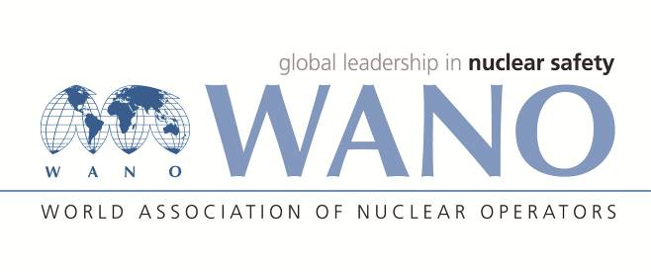 | Moscow Centre  World Association of Nuclear Operators  WANO MC  Russia, 109507, Moscow, 25 Ferganskaya Str.  Tel.: +7 495 376 15 87  Fax: +7 495 376 08 97  info@wanomc.ru

REQUEST
for technical and organizational information
via WANO

- NPP/Organization: Kozloduy NPP

- Request subject: Containment leak-tightness testing system

- Request objective: Research about companies that design and manufacture licensed containment leak-tightness testing systems

- Issue description: The operating lifetime of the current containment leak-tightness testing system has expired.
- Specific questions:
1. What containment leak-tightness testing system do you use?
2. Who designed the system?
3. Who manufactured the system?
4. What is the duration of the test following containment pressure stabilisation?
5. Is the testing system capable of forecasting containment leak rates prior to test completion?
6. Has the testing system failed during containment leak-tightness tests resulting in retesting?
7. Is it necessary to back up the measurement channels and hardware?
8. Are the sensors permanently fixed within the containment, or is it necessary to install/replace them before testing and dismantle/collect them upon completion of the test?
9. What is the operating lifetime of the containment leak-tightness testing system you are using?
10. When was the containment leak-tightness testing system implemented?
- Suggested organisations to receive this request:
All plants that are WANO members
- Administrative unit – request initiator: Instrumentation and Control Systems Workshop, Process Measurements and Automation Section

- Request initiator contact details: Emil Sherbanov, Head of Process Measurements and Automation Section, Tel.: +35997372230, e-mail: eysherbanov@npp.bg

- Request date: 15 Feb 2022

Accountable person Veselin Nikolov, Contact person with WANO
Responsible person
surname, name, father’s name
Tel.:

