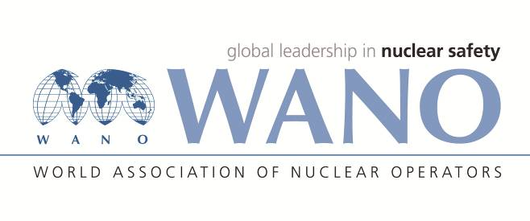 | World Association of Nuclear Operators  Moscow Centre  WANO – MC  25 Ferganskaya, Moscow, 109507, Russia  Phone. +7 495 376 15 87  Fax: +7 495 376 08 97  info@wanomc.ru
REQUEST
to provide technical and organizational information via WANO

- NPP/Organization: Jiangsu Nuclear Power Corporation, Tianwan NPP
- The topic of information request:
Service life of the gas fire-fighting cylinder
- The goal of information request:
We hope to know which NPP use the gas fire-fighting cylinder produced by manufacturer АРТСОК and the actual service life of this gas fire-fighting cylinder.
- Problem description:
Tianwan NPP Units 1&2 are using the gas fire-fighting cylinder produced by manufacturer АРТСОК. According to the manufacturer’s documents, service life of the cylinder is 30 years. According to the regulation ТУ 4854-001-33075088-96, service life before major overhaul of the cylinder is not less than 25 years. We hope to know how each NPP performs.
- Specific questions:
- Does your NPP use the gas fire-fighting cylinder produced by manufacturer АРТСОК?
- How long is the service life of the gas fire-fighting cylinder at your NPP?
- Proposed organizations for sending this request:
WANO-MC NPPs
- Department – request initiator:
Mr. Liu Jianmin, Engineer of maintenance department, Tianwan NPP.
- Contact details of the requester:
Tel. (office): +86 518 82208045
E-mail. liujm01@cnnp.com.cn
- Date of request: 8.2.2022

